Categorical variable encoding:

Replacing categorical string to numeriscal representation

Goal:

To transform categories that can be used to train machine learning models

To built predictive features from categories

Traditional encoding:

One hot

Count/freq encoding

Ordinal/label encoding

**Encoding tech which creates monotonic relationship between variables and targets:**

Ordered lablel encoding

Mean encoding

Weight evidence

Monotonic relationship:

When variable increases target increase

When variable increases targetdecrease

Monotonic can be linear or non linear

Used to improve performance of linearrmodels

Also used in tree based (creats shallower trees)

**Alternative tech:**

Binary order

Feature hashing

Others

Wont use in org

They cant interpretable

---

Encoding tech of rare lables:

Infrequent lables

If data highly cardinal

It may be problem

If present only in train set: overfit

If its present only in test: machine model doent know what to do

Model will not score observation

Solution:

Onehot encoding of freq lable only

Or grouping rare categories into single category

It will be imp in production

One hot encoding: encoding each categorical variables with a set of Boolean variables which takes values 0 or 1

Colour: red , yellow green

One variables for each label

Red yello green

1 0 0

0 1 0

Remove dummy

How many variables should be created K-1

K is distinct lables which each variable has

Binary variables: 1 variable will be created

k-1 variables still represent whole info

few occasion: we should use k

tree based

doing feature selection by recursive algorithm

when we interested in determine the importance of each single category

advantages:

its keeps all inf

suitable for linear models

limit:

expands feature space

doent add any extra info about variables

many dummy variables may be identical, introducing redundant info

**Important: Feature-engine version 1.0.0**

From version 1.0.0 onward:

* categorical encoders are imported from feature_engine.encoding instead of feature_engine_categorical_encoders.
* the word Categorical was removed from the classes name.
  + e.g., instead of MeanCategoricalEncoder, the class is called MeanEncoder.
  + e.g., instead of RareLabelCategoricalEncoder it is RareLabelEncoder
  + and so on.

Please check the [encoders documentation](https://feature-engine.readthedocs.io/en/latest/encoding/index.html) for more details.

**The code in the github repo is updated to run with the latest version of the code. The video shows the notebook with the old version imports. However, it will provide you with all the knowledge you need to understand how to use the transformers.**

**One Hot Encoding**

One hot encoding, consists in **encoding each categorical variable** with **different boolean variables** (also **called dummy variables**) which take values **0 or 1**, indicating if **a category is present in an observation.**

For example, for the categorical variable **"Gender",** with labels 'female' and 'male', we can generate the boolean variable **"female", which takes 1 if** the person is 'female' or 0 otherwise, or we can generate the variable "male", which takes 1 if the person is 'male' and 0 otherwise.

For the categorical variable "colour" with values 'red', 'blue' and 'green', we can create 3 new variables called "red", "blue" and "green". These variables will take the value 1, if the observation is of the said colour or 0 otherwise.

**Encoding into k-1 dummy variables**

Note however, that for the variable "**colour", by creating 2 binary variables, say "red" and "blue**", we already encode **ALL** the information:

* **if the observation is red, it will be captured by the variable "red" (red = 1, blue = 0)**
* **if the observation is blue, it will be captured by the variable "blue" (red = 0, blue = 1)**
* **if the observation is green, it will be captured by the combination of "red" and "blue" (red = 0, blue = 0)**

We **do not need to add a third variable "green"** to capture that the observation is green.

More generally, a categorical variable should be encoded by **creating k-1 binary variables**, **where k is the number of distinct categories**. In the case of gender, k=2 (male / female), therefore we need to create only 1 (k - 1 = 1) binary variable. In the case of colour, which has 3 different categories (k=3), we need to create 2 (k - 1 = 2) binary variables to capture all the information.

One hot encoding into k-1 binary variables takes into account that we can use 1 less dimension and still represent the whole information: if the observation is 0 in all the binary variables, then it must be 1 in the final (not present) binary variable.

**When one hot encoding categorical variables, we create k - 1 binary variables**

Most machine learning algorithms, consider the entire data set while being fit. Therefore, encoding categorical variables into k - 1 binary variables, is better, as it avoids introducing redundant information.

**Exception: One hot encoding into k dummy variables**

There are a few occasions when it is better to encode variables into k dummy variables:

* when building **tree based algorithms**
* when doing feature selection by **recursive algorithm**s
* when interested **in determine the importance of each single category**

Tree based algorithms, as opposed to the majority of machine learning algorithms, **do not** evaluate the entire dataset while being trained. **They randomly extract a subset of features** from the data set at each node for each tree. Therefore, if we want a tree based algorithm **to consider all the categories**, we need to encode categorical variables into **k binary variables**.

If we are planning to do feature selection by **recursive elimination (or addition**), or if we want to **evaluate the importance of each single category of the categorical variable**, then we will also need the entire set of binary variables (k) to let the machine learning model select which ones have the most predictive power.

**Advantages of one hot encoding**

* Straightforward to implement
* Makes no assumption about the distribution or categories of the categorical variable
* Keeps all the information of the categorical variable
* Suitable for linear models

**Limitations**

* Expands the feature space
* Does not add extra information while encoding
* Many dummy variables may be identical, introducing redundant information

**Notes**

If our datasets contain a few highly cardinal variables, we will end up very soon with datasets with **thousands of columns,** which may make training of our algorithms slow, and model interpretation hard.

In addition, many of these dummy variables **may be similar to each other,** since it is not unusual that 2 or more variables share the same combinations of 1 and 0s. Therefore one hot encoding may **introduce redundant or duplicated information** even if we encode into k-1.

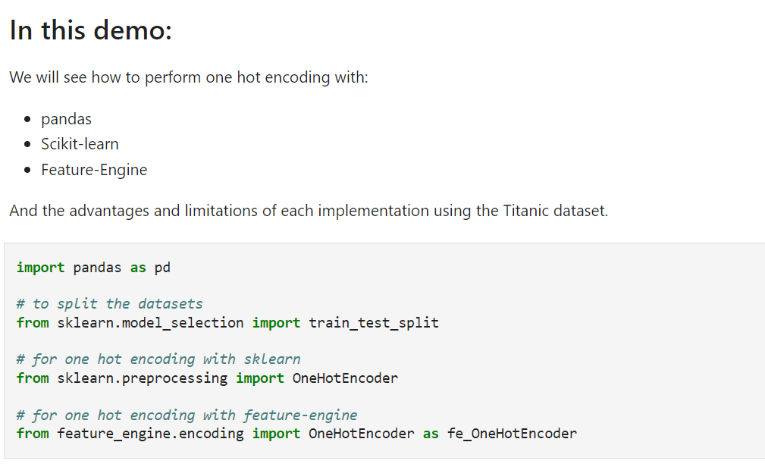

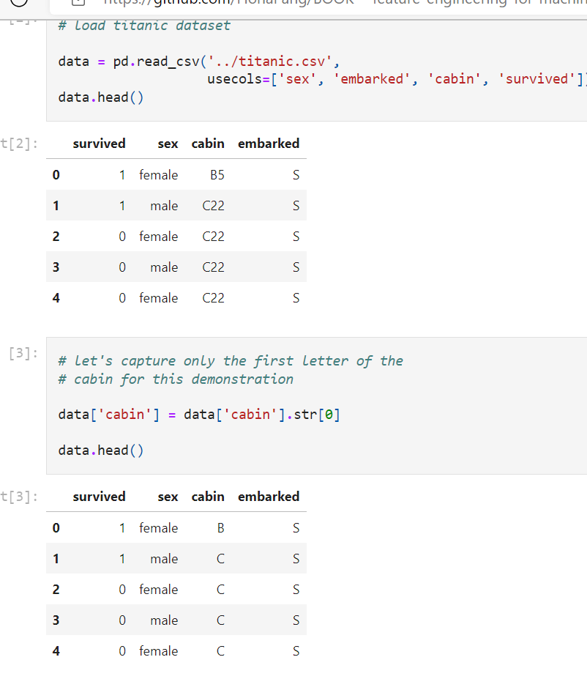

**Encoding important**

Just like imputation, all methods of categorical encoding should be performed **over the training set,** and then **propagated to the test set.**

Why?

Because **these methods will "learn" patterns from the train data**, and therefore you want to **avoid leaking information and overfitting**.

But more importantly, because we don't know **whether in future / live data,** we will have all the **categories present in the train data,** or if there will be more or less categories. Therefore, we want to anticipate this **uncertainty by setting the right processes right from the start**. We want to **create transformers that learn the categories from the train set**, and used those learned categories to create the dummy variables in both train and test sets.

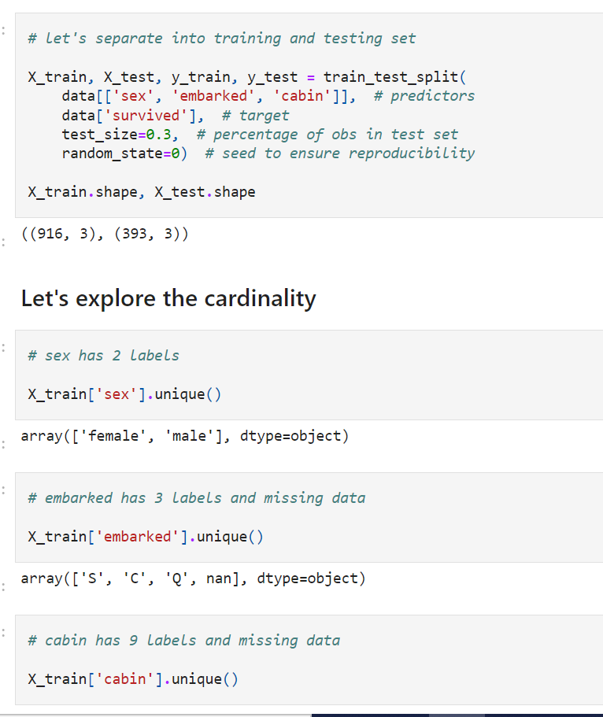

**One hot encoding with pandas**

**Advantages**

* quick
* returns **pandas dataframe**
* returns **feature names for the dummy variables**

**Limitations of pandas:**

* it does not **preserve information from train data to propagate to test data**

The pandas method **get_dummies(), will** create as many binary variables as categories in the variable:

If the variable **colour has 3 categories in the train data**, it will create 2 dummy variables. However, if the variable **colour has 5 categories in the test data,** it will create 4 binary variables, therefore train and test sets will end up with different number of features and will be incompatible with training and scoring using Scikit-learn.

In practice, **we shouldn't be using get-dummies in our machine learning pipelines**. It is however useful, for a quick data exploration. Let's look at this with examples.

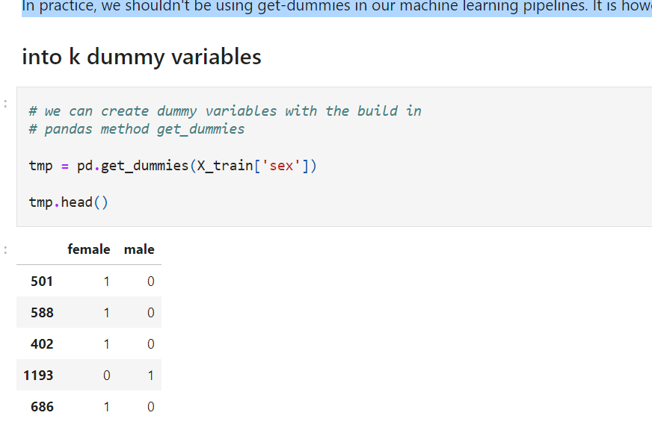

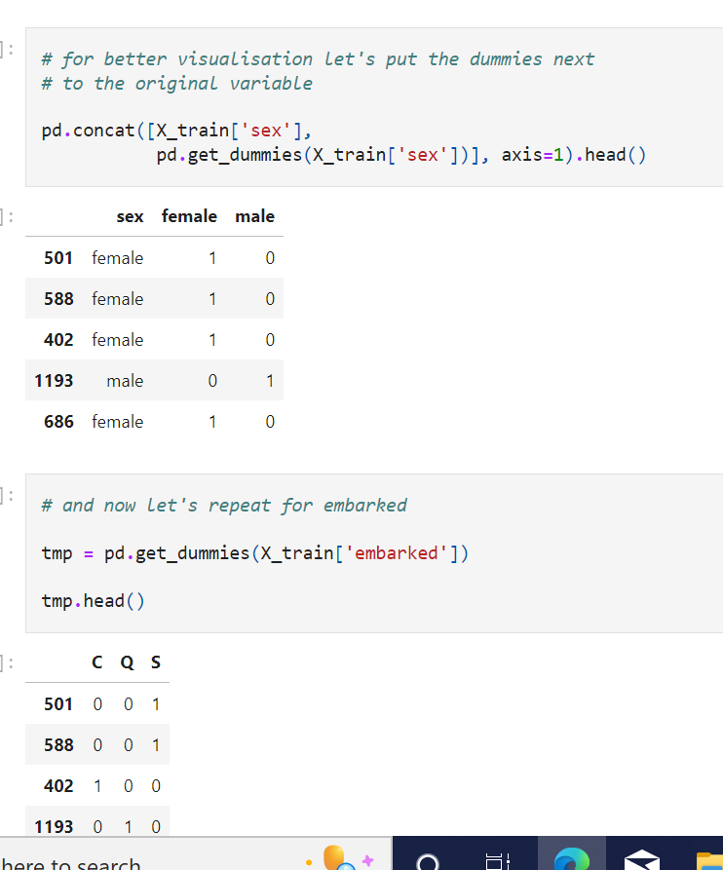

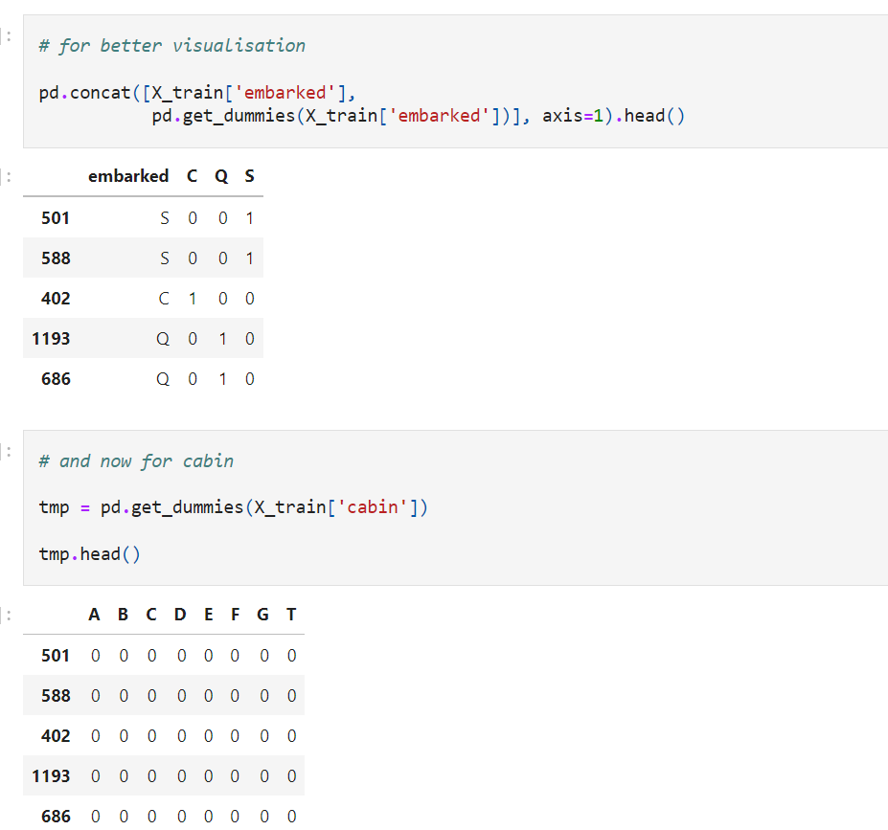

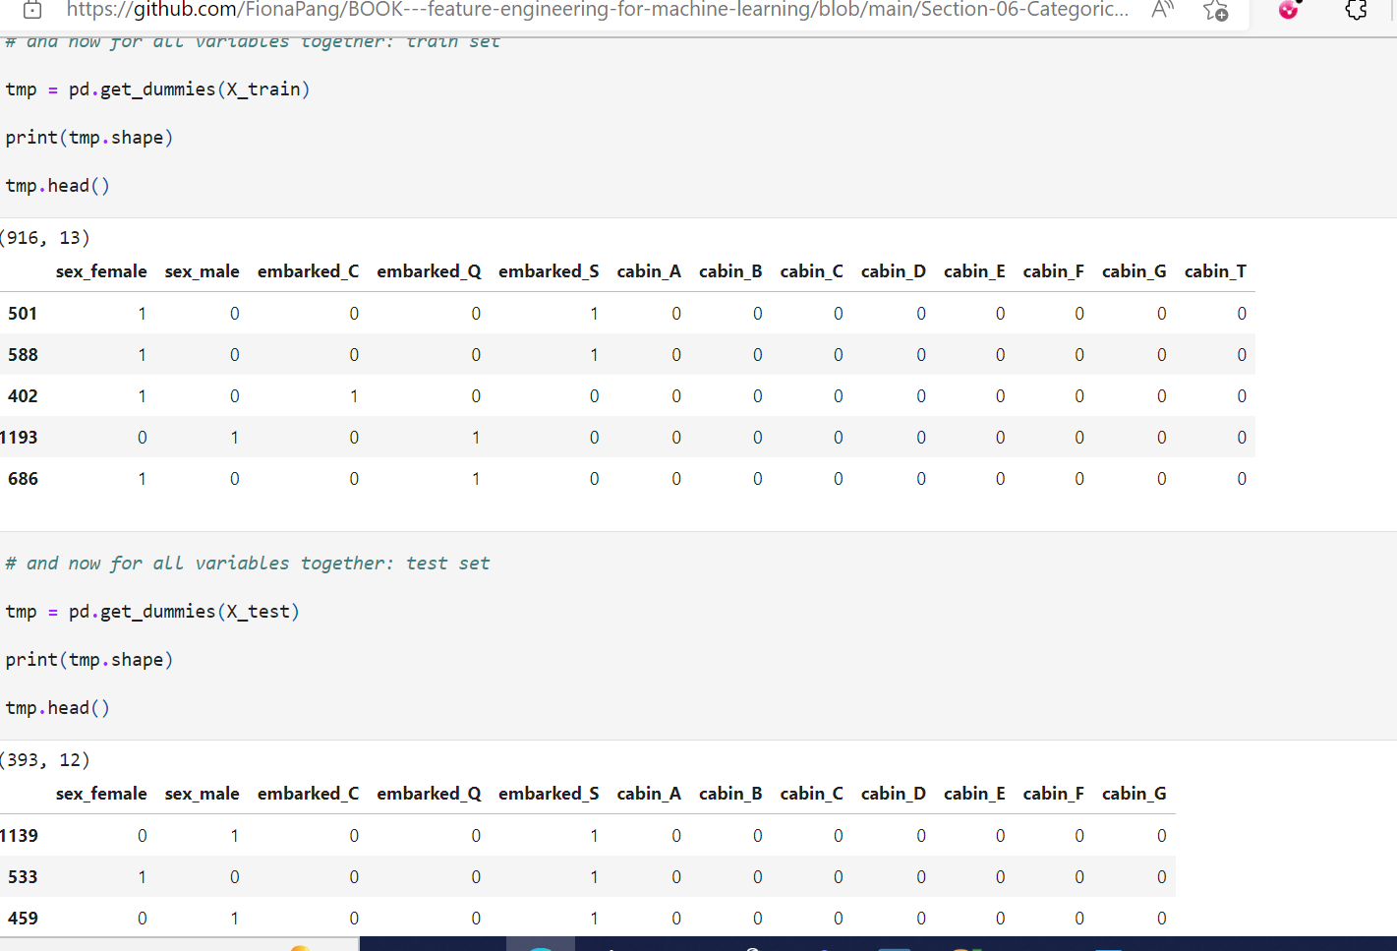

Notice the positives of pandas get_dummies:

* dataframe returned with feature names

**And the limitations:**

The **train set contains 13 dummy features**, whereas the **test set contains 12 features.** This occurred because there was **no category T in cabin in the test set.**

This will **cause problems if training and scoring models with scikit-learn**, because predictors require **train and test sets to be of the same shape.**

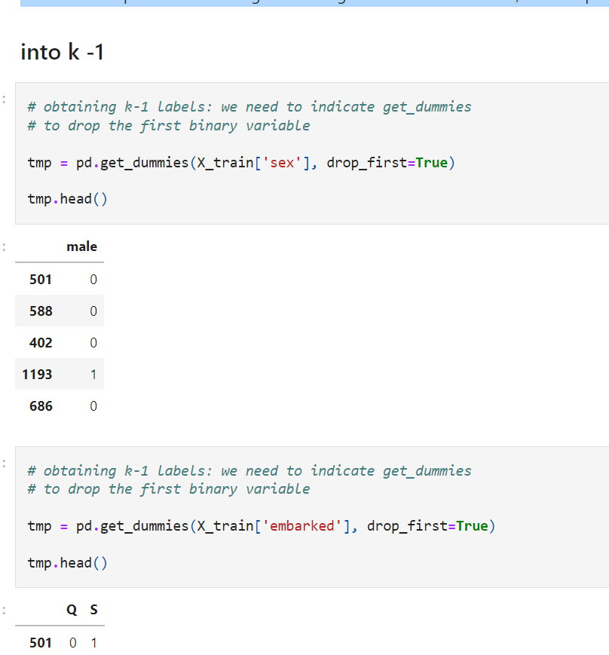

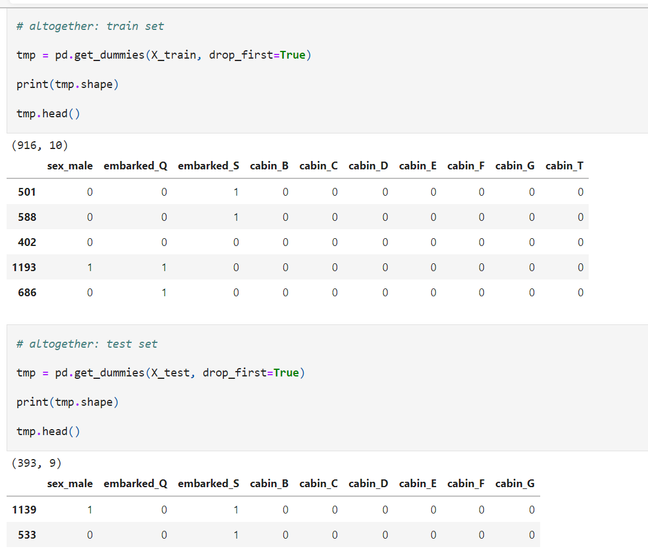

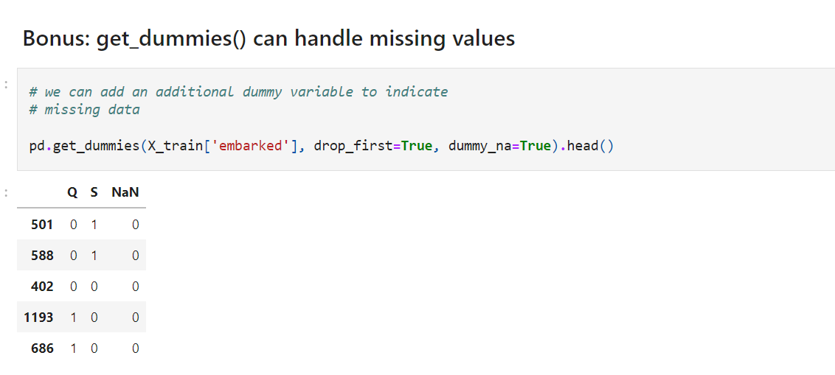

**One hot encoding with Scikit-learn**

**Advantages**

* quick
* Creates the same number of features in train and test set

**Limitations**

* it returns a numpy array instead of a pandas dataframe
* it does not return the variable names, therefore inconvenient for variable exploration

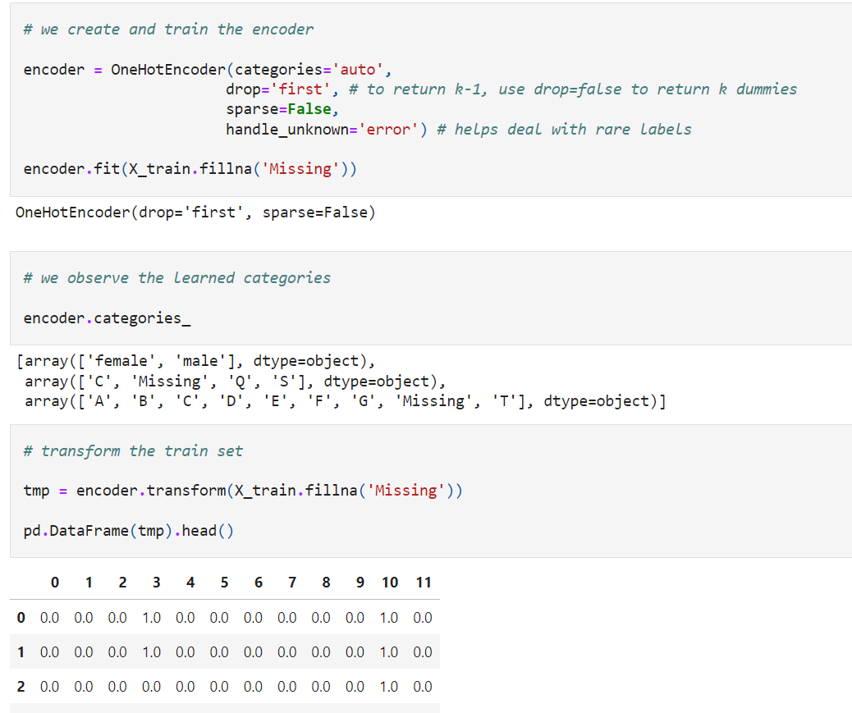

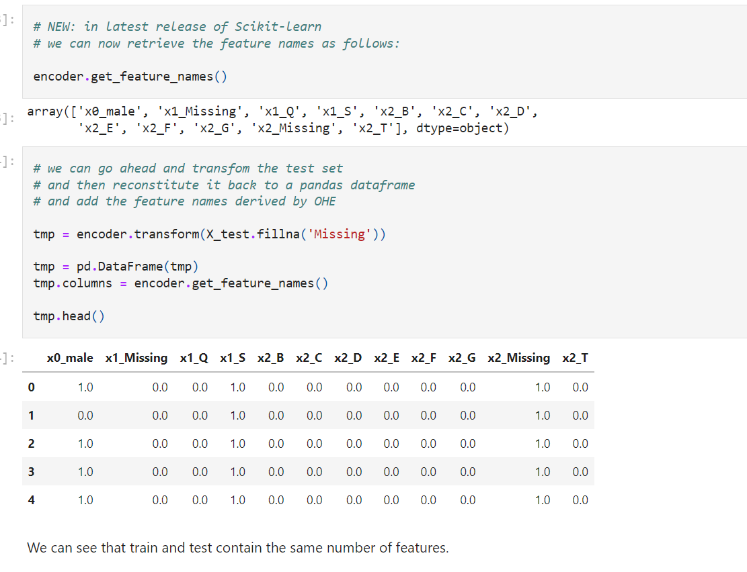

**One hot encoding with Feature-Engine**

**Advantages**

* quick
* returns dataframe
* returns feature names
* allows to select features to encode

**Limitations**

* Not sure yet.

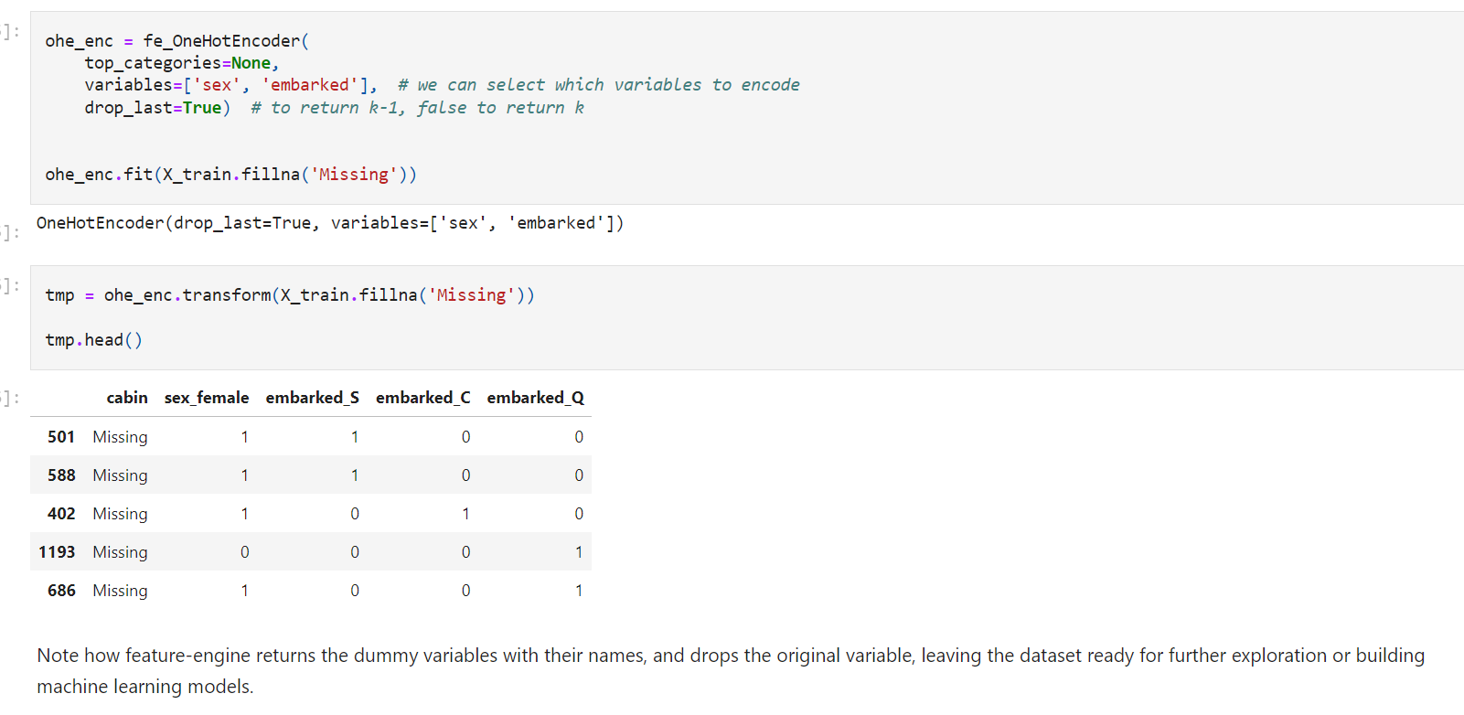

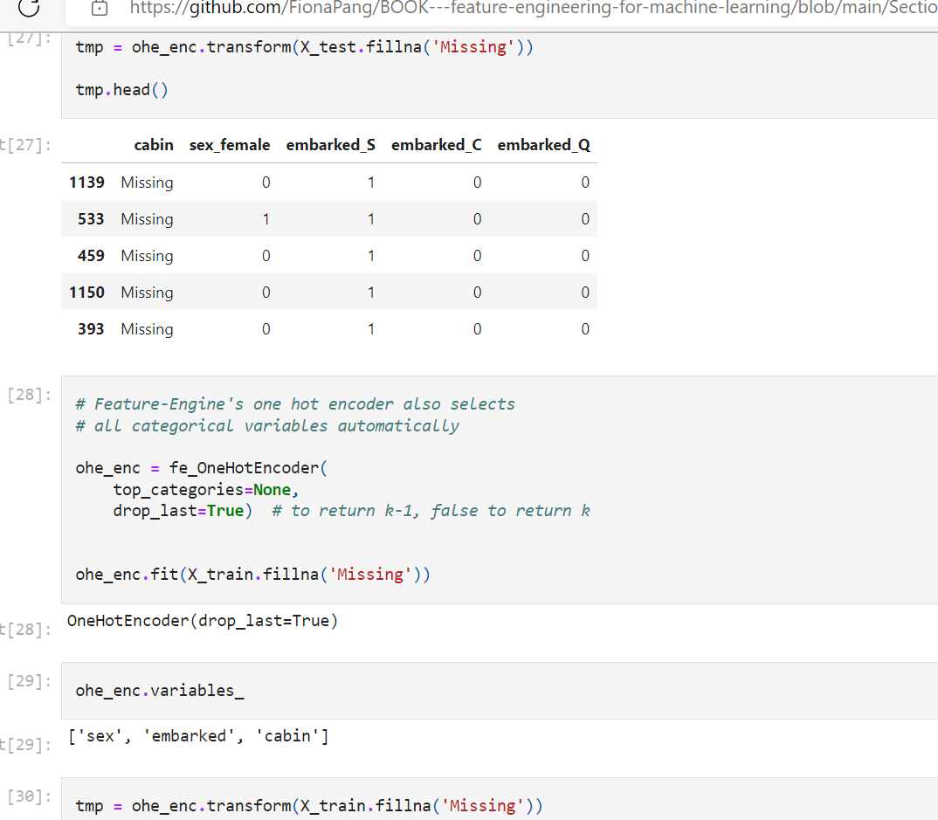

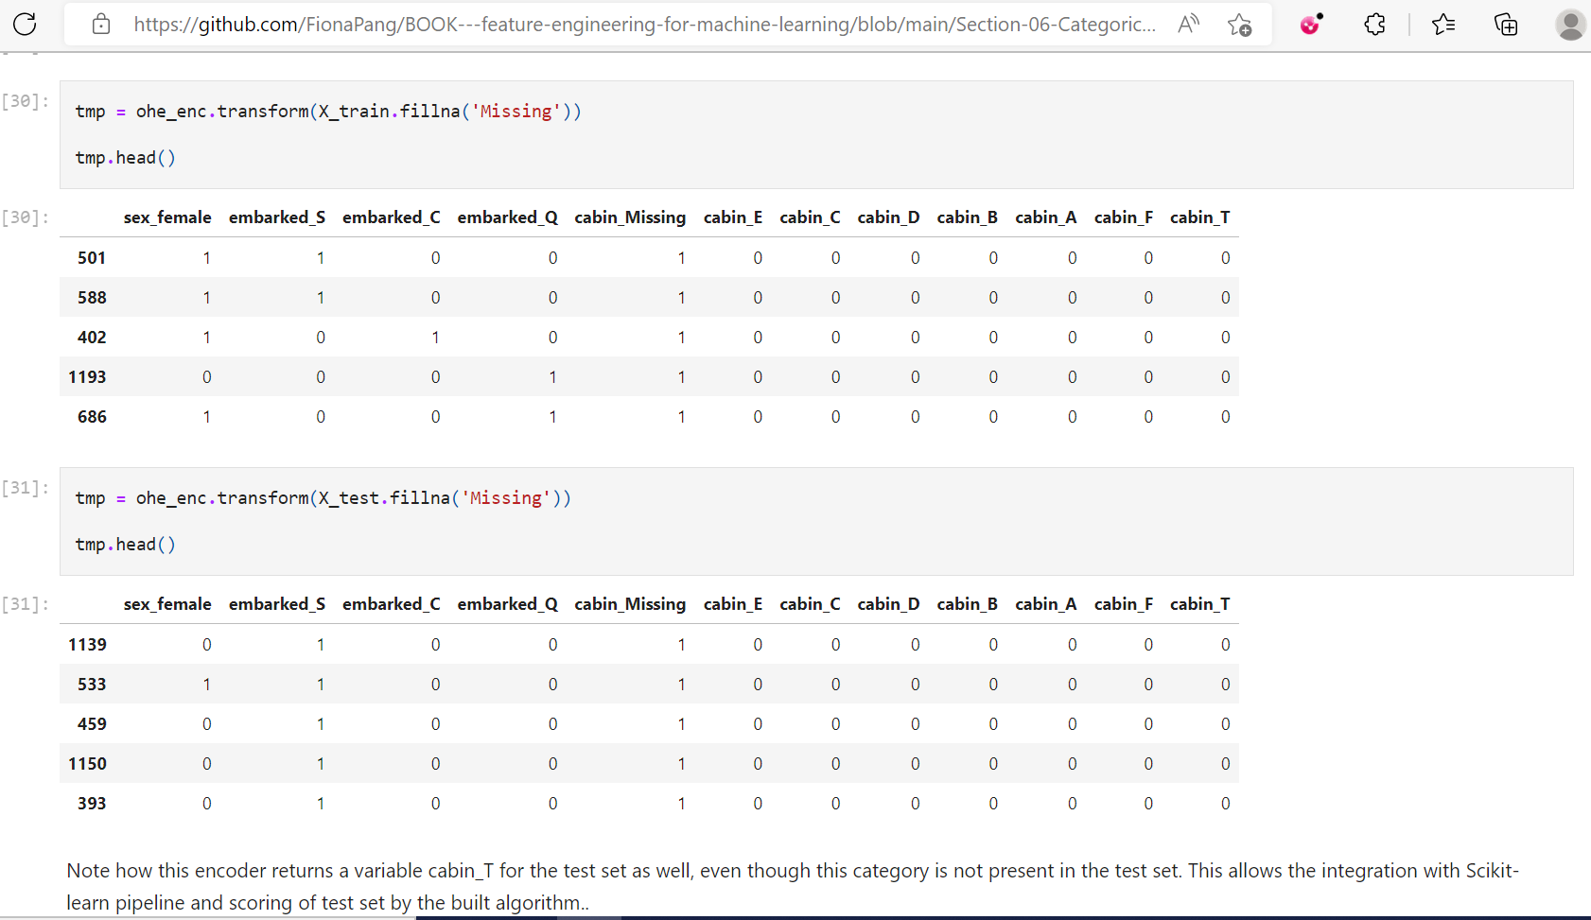

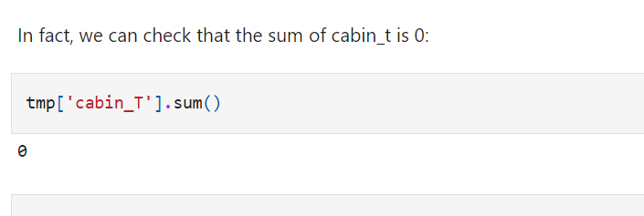

--

One hot encoding for freq /top categories:

Only considering most freq categories

If we want to consider only 3 top labels

Create 3 variables

If all variables indicates 000 means not related to any one of above top

**One Hot Encoding of Frequent Categories**

We learned in Section 3 that **high cardinality** and **rare labels** may result in certain categories appearing only in the **train set**, therefore causing **over-fitting**, or only in the **test set,** and then our **models wouldn't know how to score those observations.**

We also learned in the previous lecture on one hot encoding, that if categorical variables contain multiple labels, then by re-encoding them with dummy variables we will expand the feature space dramatically.

**In order to avoid these complications, we can create dummy variables only for the most frequent categories**

This procedure is also **called one hot encoding of top categories.**

In fact, in the winning solution of the KDD 2009 cup: ["Winning the KDD Cup Orange Challenge with Ensemble Selection"](http://www.mtome.com/Publications/CiML/CiML-v3-book.pdf), the authors limit one hot encoding to the 10 most frequent labels of the variable. This means that they would make one binary variable for each of the 10 most frequent labels only.

OHE of frequent or top categories is equivalent to **grouping all the remaining categories under a new category.** We **will have a better look at grouping rare values into a new category** in a **later notebook in this section.**

**Advantages of OHE of top categories**

* Straightforward to implement
* Does not require hrs of variable exploration
* Does **not expand massively the feature space**
* Suitable for **linear models**

**Limitations**

* Does not **add any information** that may make the variable more predictive
* Does not keep the **information of the ignored labels**

Often, categorical variables show a few dominating categories while the remaining labels add little information. Therefore, OHE of top categories is a simple and useful technique.

**Note**

The number of top variables is set arbitrarily. In the KDD competition the authors selected 10, but it could have been 15 or 5 as well. This number can be chosen arbitrarily or derived from data exploration.

We will see how to perform one hot encoding with:

* pandas and NumPy
* Feature-Engine

And the advantages and limitations of these implementations using the House Prices dataset

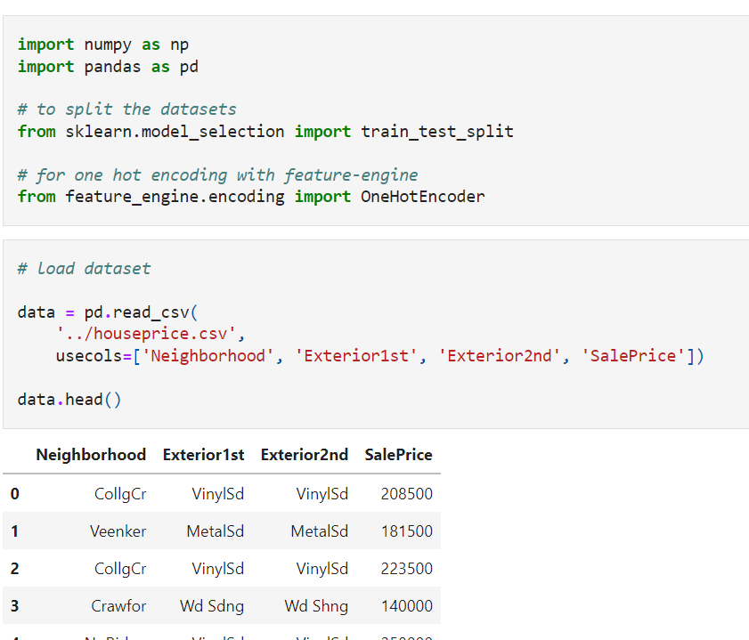

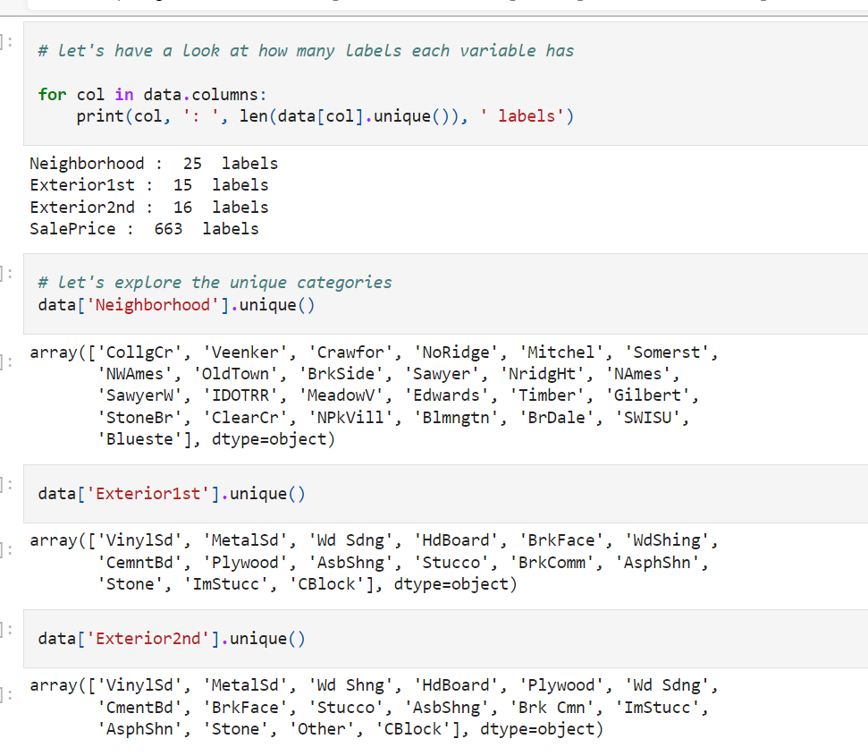

**Encoding important**

It is important to **select the top or most frequent categories** based of the **train data**. Then, we will use those top categories to encode the variables in the test data as well

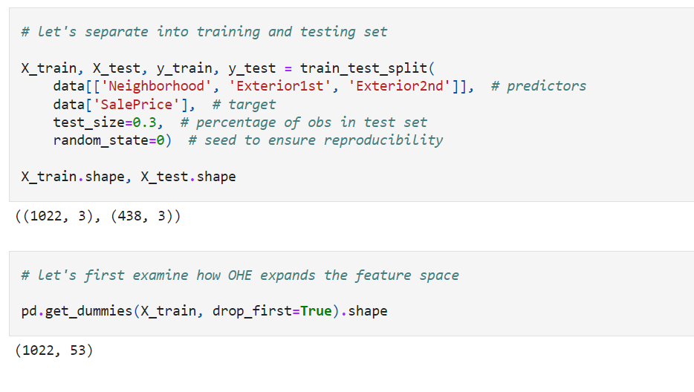

From the initial 3 categorical variables, we end up with 53 variables.

These numbers are **still not huge**, and in practice we could work with them relatively easily. However, in real-life datasets, **categorical variables can be highly cardinal**, and with OHE we can end up with datasets with thousands of columns.

**OHE with pandas and NumPy**

**Advantages**

* quick
* returns pandas dataframe
* returns feature names for the dummy variables

**Limitations:**

* it does not preserve information from train data to propagate to test data

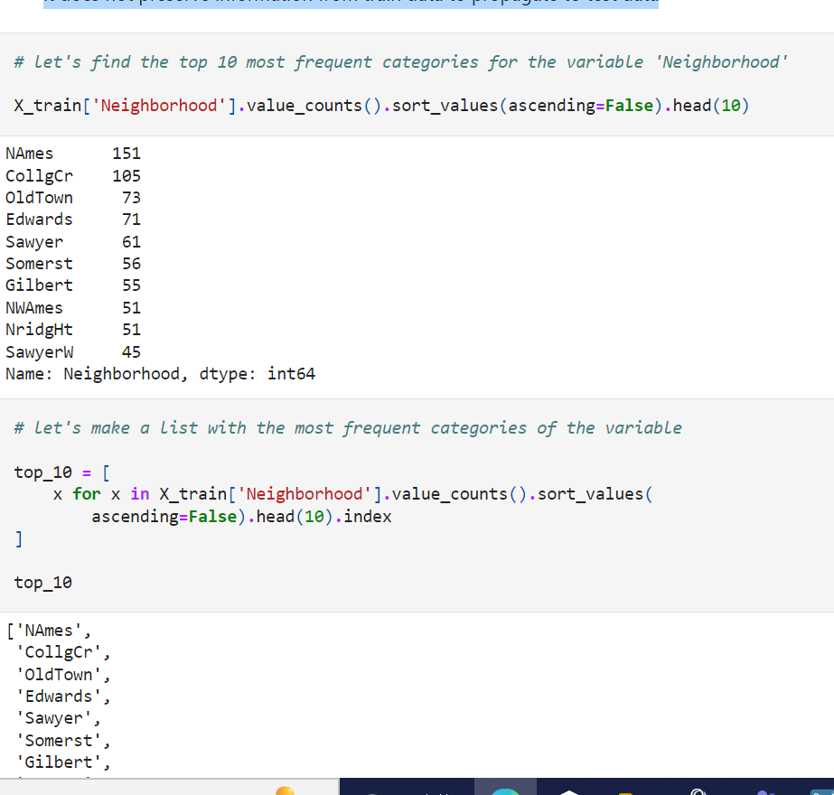

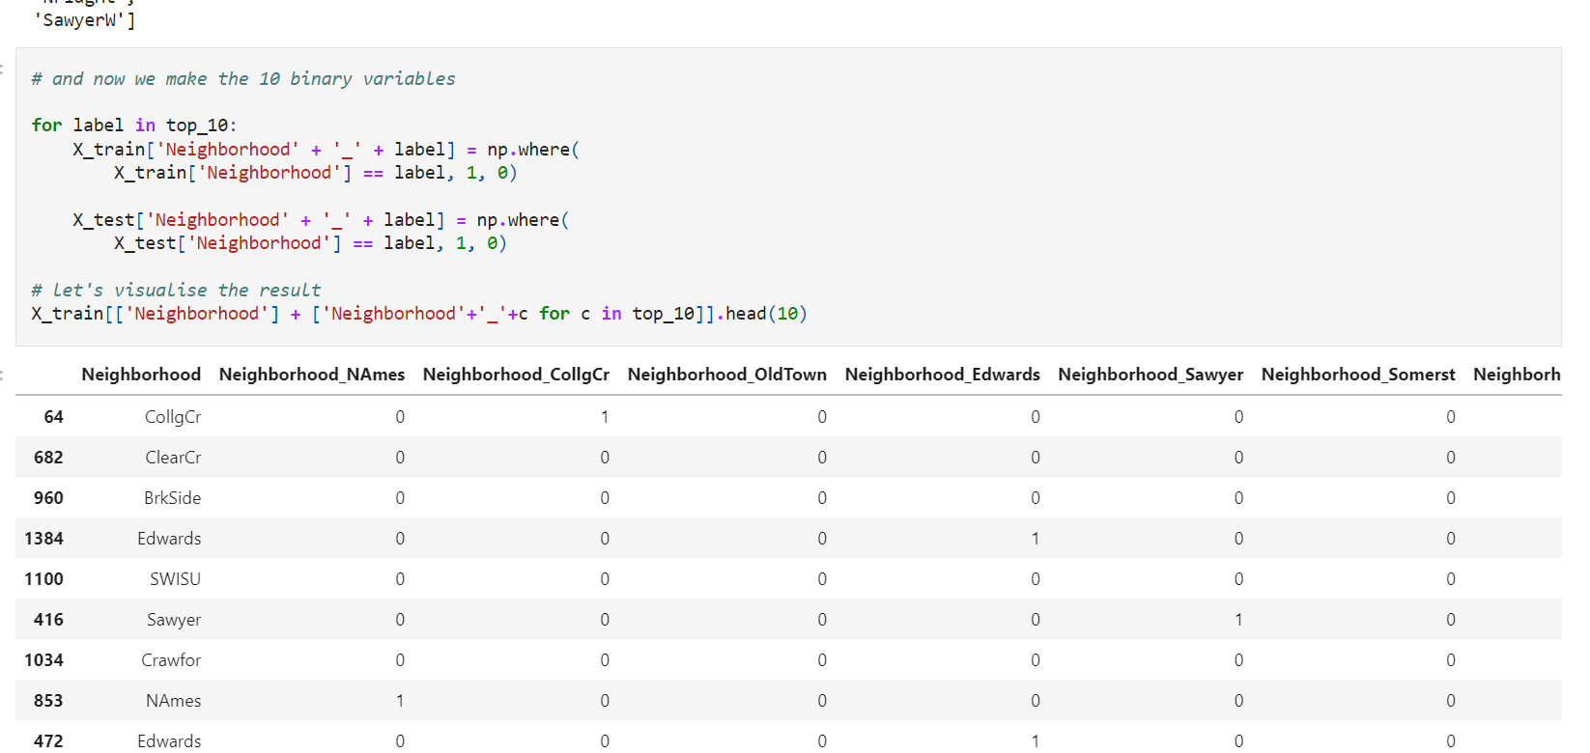

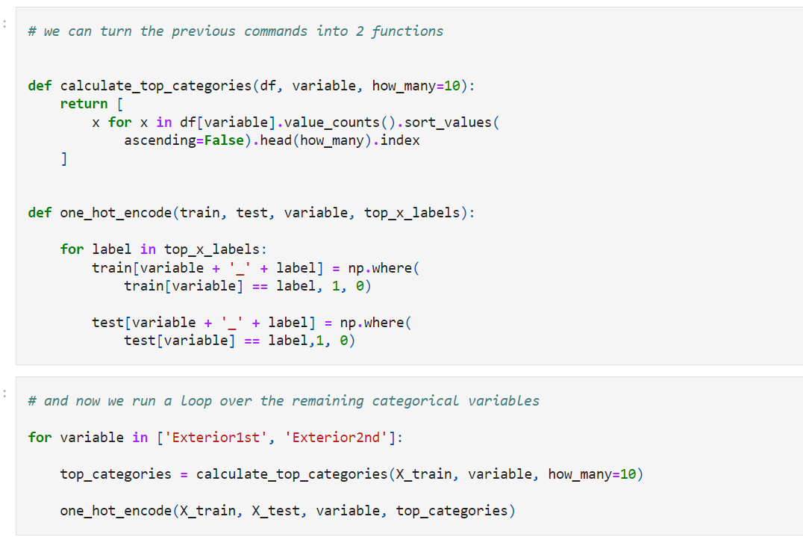

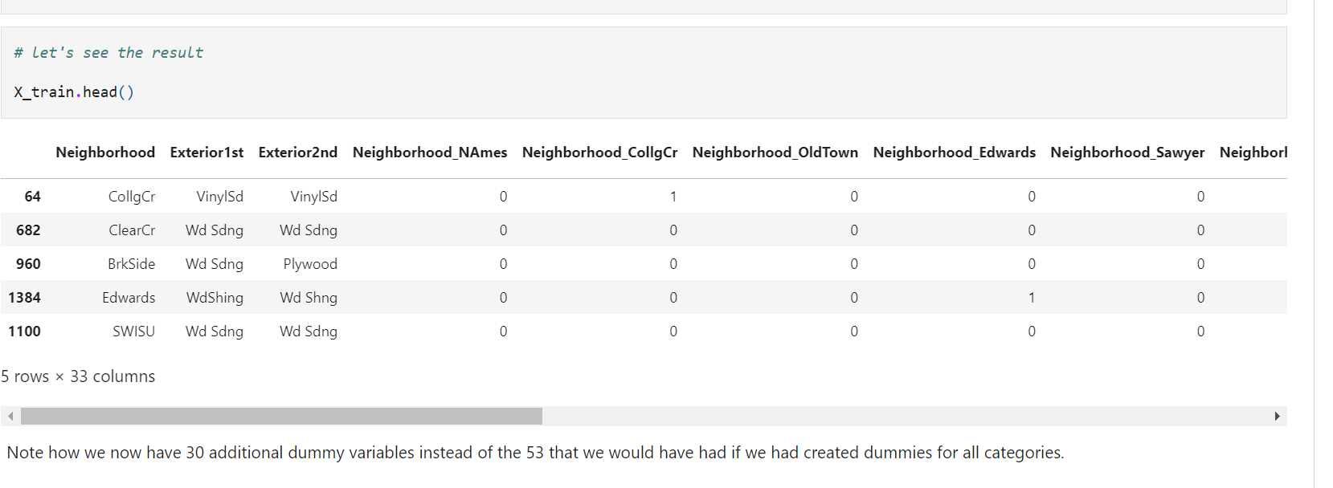

**One hot encoding of top categories with Feature-Engine**

**Advantages**

* quick
* creates the same number of features in train and test set

**Limitations**

* None to my knowledge

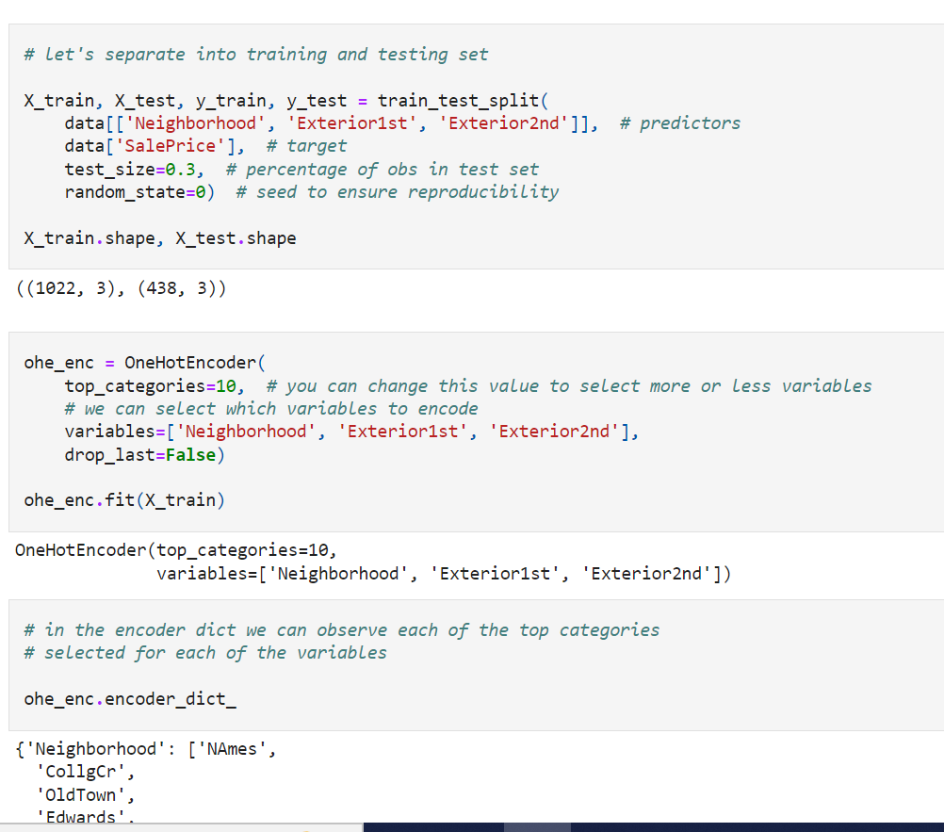

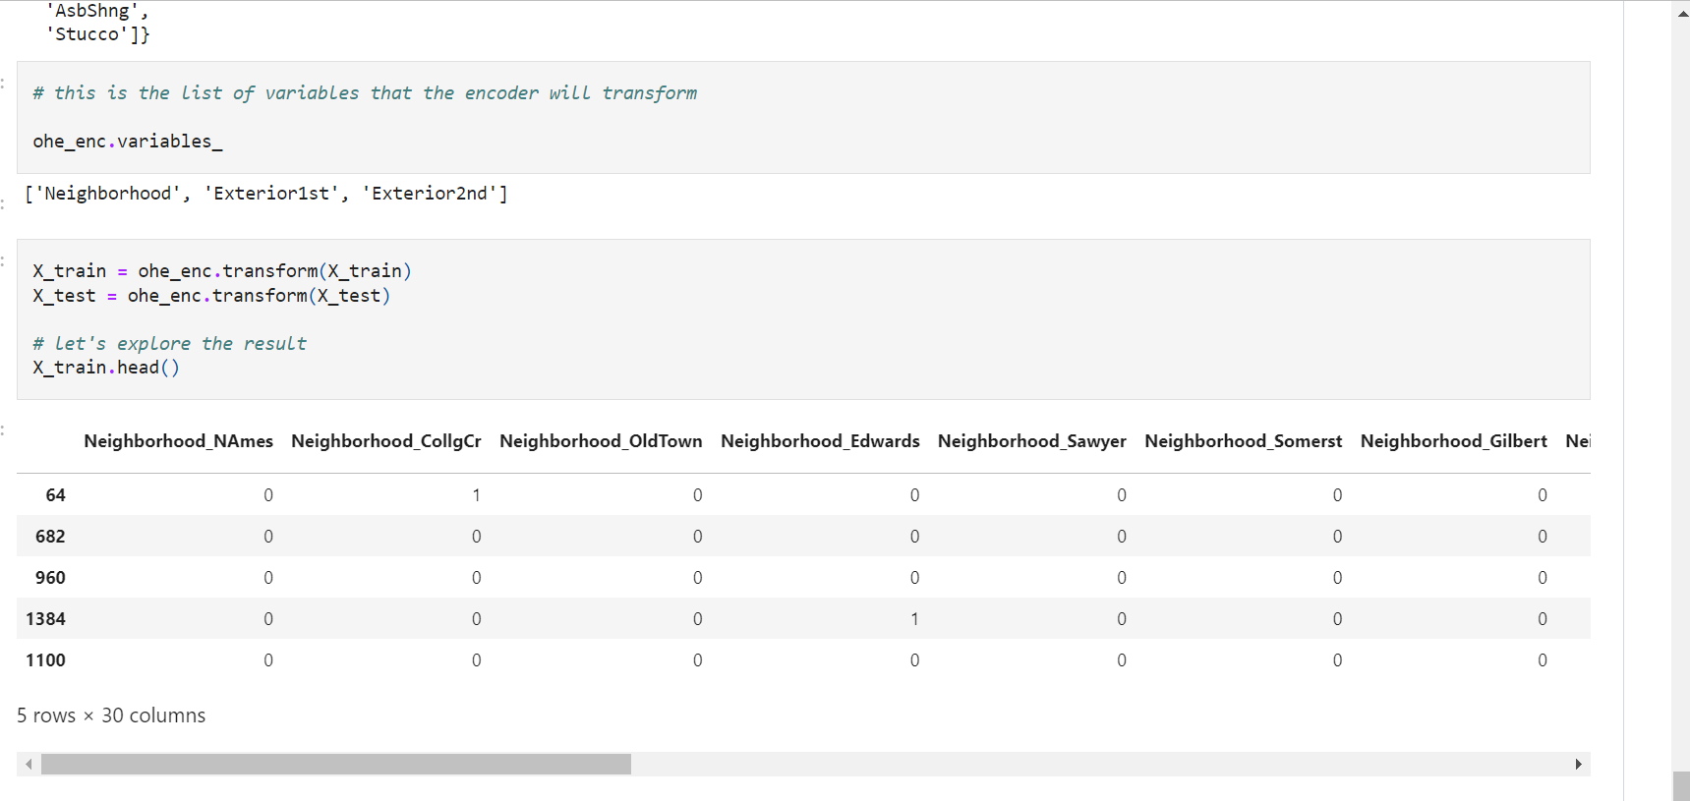

If the argument variables is left to None, then the encoder will automatically identify **all categorical variables**. Is that not sweet?

The encoder will not encode numerical variables. So if some of your numerical variables are in fact categories, you will need to re-cast them as object before using the encoder.

**One Hot Encoding of Frequent Categories**

We learned in Section 3 that high cardinality and rare labels may result in certain categories appearing only in the train set, therefore causing over-fitting, or only in the test set, and then our models wouldn't know how to score those observations.

We also learned in the previous lecture on one hot encoding, that if categorical variables contain multiple labels, then by re-encoding them with dummy variables we will expand the feature space dramatically.

**In order to avoid these complications, we can create dummy variables only for the most frequent categories**

This procedure is also called one hot encoding of top categories.

In fact, in the winning solution of the KDD 2009 cup: ["Winning the KDD Cup Orange Challenge with Ensemble Selection"](http://www.mtome.com/Publications/CiML/CiML-v3-book.pdf), the authors limit one hot encoding to the 10 most frequent labels of the variable. This means that they would make one binary variable for each of the 10 most frequent labels only.

OHE of frequent or top categories is equivalent to grouping all the remaining categories under a new category. We will have a better look at grouping rare values into a new category in a later notebook in this section.

**Advantages of OHE of top categories**

* Straightforward to implement
* Does not require hrs of variable exploration
* Does not expand massively the feature space
* Suitable for linear models

**Limitations**

* Does not add any information that may make the variable more predictive
* Does not keep the information of the ignored labels

Often, categorical variables show a few dominating categories while the remaining labels add little information. Therefore, OHE of top categories is a simple and useful technique.

**Note**

The number of top variables is set arbitrarily. In the KDD competition the authors selected 10, but it could have been 15 or 5 as well. This number can be chosen arbitrarily or derived from data exploration.

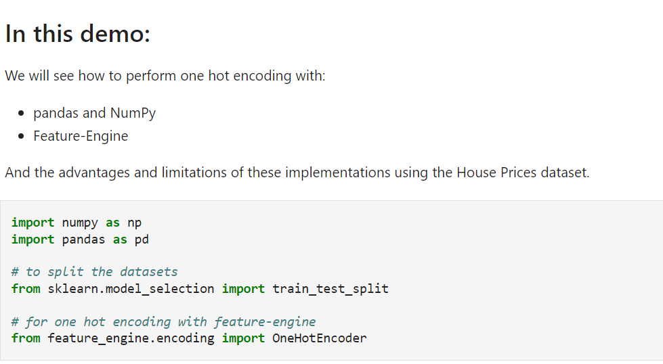

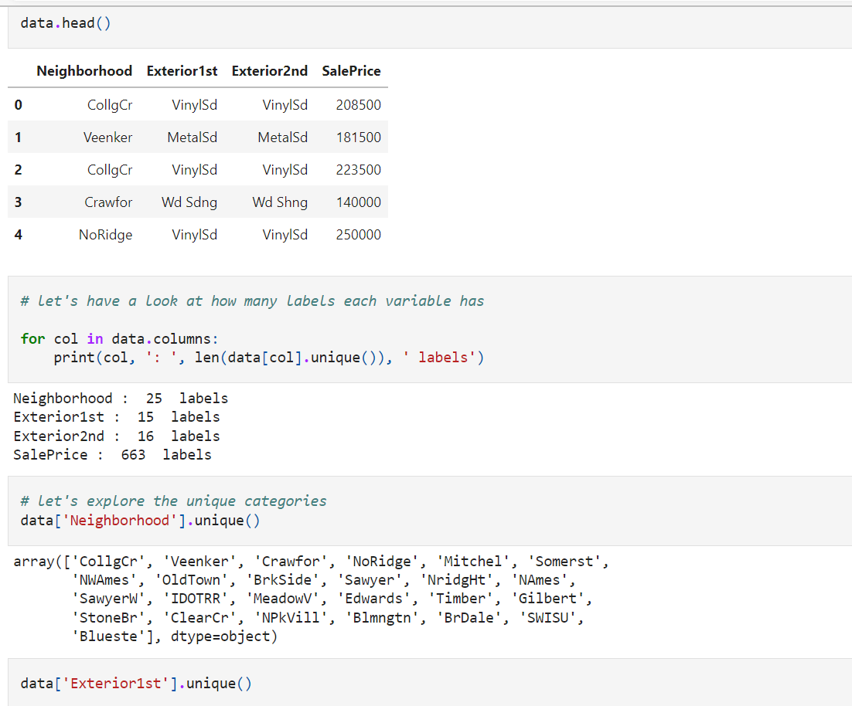

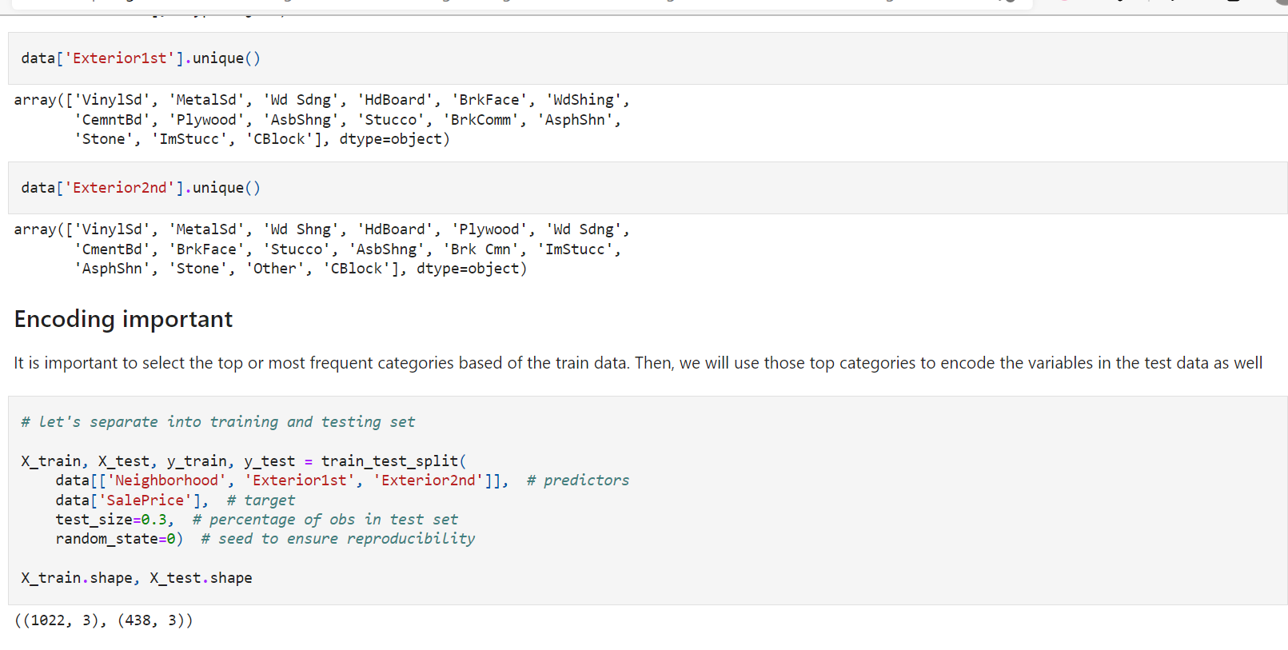

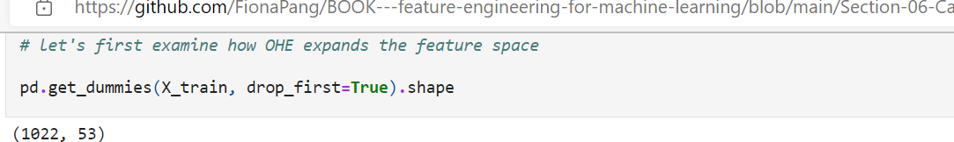

From the initial 3 categorical variables, we end up with 53 variables.

These numbers are still not huge, and in practice we could work with them relatively easily. However, in real-life datasets, categorical variables can be highly cardinal, and with OHE we can end up with datasets with thousands of columns.

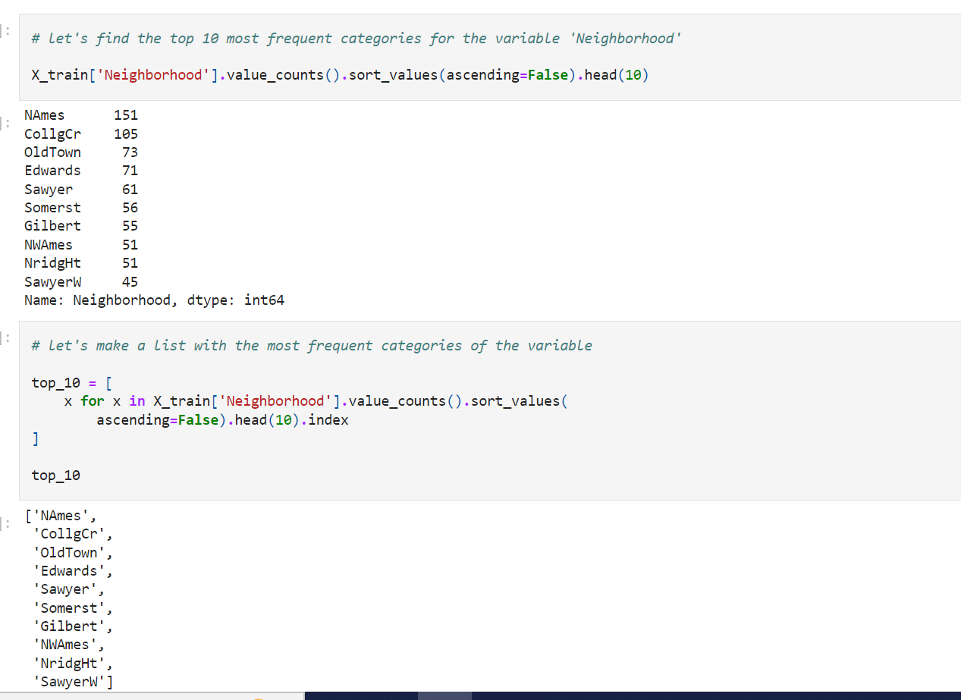

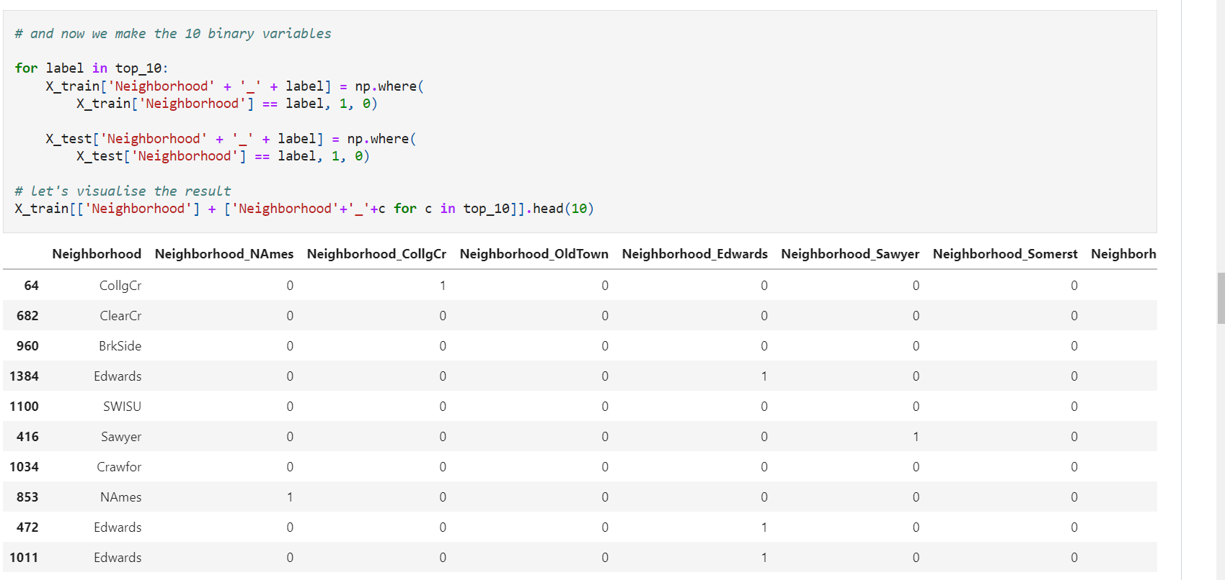

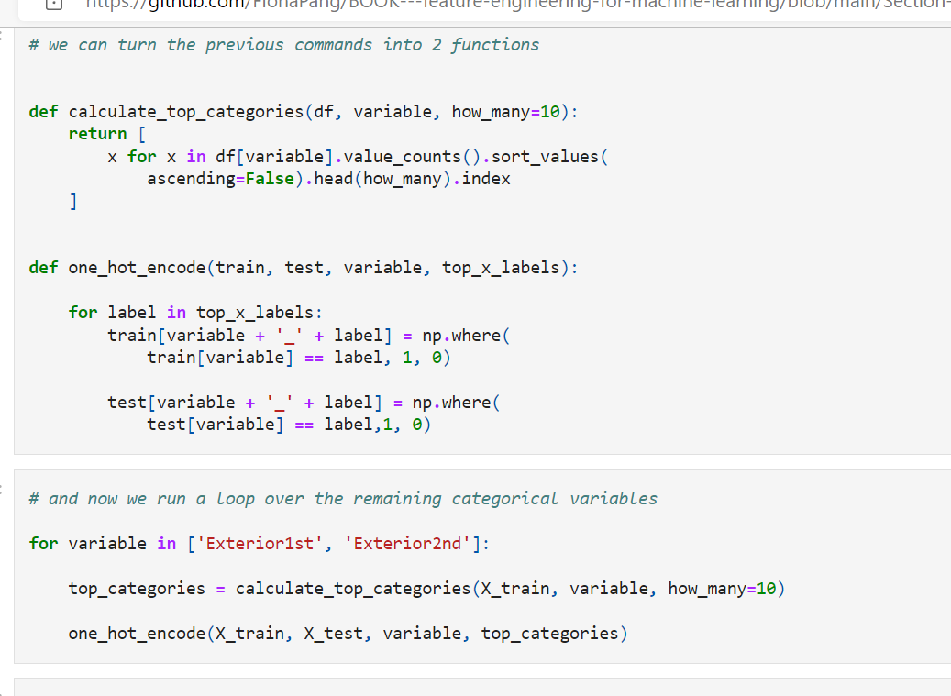

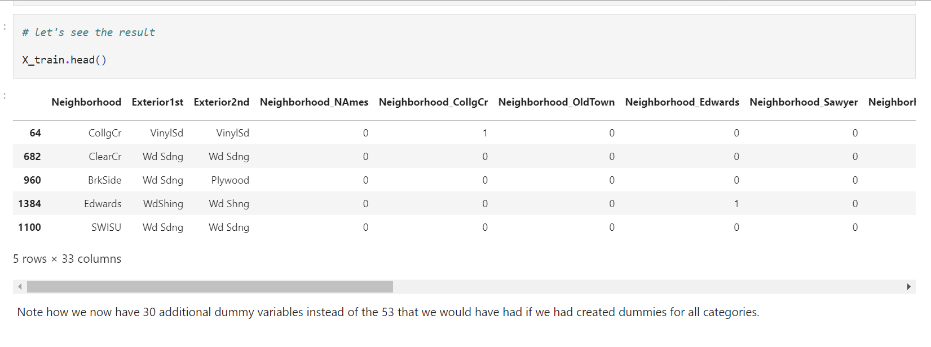

**One hot encoding of top categories with Feature-Engine**

**Advantages**

* quick
* creates the same number of features in train and test set

**Limitations**

* None to my knowledge

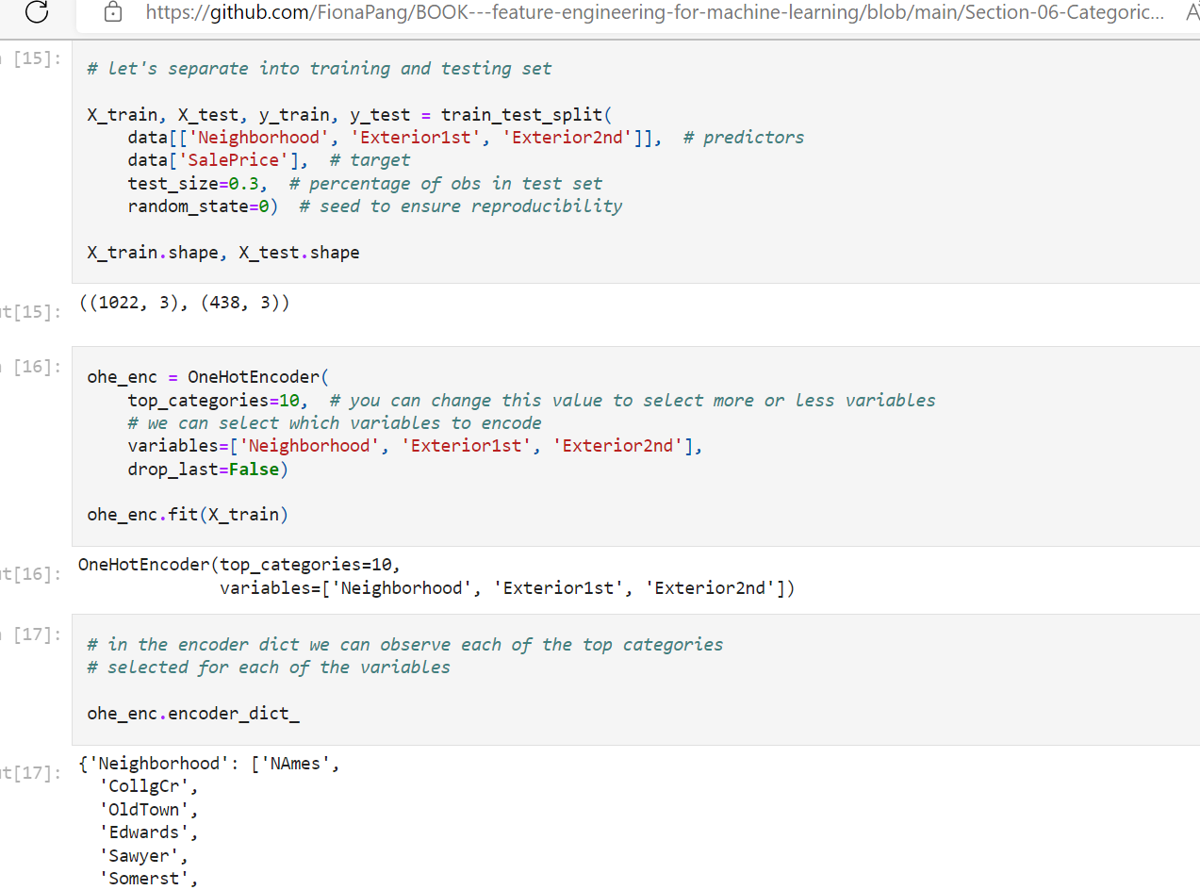

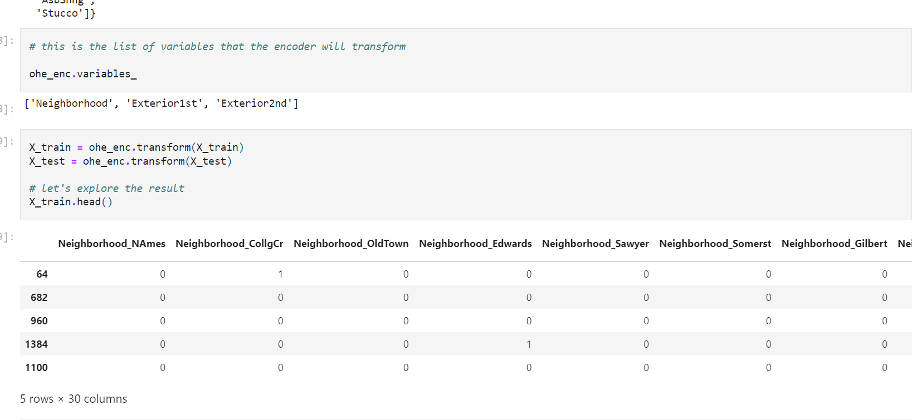

**Integer Encoding/label/ordinal**

Integer encoding consist in replacing the **categories by digits from 1 to n (or 0 to n-1**, depending the implementation), where **n is the number of distinct categories of the variable.**

The numbers are assigned arbitrarily. This encoding method allows for quick benchmarking of machine learning models.

**Advantages**

* Straightforward to implement
* **Does not expand the feature space**

**Limitations**

* Does **not capture any information about the categories labels**
* **Not suitable for linear models**.

Integer encoding is better suited for **non-linear methods which are able to navigate through** the arbitrarily assigned digits to try and find patters that relate them to the target.

**In this demo:**

We will see how to perform one hot encoding with:

* pandas
* Scikit-learn
* Feature-Engine

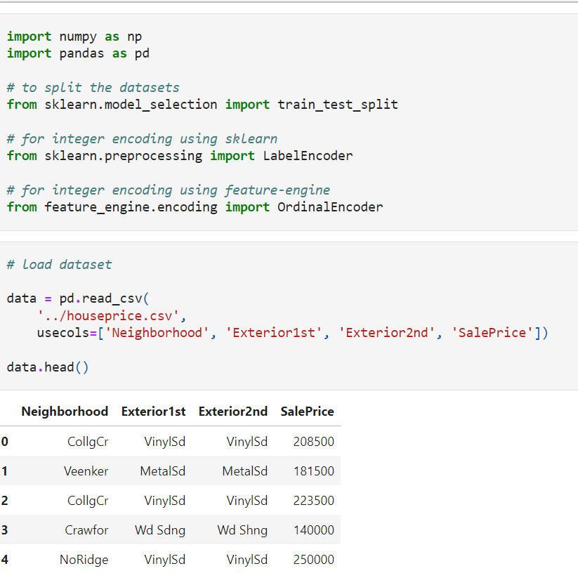

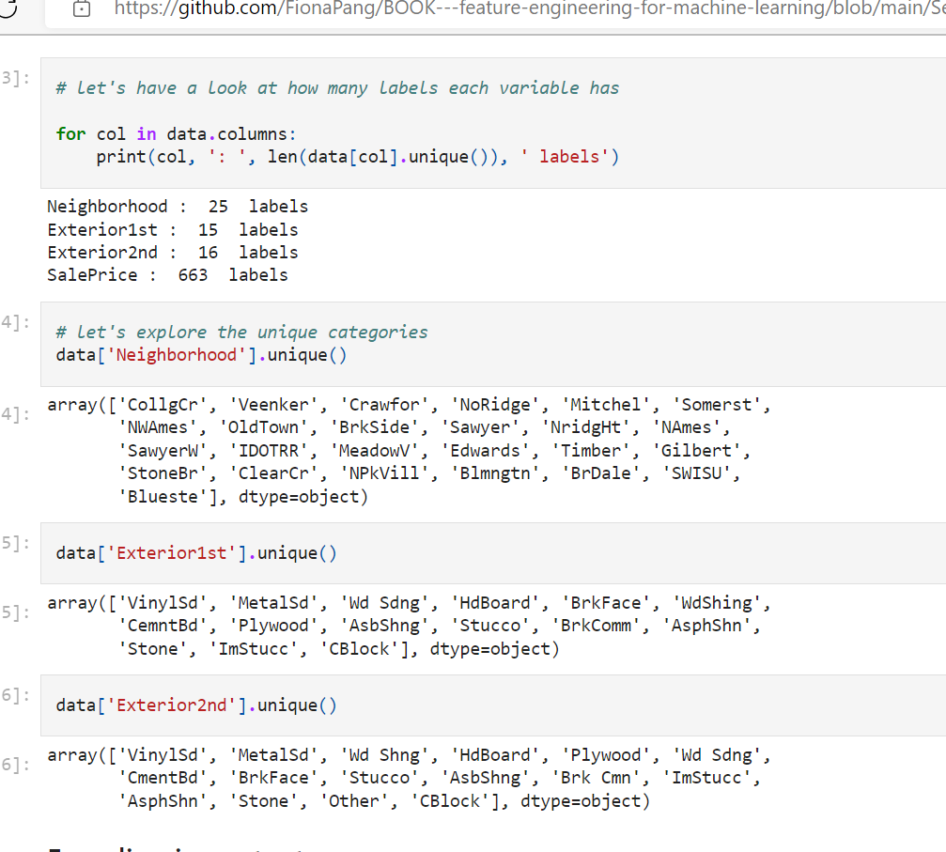

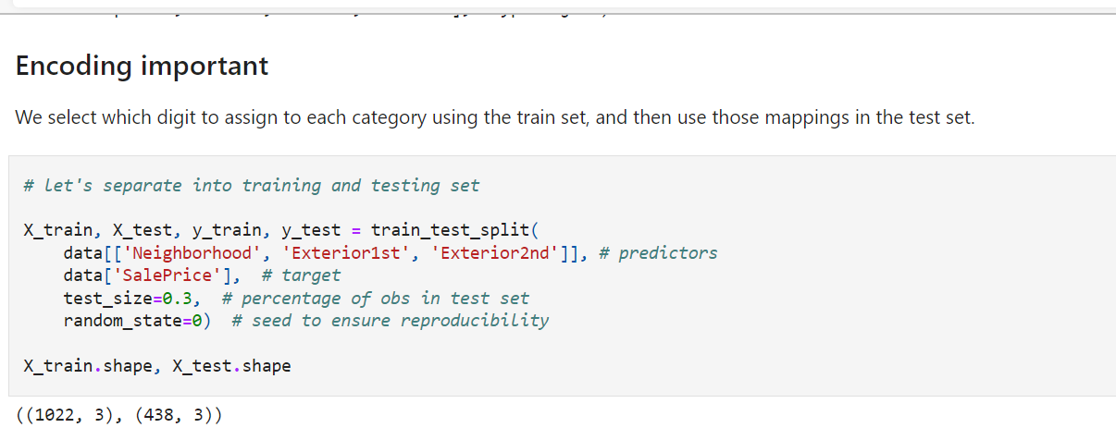

**Integer encoding with pandas**

**Advantages**

* quick
* returns pandas dataframe

**Limitations of pandas:**

* it does not preserve information from train data to propagate to test data

We need to capture and save the mappings one by one, manually, if we are planing to use those in production.

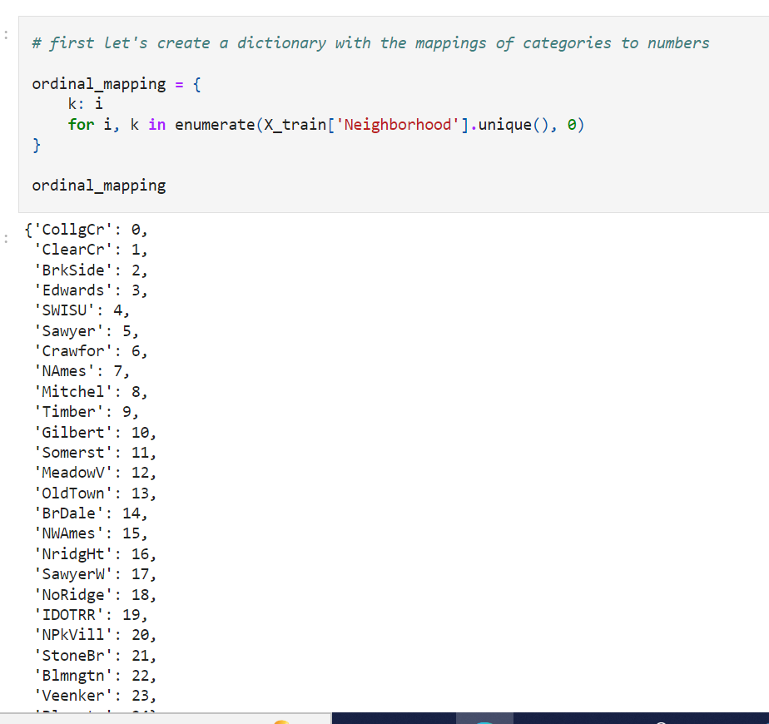

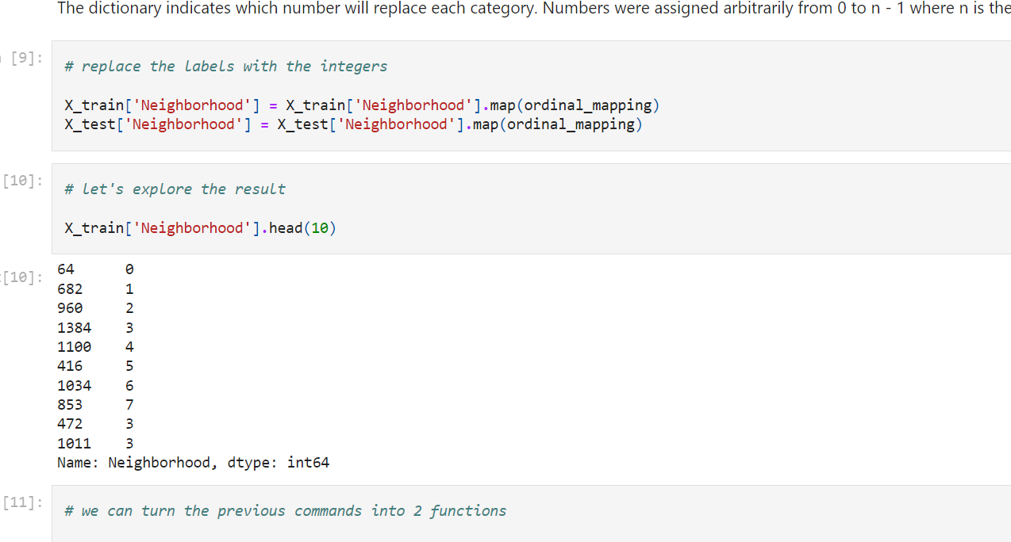

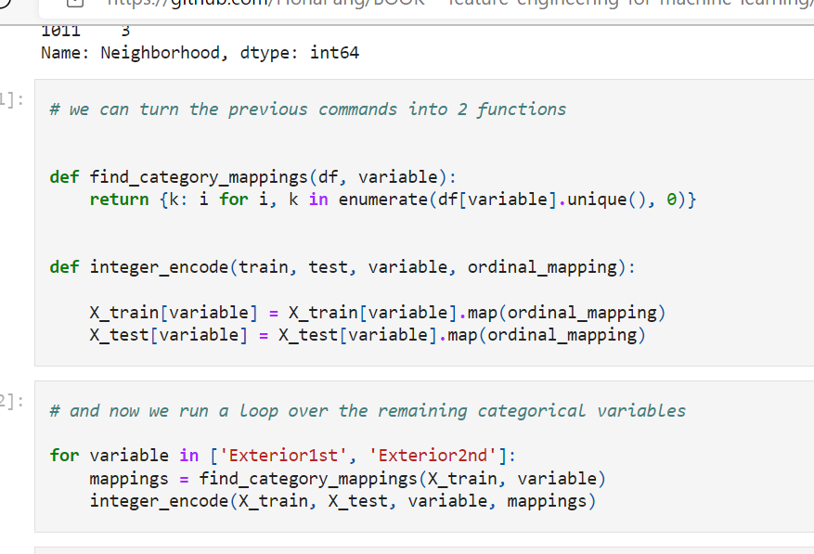

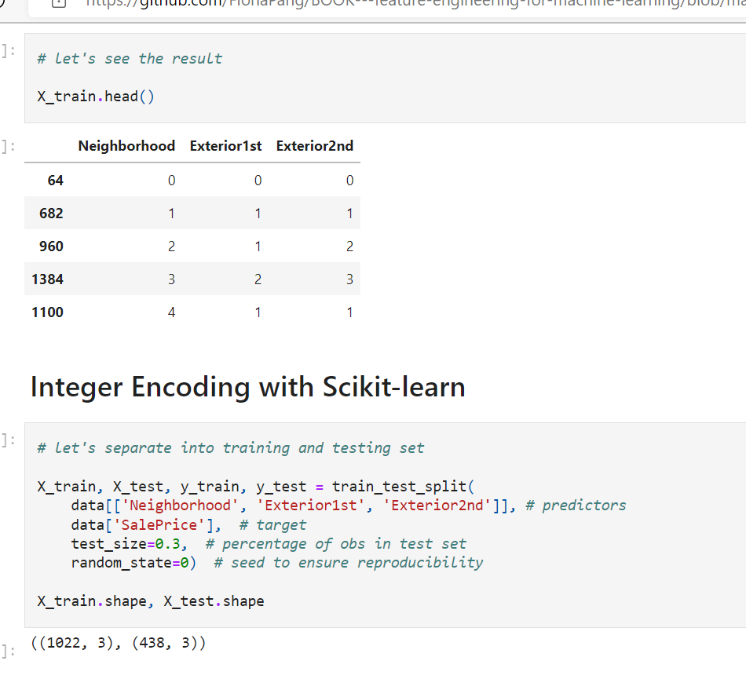

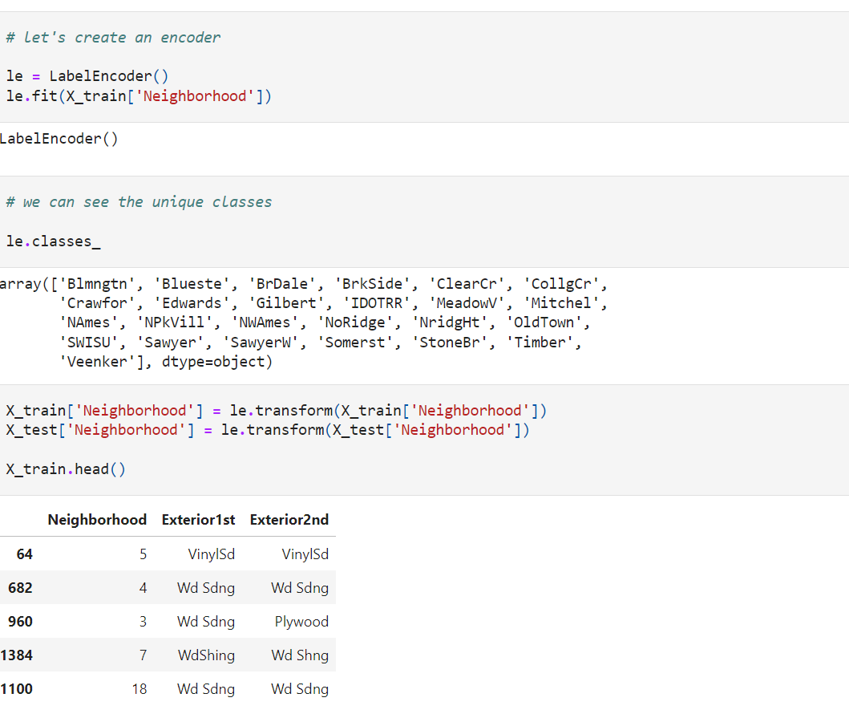

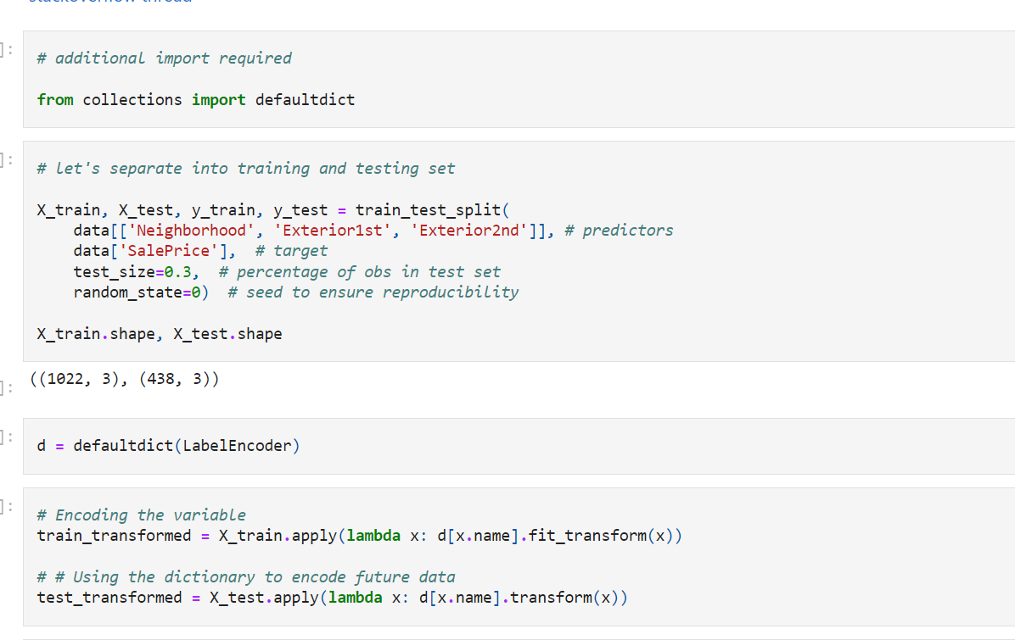

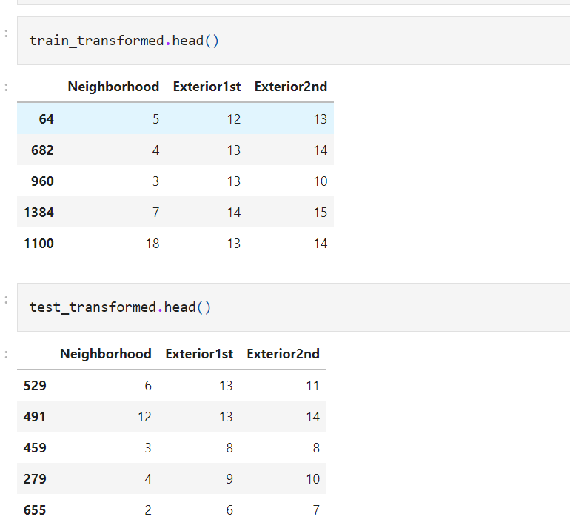

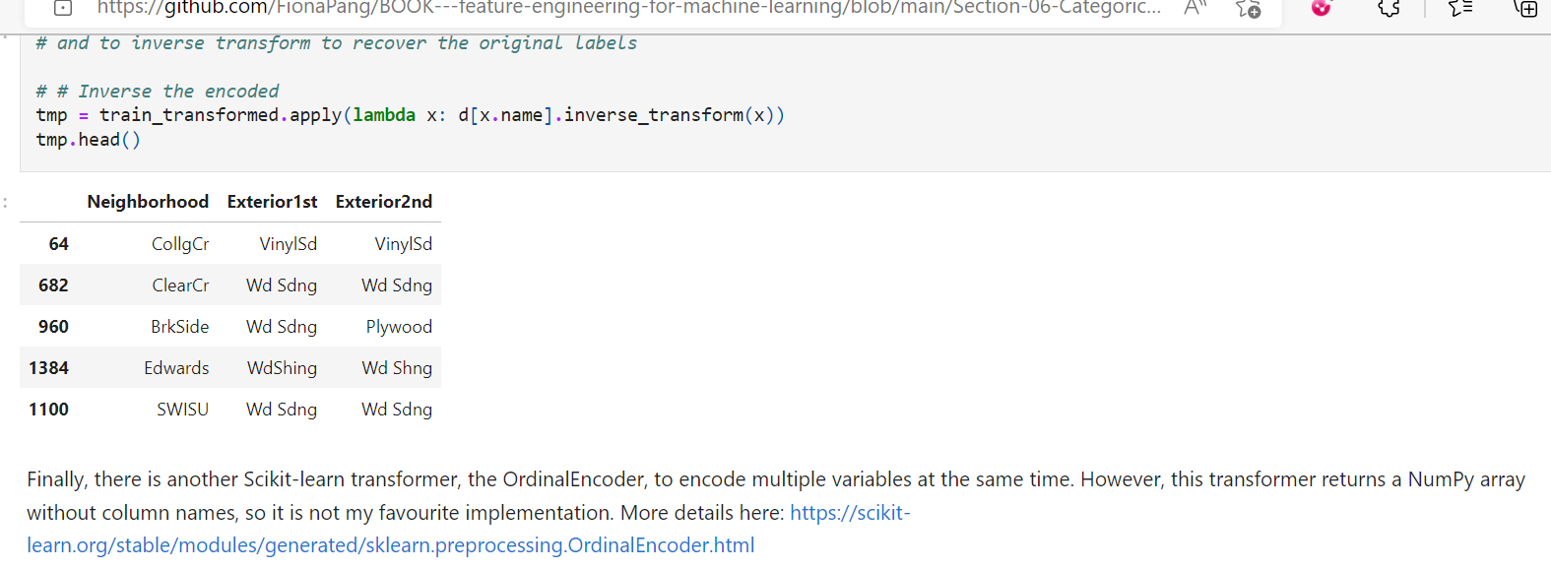

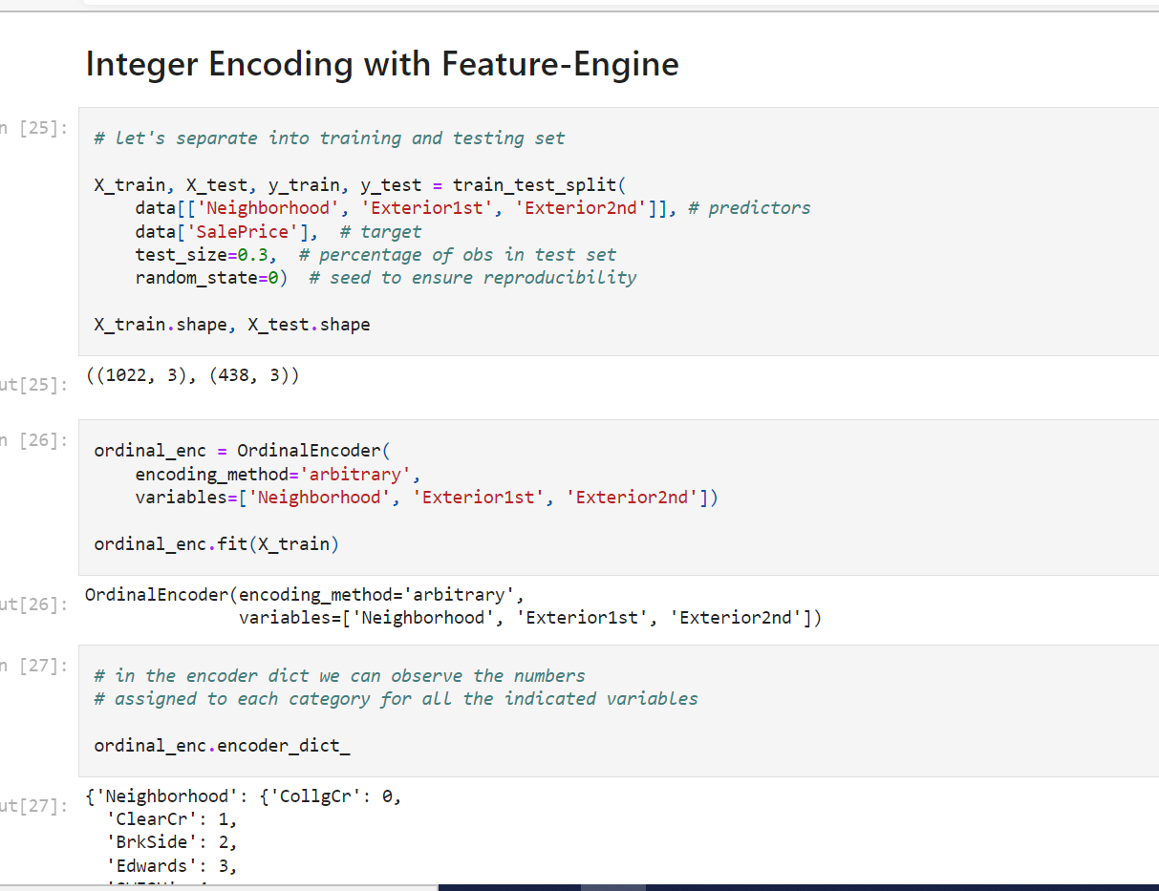

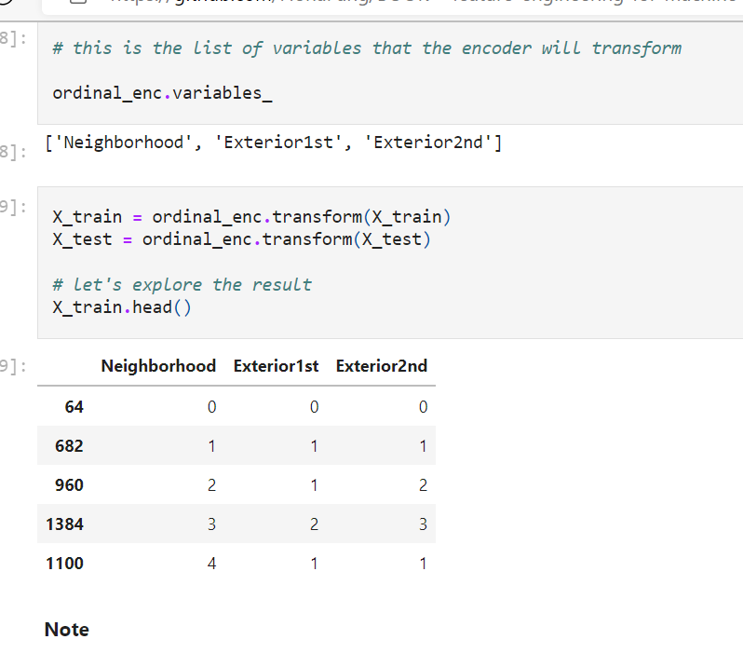

If the argument variables is left to None, then the encoder will automatically identify all categorical variables. Is that not sweet?

The encoder will not encode numerical variables. So if some of your numerical variables are in fact categories, you will need to re-cast them as object before using the encoder.

Note, if there is a variable in the test set, for which the encoder doesn't have a number to assigned (the category was not seen in the train set), the encoder will return an error.

**Count or frequency encoding**

In count encoding **we replace the categories** by **the count of the observations** that show that category in the dataset. Similarly, **we can replace the category by the frequency -or percentage- of** observations in the dataset. That is, if **10 of our 100 observations** show the colour blue, we would replace **blue by 10 if doing count encoding**, or by **0.1 if replacing by the frequency**. These **techniques capture the representation of each label in a dataset**, but the encoding may not necessarily **be predictive of the outcome**. These are however, very popular encoding methods in Kaggle competitions.

The assumption of this technique is that the **number observations shown by each variable** is somewhat **informative of the predictive power of the category.**

**Advantages**

* Simple
* Does **not expand the feature space**

**Disadvantages**

* If **2 different categories appear the same amount of times** in the dataset, that is, they appear in the same number of observations, they will be replaced by the **same number: may lose valuable information.**

For example, if there are 10 observations for the category blue and 10 observations for the category red, both will be replaced by 10, and therefore, after the encoding, will appear to be the same thing.

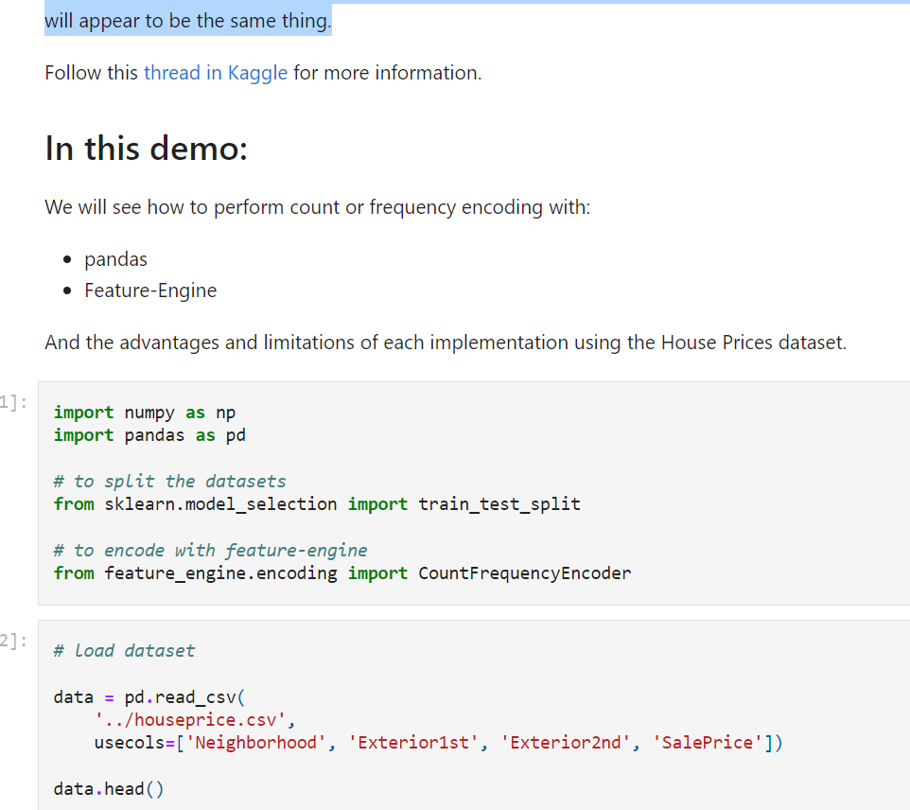

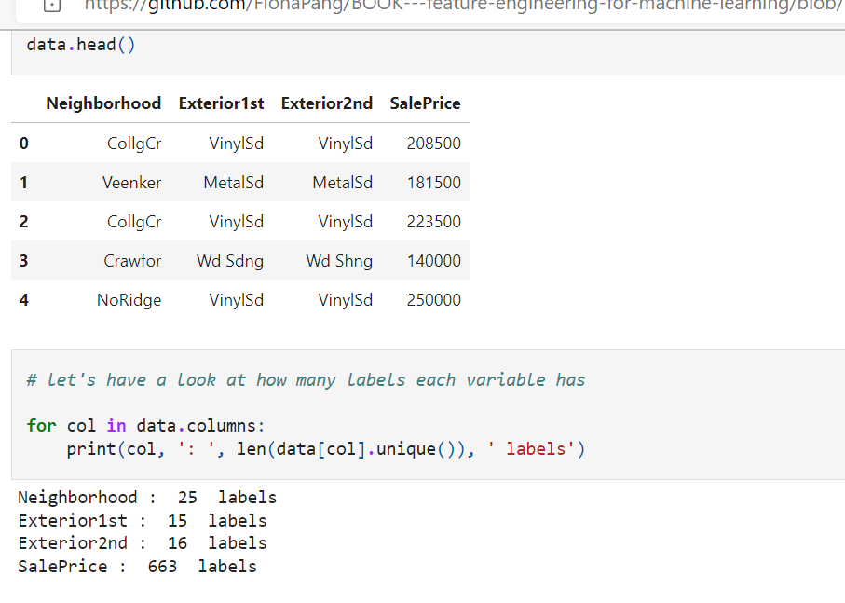

**Important**

When doing count transformation of categorical variables, it is **important to calculate the count** (or **frequency = count / total observations**) **over the training set**, and then use those numbers to replace the labels in the test set.

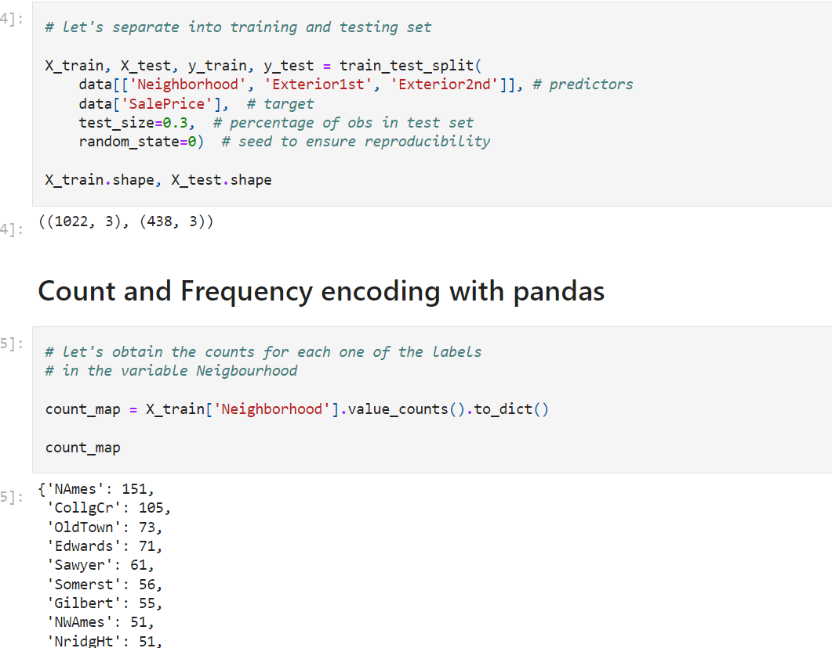

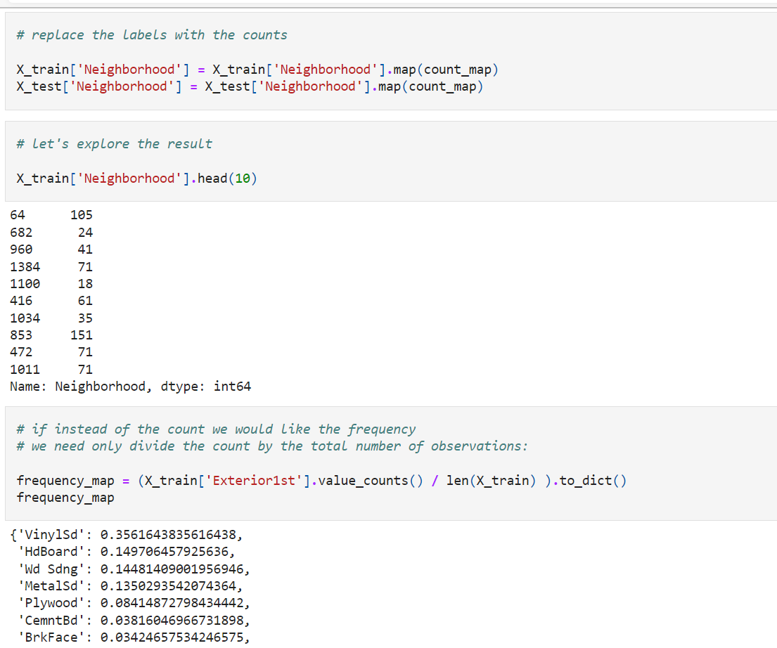

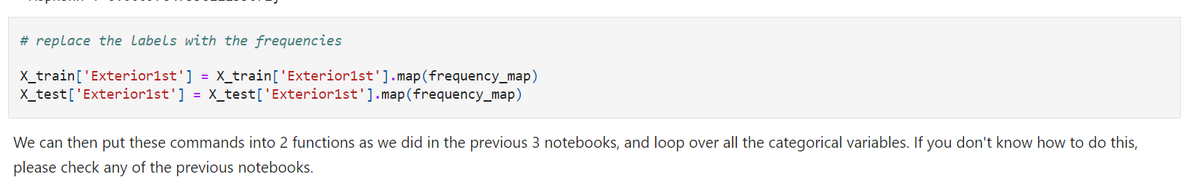

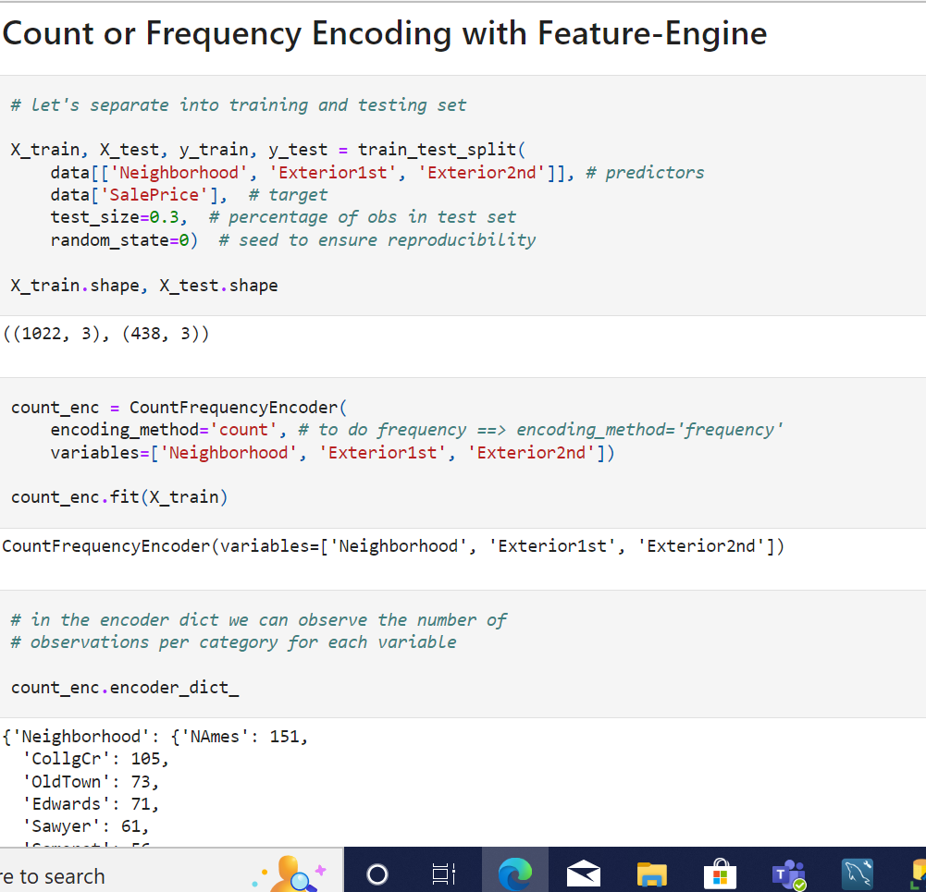

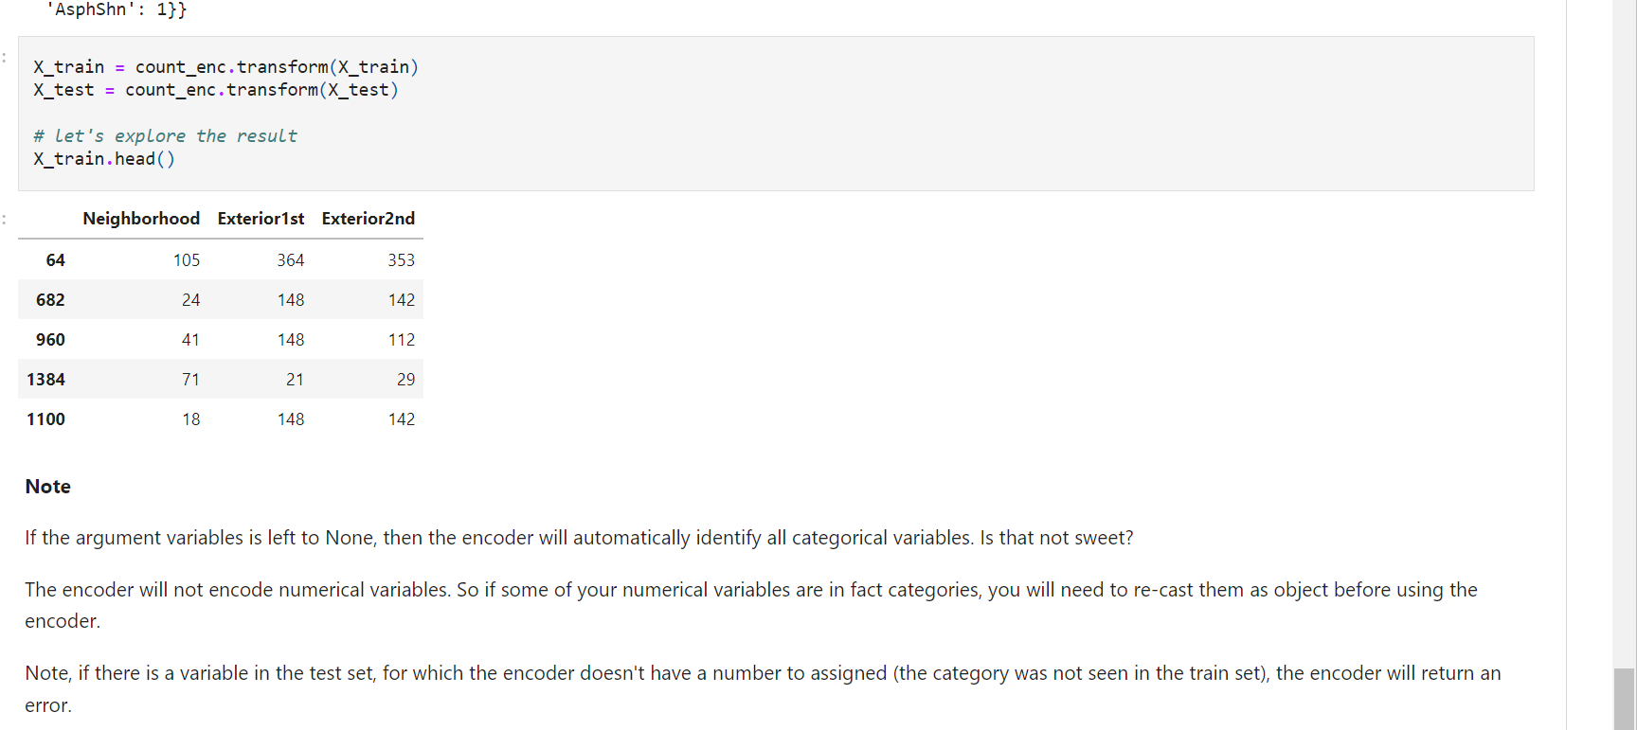

**Target guided encodings**

In the **previous lectures** in this section, we learned how to convert a **label into a number,** by using one hot encoding, replacing by a digit or replacing by frequency or counts of observations. These methods are simple, make (almost) no assumptions and work generally well in different scenarios.

There are however methods that allow us to capture information while pre-processing the labels of categorical variables. These methods include:

* Ordering the labels according to the target
* Replacing labels by the target mean (mean encoding / target encoding)
* Replacing the labels by the probability ratio of the target being 1 or 0
* Weight of evidence.

All of the above methods have something in common:

* the encoding is **guided by the target**, and
* they create a **monotonic relationship** between the **variable and the target.**

**Monotonicity**

A monotonic relationship is a relationship that does one of the following:

* (1) as the value of **one variable increases, so does the value of the other variable;** or
* (2) as the value of **one variable increases, the value of the other variable decreases**.

In this case, as the value of the **independent variable (predictor) increases**, so does the target, or conversely, as the value of the variable increases, the target value decreases.

**Advantages of target guided encodings**

* **Capture information within the category**, therefore creating **more predictive features**
* Create a **monotonic relationship between the variable and the target**, therefore suitable for **linear models**
* **Do not expand the feature space**

**Limitations**

* Prone to cause **over-fitting**
* **Difficult to cross-validate** with current libraries

**Note**

The methods discussed in this and the coming 3 lectures can be also used **on numerical variables, after discretisation.** This creates a **monotonic relationship between the numerical variable and the target,** and therefore improves the performance of linear models. I will discuss this in more detail in the section "Discretisation".

===============================================================================

**Ordered Integer Encoding**

**Ordering the categories according to the target** means **assigning a number to the category from 1 to k,** where **k is the number of distinct categories** in the variable, **but this numbering is informed by the mean of the target for each category.**

For example, we have the **variable city with values London, Manchester and Bristol;** if the **default rate is 30% in London, 20% in Bristol and 10% in Mancheste**r, then we **replace London by 1, Bristol by 2 and Manchester by 3.**

**In this demo:**

We will see how to perform one hot encoding with:

* pandas
* Feature-Engine

And the advantages and limitations of these implementations using the House Prices dataset.

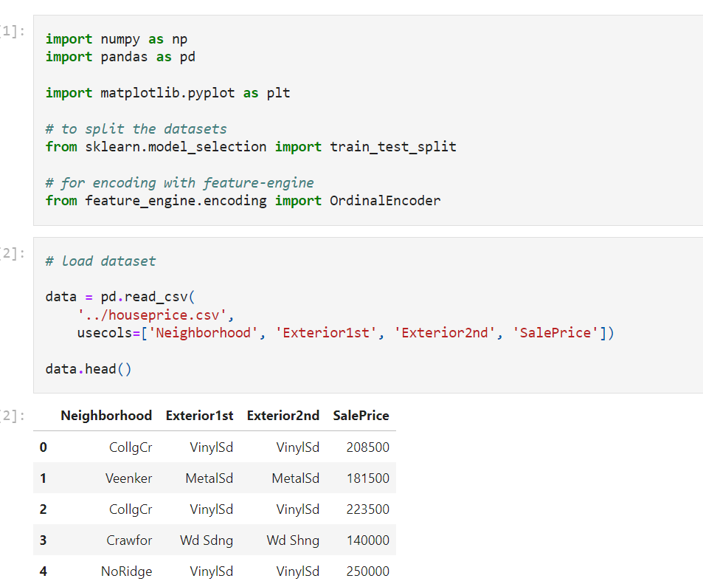

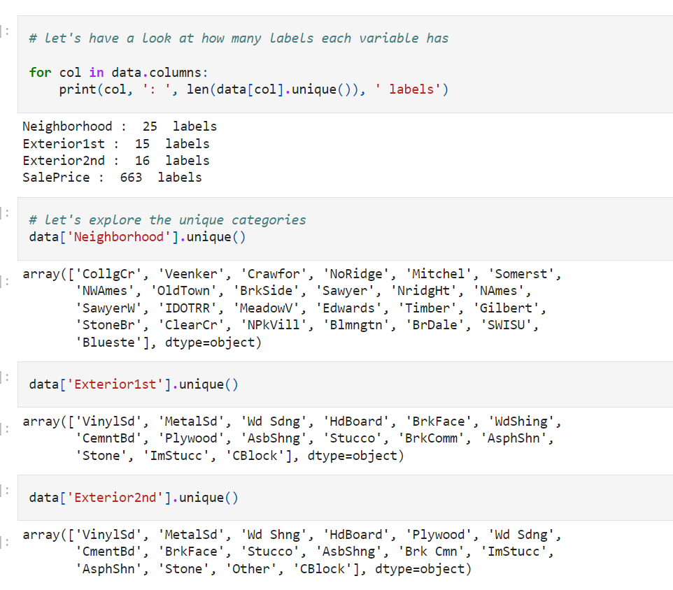

**Encoding important**

We select which digit to assign each category using the train set, and then use those mappings in the test set.

**Note that to do this technique with pandas, we need to keep the target within the training set**

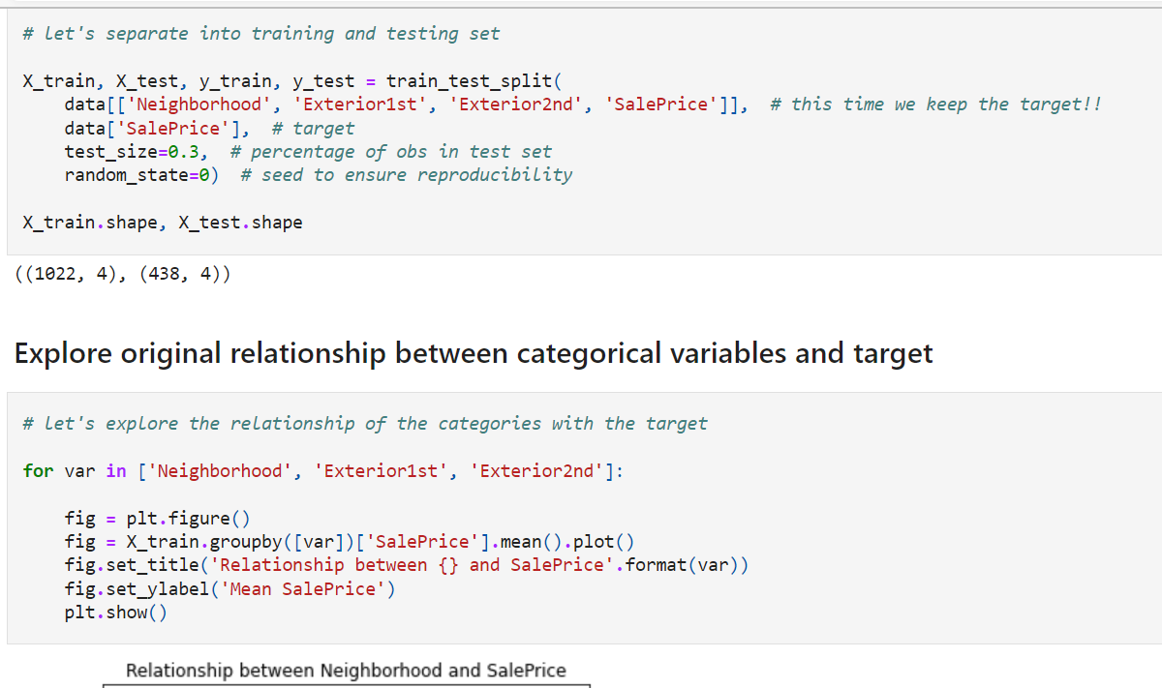

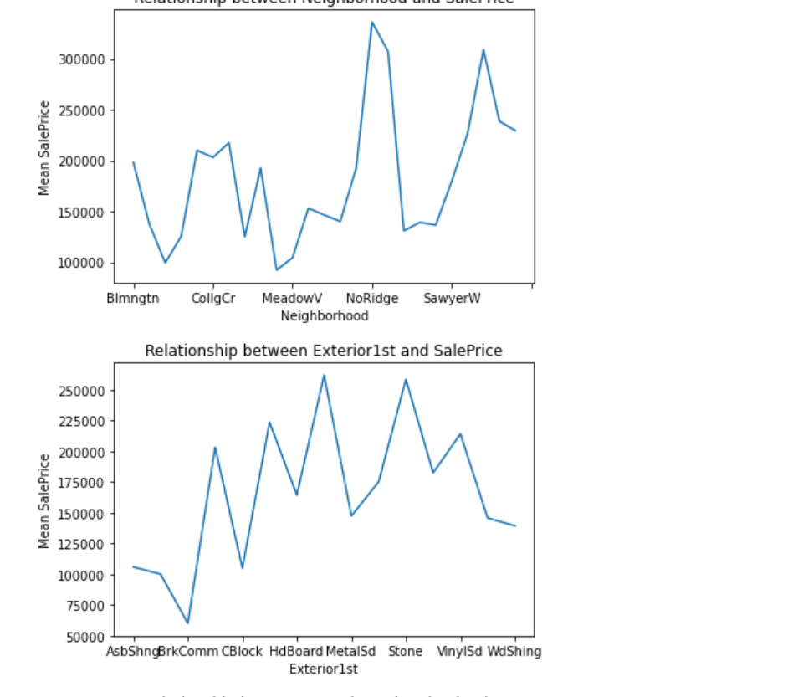\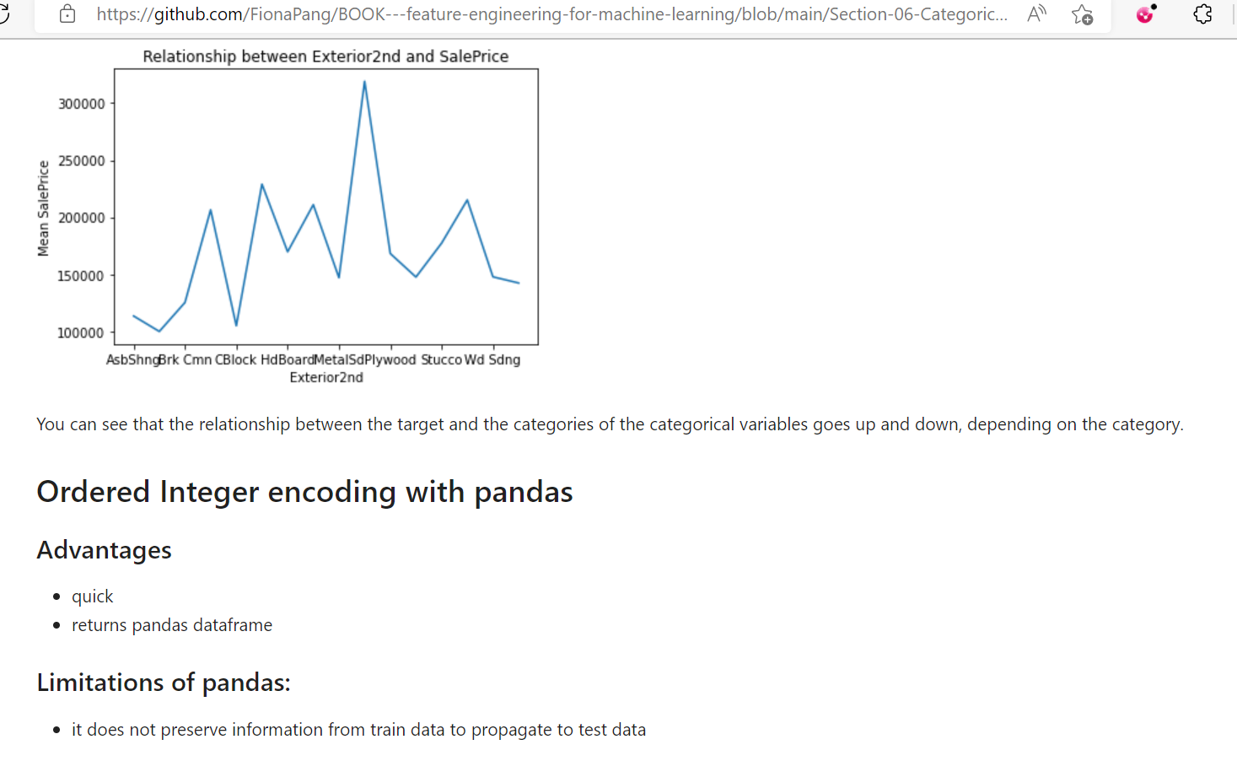

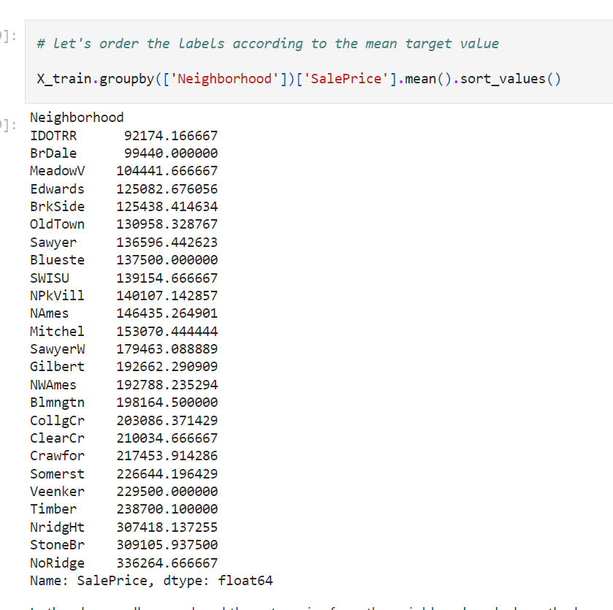

In the above cell, we ordered the categories from the neighbourhood where the houses sale prices are cheaper (IDOTRR), to the neighbourhood where the house prices are, on average, more expensive (NoRidge).

In the next cells, we will replace those categories, ordered as they are, by the numbers 0 to k, where k is the number of different categories minus 1, in this case 25 - 1 = 24.

So IDOTRR will be replaced by 0 and NoRidge by 24, just to be clear.

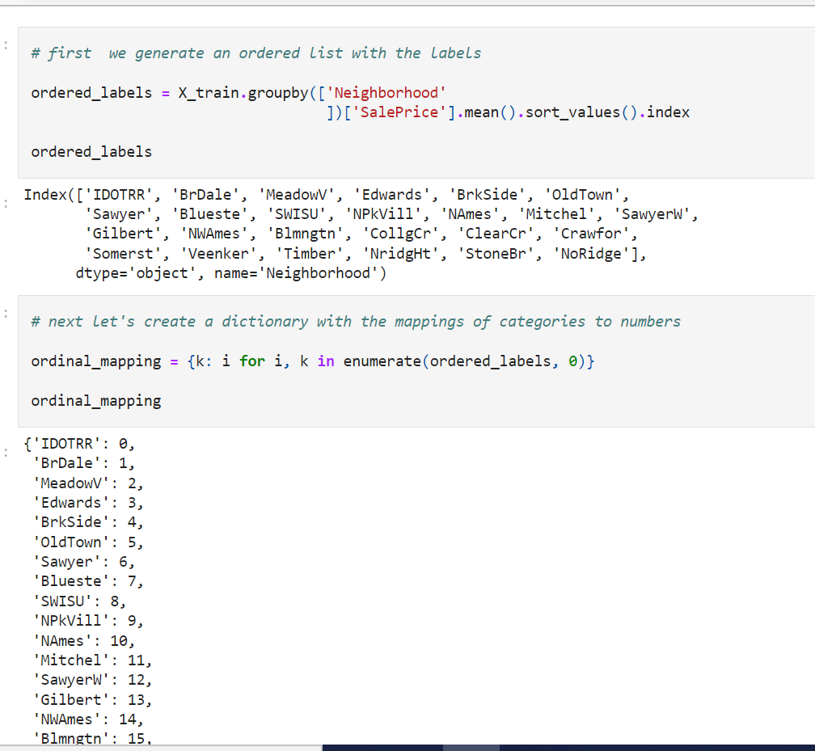

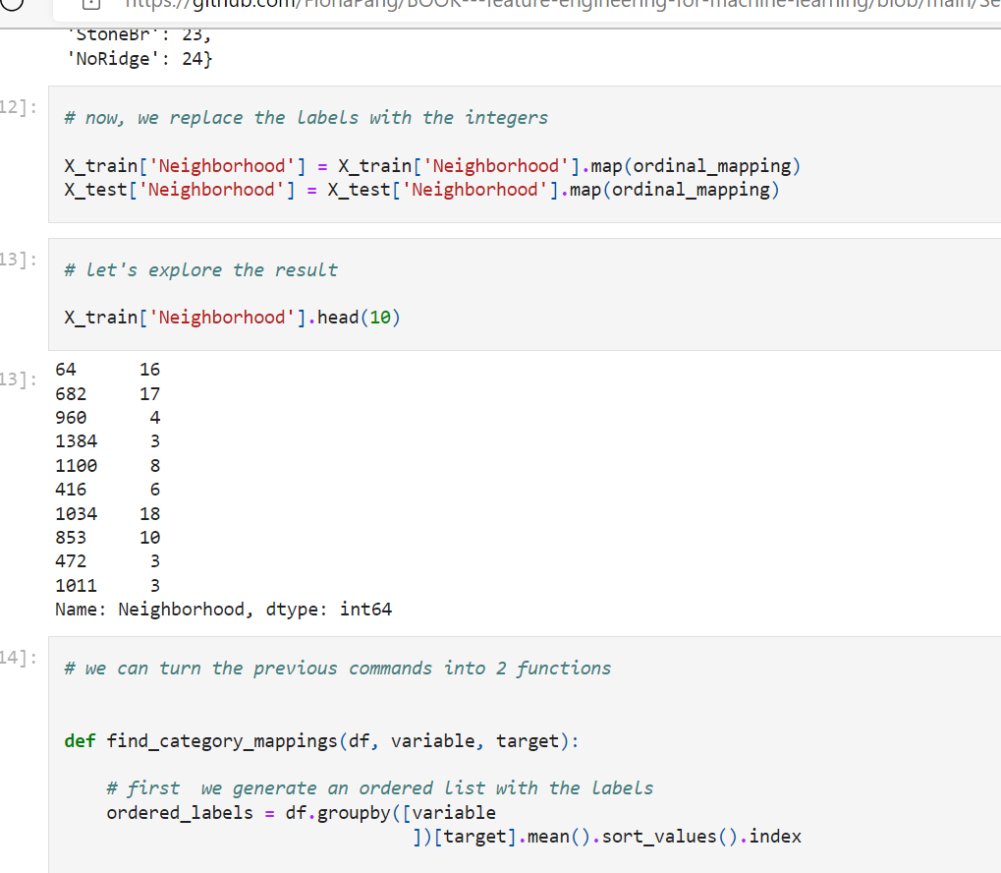

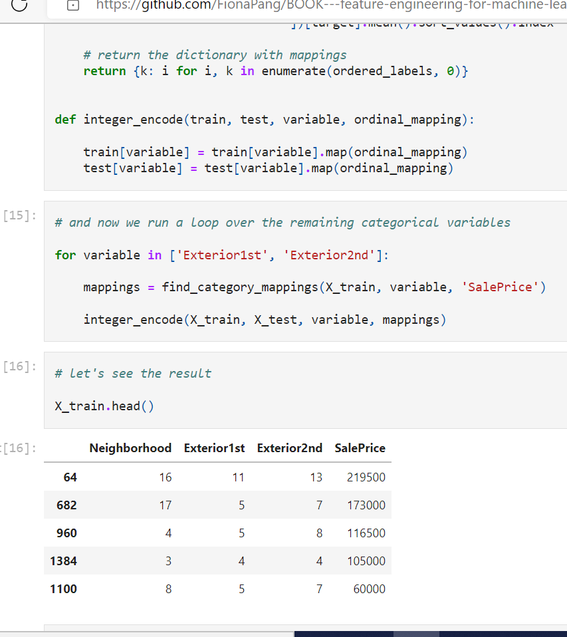

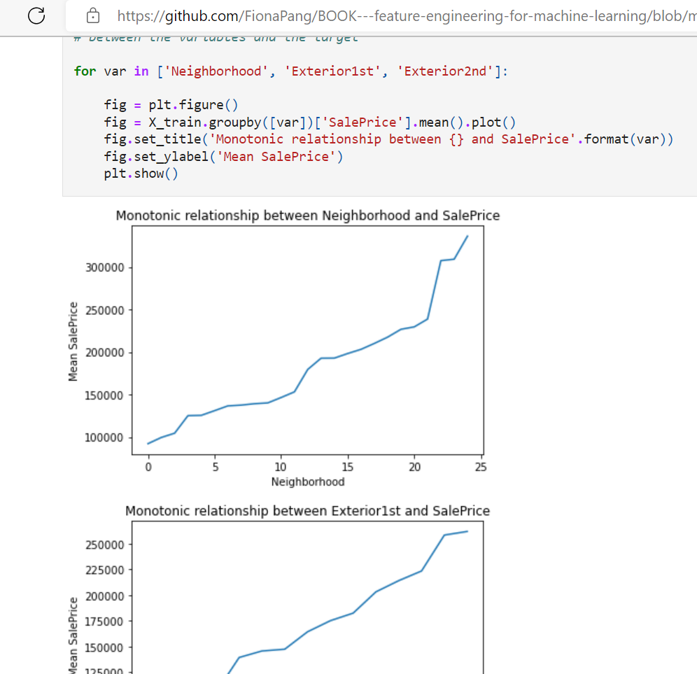

We see from the plots above that the relationship between the categories and the target is now monotonic, and for the first 2 variables, almost linear, which helps improve linear models performance.

**Note**

Monotonic does not mean strictly linear. Monotonic means that it increases constantly, or it decreases constantly.

Replacing categorical labels with this code and method will generate missing values for categories present in the test set that were not seen in the training set. Therefore it is extremely important to handle rare labels before-hand. I will explain how to do this, in a later notebook.

**Integer Encoding with Feature-Engine**

If using Feature-Engine, instead of pandas, we do not need to keep the target variable in the training dataset.

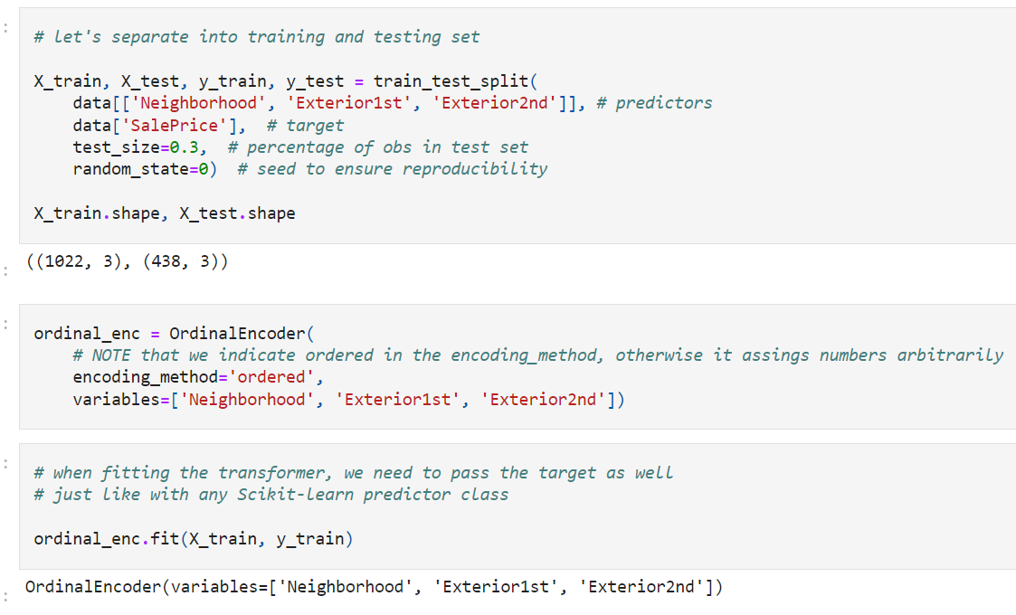

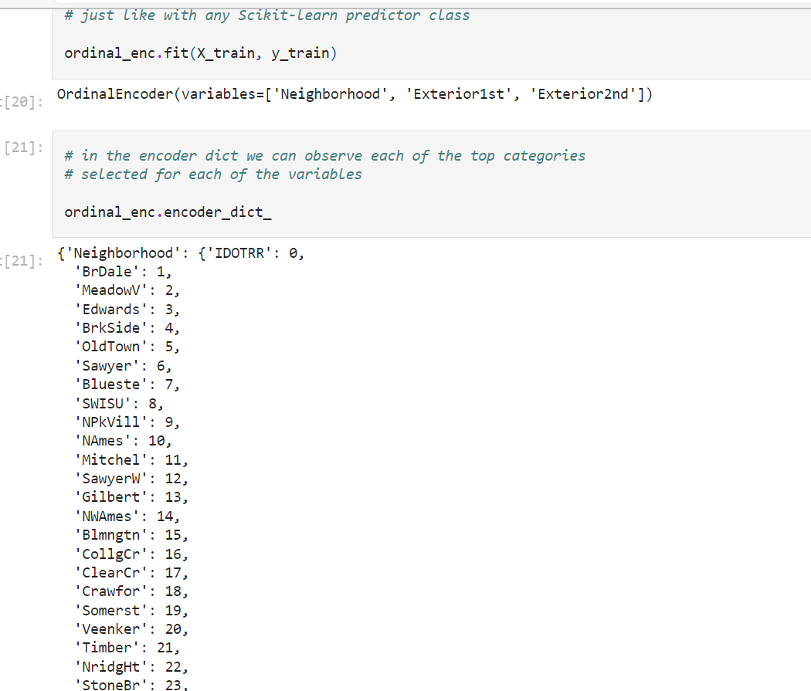

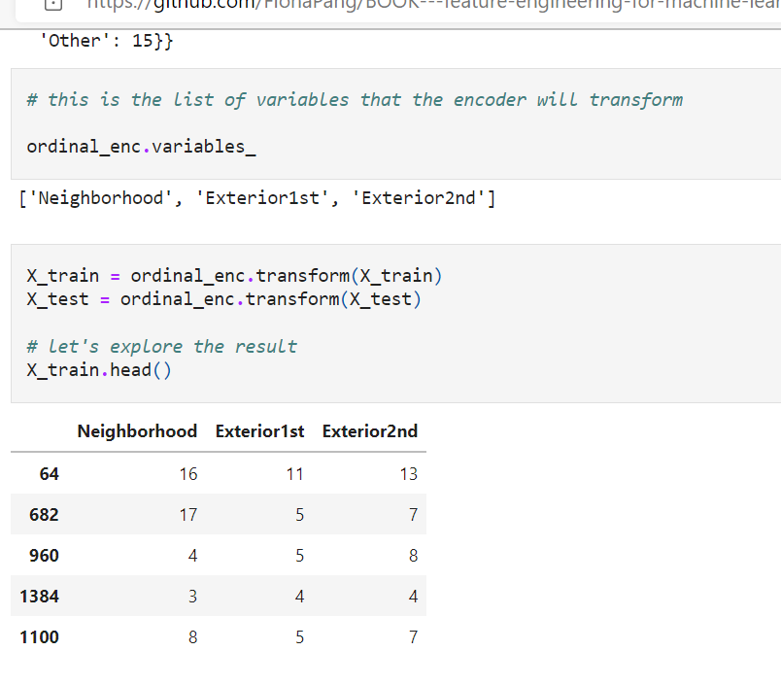

**Target guided encodings**

In the previous lectures in this section, we learned how to convert a label into a number, by using one hot encoding, replacing by a digit or replacing by frequency or counts of observations. These methods are simple, make (almost) no assumptions and work generally well in different scenarios.

There are however methods that allow us to capture information while pre-processing the labels of categorical variables. These methods include:

* Ordering the labels according to the target
* Replacing labels by the target mean (mean encoding / target encoding)
* Replacing the labels by the probability ratio of the target being 1 or 0
* Weight of evidence.

All of the above methods have something in common:

* the encoding is **guided by the target**, and
* they create a **monotonic relationship** between the variable and the target.

**Monotonicity**

A monotonic relationship is a relationship that does one of the following:

* (1) as the value of one variable increases, so does the value of the other variable; or
* (2) as the value of one variable increases, the value of the other variable decreases.

In this case, as the value of the independent variable (predictor) increases, so does the target, or conversely, as the value of the variable increases, the target value decreases.

**Advantages of target guided encodings**

* **Capture information within the category,** therefore creating more predictive features
* Create a monotonic relationship between the variable and the target, therefore suitable for linear models
* Do not expand the feature space

**Limitations**

* Prone to cause over-fitting
* Difficult to cross-validate with current libraries

**Note**

The methods discussed in this and the coming 3 lectures can be also used on **numerical variables, after discretisation**. This creates a monotonic relationship between the numerical variable and the target, and therefore improves the performance of linear models. I will discuss this in more detail in the section "Discretisation".

===============================================================================

**Mean Encoding or Target Encoding**

Mean encoding implies **replacing the category by the average target value for that category**. For example, if we have the **variable city, with categories London, Manchester and Bristol,** and we want to **predict the default rate**, if the default rate for **London is 30% we replace London by 0.3**, if the default rate for **Manchester is 20% we replace Manchester by 0.2 and so on.**

**In this demo:**

We will see how to perform one hot encoding with:

* pandas
* Feature-Engine

And the advantages and limitations of each implementation using the Titanic dataset.

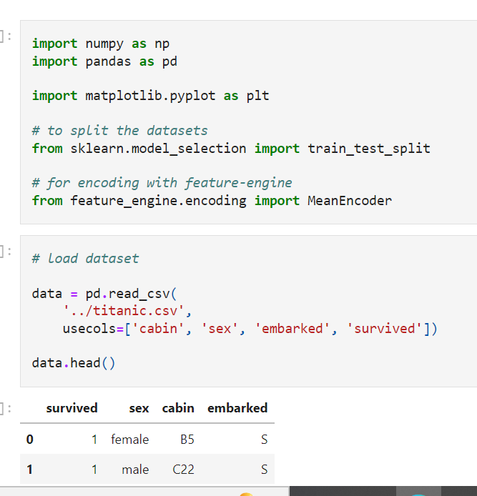

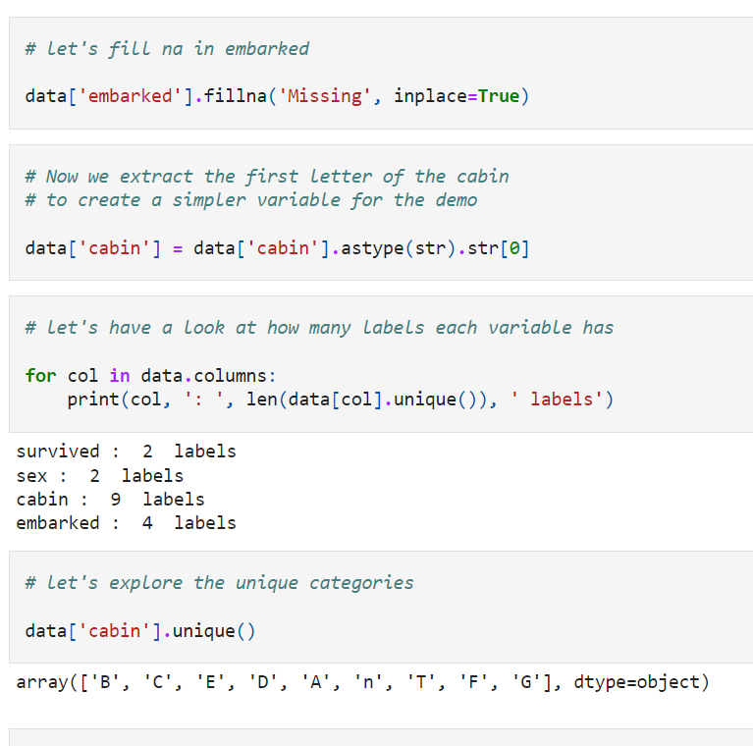

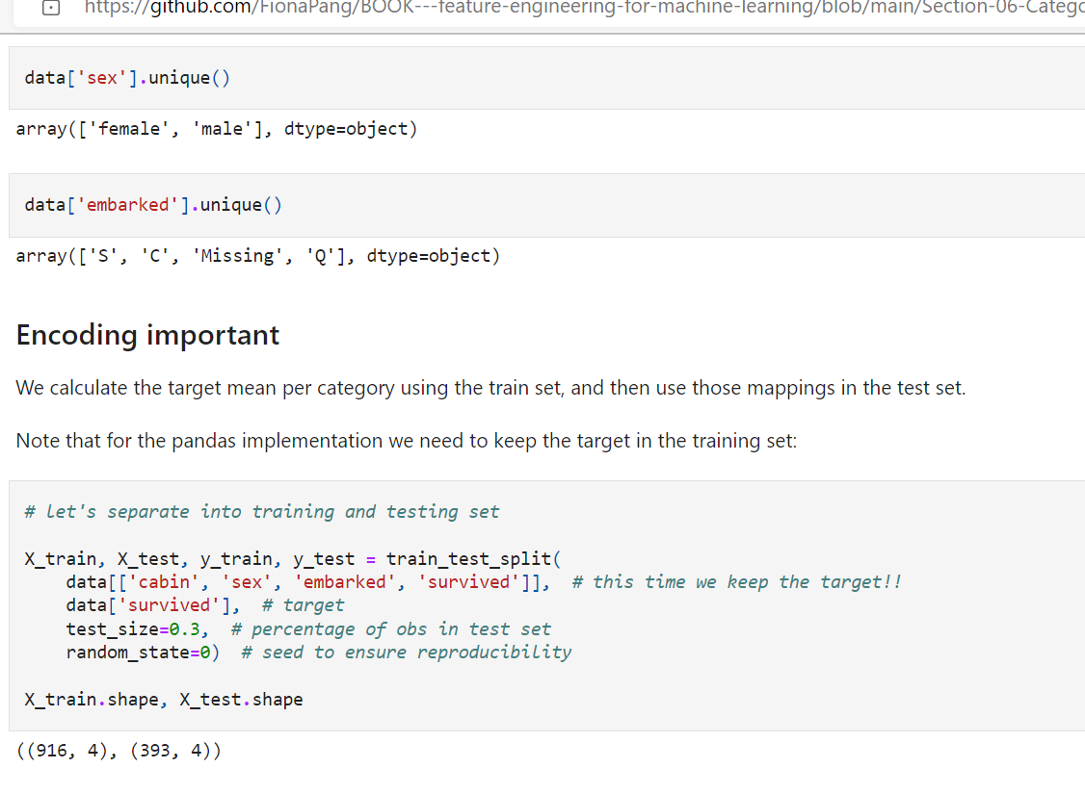

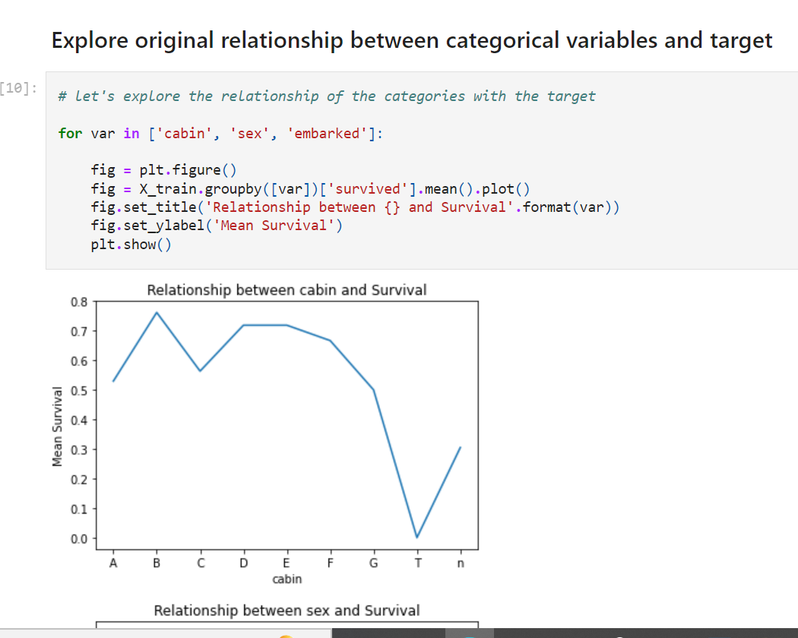

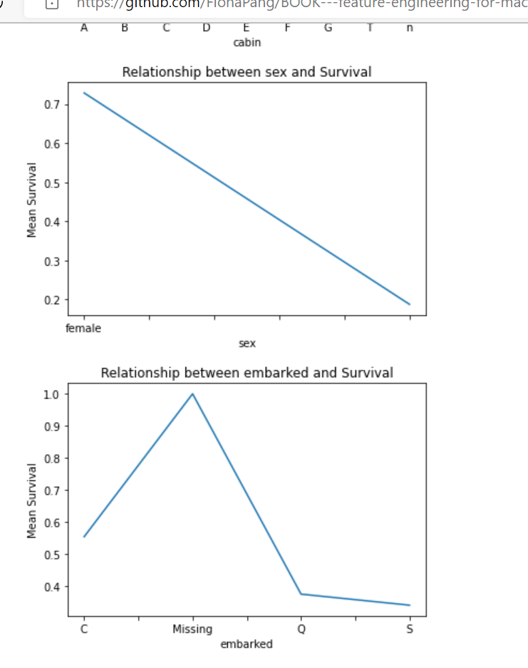

You can see that the **relationship between the target and cabin and embarked** goes up and down, depending on the category.

**Mean encoding with pandas**

**Advantages**

* quick
* returns pandas dataframe

**Limitations of pandas:**

* it does not preserve information from train data to propagate to test data

We need to store the mappings separately if planning to use the model in production.

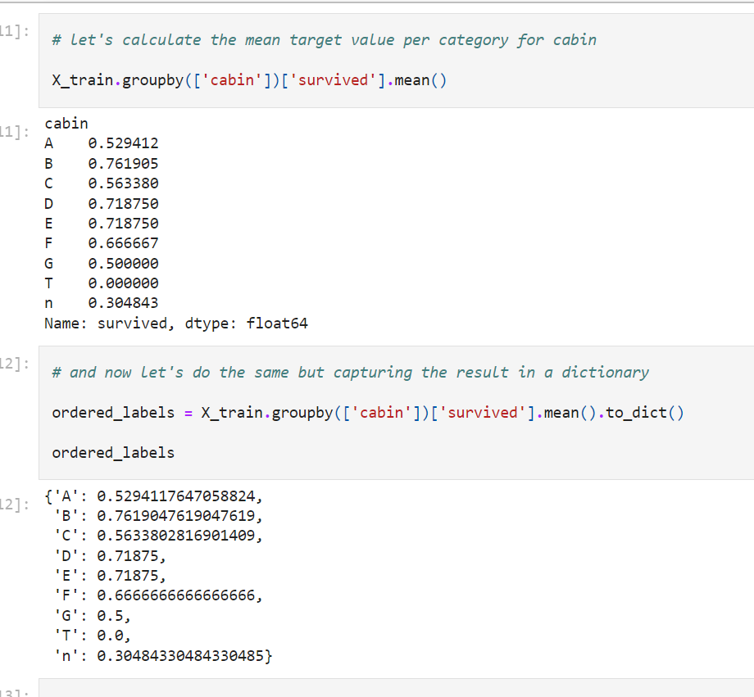

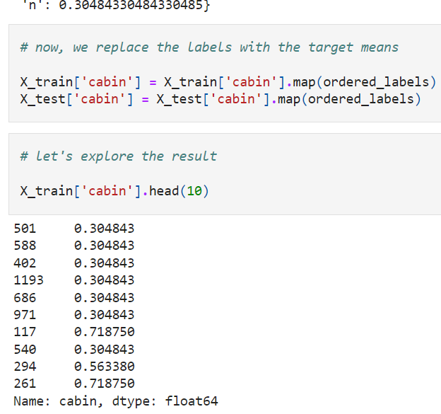

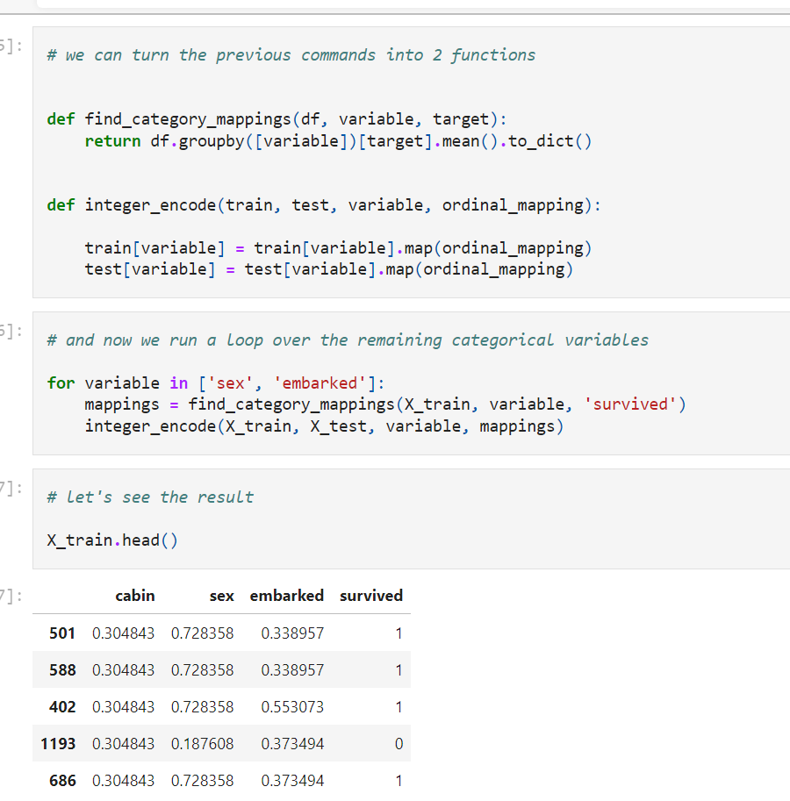

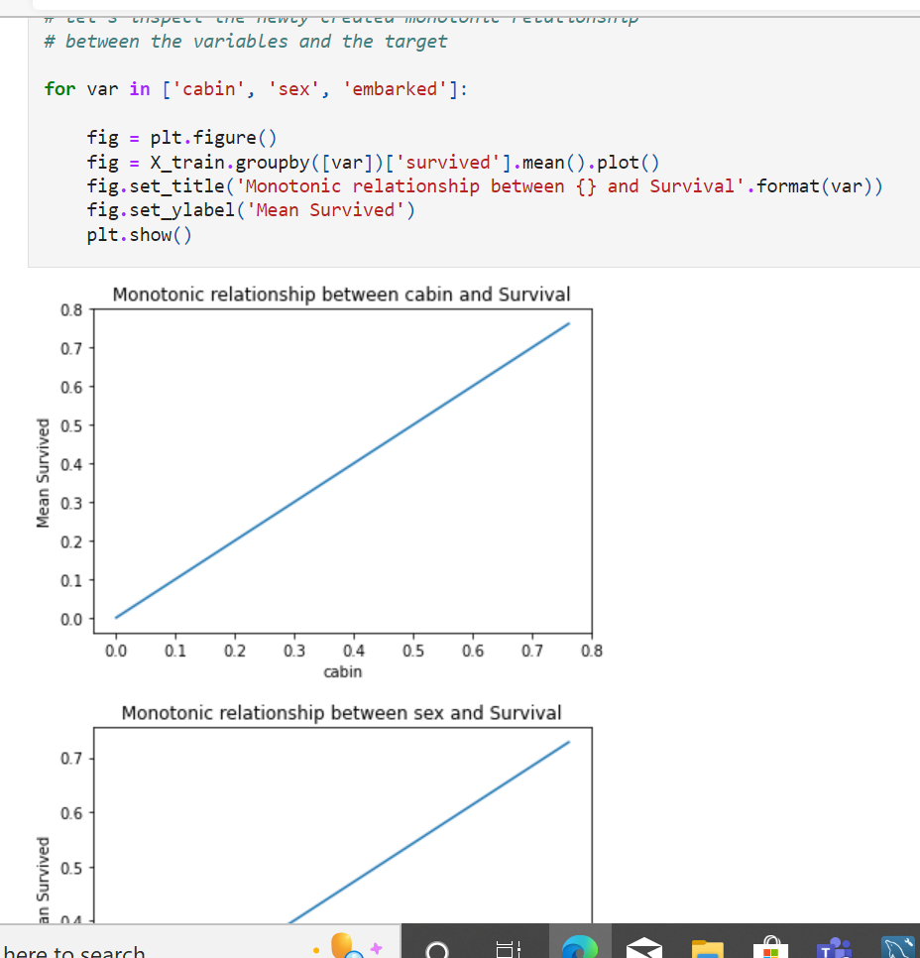

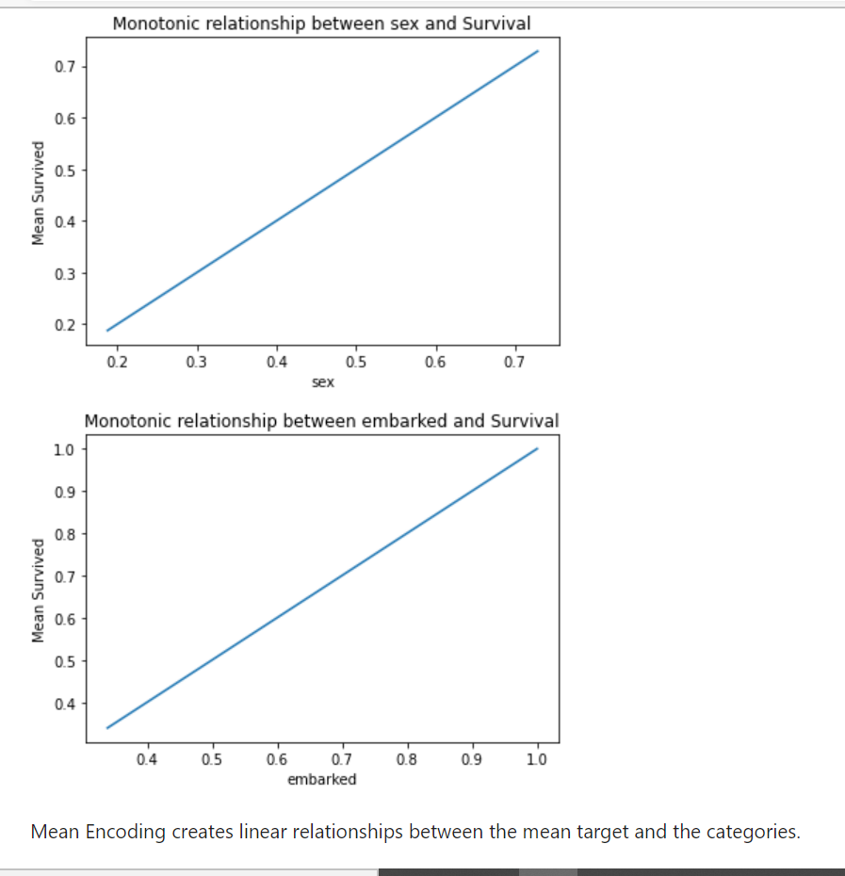

Mean Encoding creates linear relationships between the mean target and the categories.

**Note**

Replacing categorical labels with this code and method will generate missing values for categories present in the test set that were not seen in the training set. Therefore it is extremely important to handle rare labels before-hand. I will explain how to do this, in a later notebook.

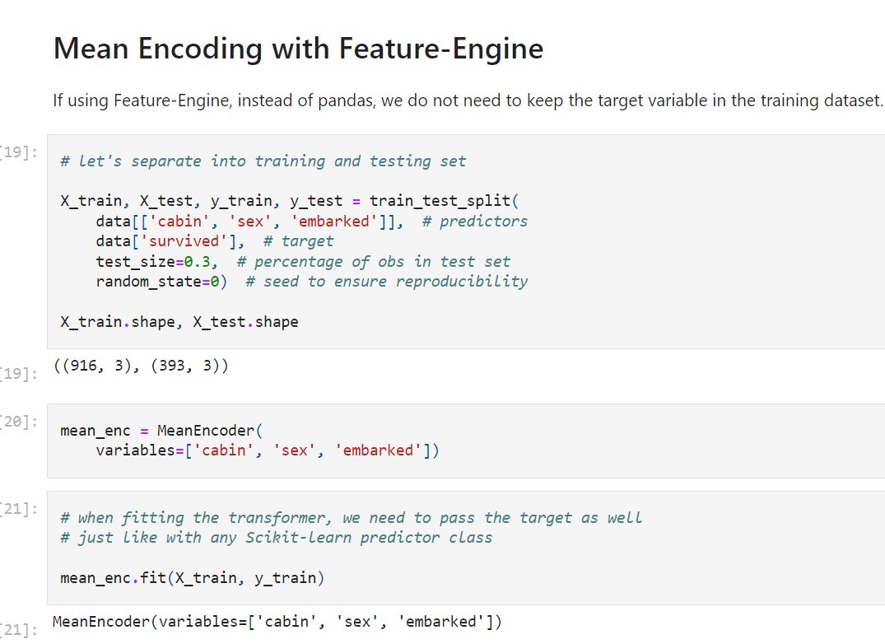

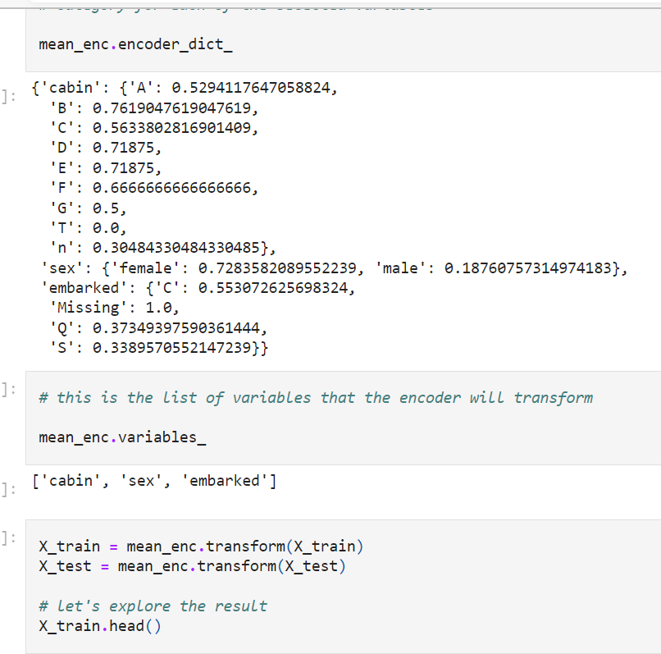

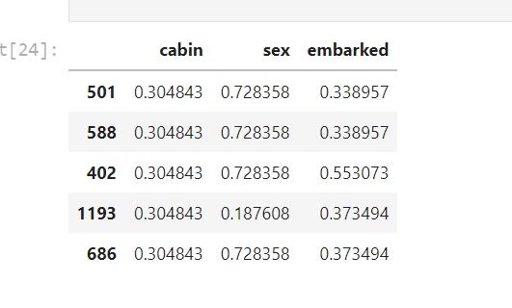

**Note**

If the argument variables is left to None, then the encoder will automatically identify all categorical variables. Is that not sweet?

The encoder will not encode numerical variables. So if some of your numerical variables are in fact categories, you will need to re-cast them as object before using the encoder.

Finally, if there is a label in the test set that was not present in the train set, the encoder will through and error, to alert you of this behaviour.

**Target guided encodings**

In the previous lectures in this section, we learned how to convert a label into a number, by using one hot encoding, replacing by a digit or replacing by frequency or counts of observations. These methods are simple, make (almost) no assumptions and work generally well in different scenarios.

There are however methods that allow us to capture information while pre-processing the labels of categorical variables. These methods include:

* Ordering the labels according to the target
* Replacing labels by the target mean (mean encoding / target encoding)
* Replacing the labels by the probability ratio of the target being 1 or 0
* Weight of evidence.

All of the above methods have something in common:

* the encoding is **guided by the target**, and
* they create a **monotonic relationship** between the variable and the target.

**Monotonicity**

A monotonic relationship is a relationship that does one of the following:

* (1) as the value of one variable increases, so does the value of the other variable; or
* (2) as the value of one variable increases, the value of the other variable decreases.

In this case, as the value of the independent variable (predictor) increases, so does the target, or conversely, as the value of the variable increases, the target value decreases.

**Advantages of target guided encodings**

* Capture information within the category, therefore creating more predictive features
* Create a monotonic relationship between the variable and the target, therefore suitable for linear models
* Do not expand the feature space

**Limitations**

* Prone to cause over-fitting
* Difficult to cross-validate with current libraries

**Note**

The methods discussed in this and the coming 3 lectures can be also used on numerical variables, after discretisation. This creates a monotonic relationship between the numerical variable and the target, and therefore improves the performance of linear models. I will discuss this in more detail in the section "Discretisation".

===============================================================================

**Probability Ratio Encoding**

These encoding is **suitable for classification problems** only, where the target is binary.

For each category, **we calculate the mean of target=1,** that is the **probability of the target being 1** ( P(1) ), and the **probability of the target=0** ( P(0) ). And then, **we calculate the ratio P(1)/P(0),** and replace the **categories by that ratio.**

**In this demo:**

We will see how to perform one hot encoding with:

* pandas
* Feature-Engine

And the advantages and limitations of each implementation using the Titanic dataset.

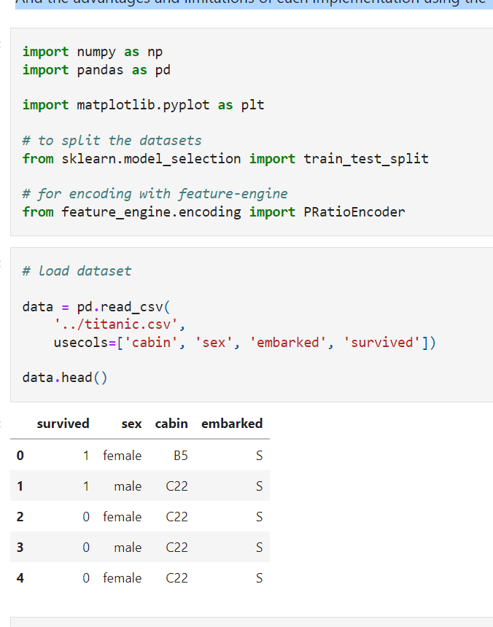

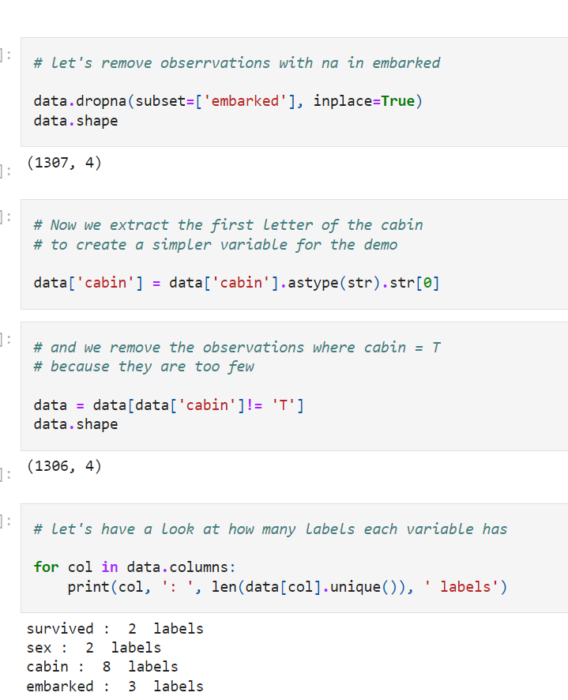

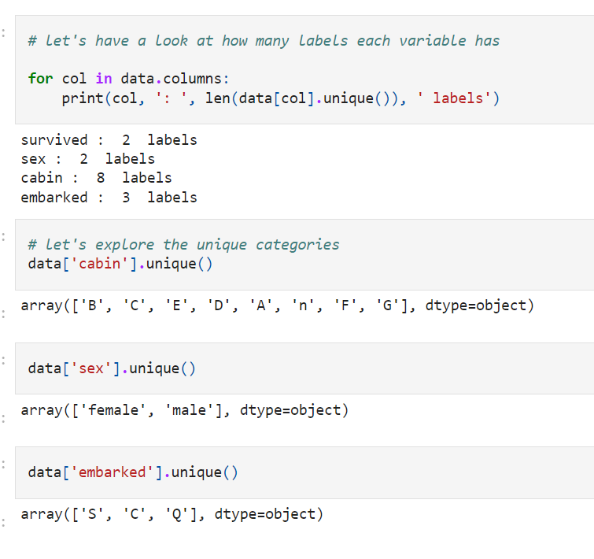

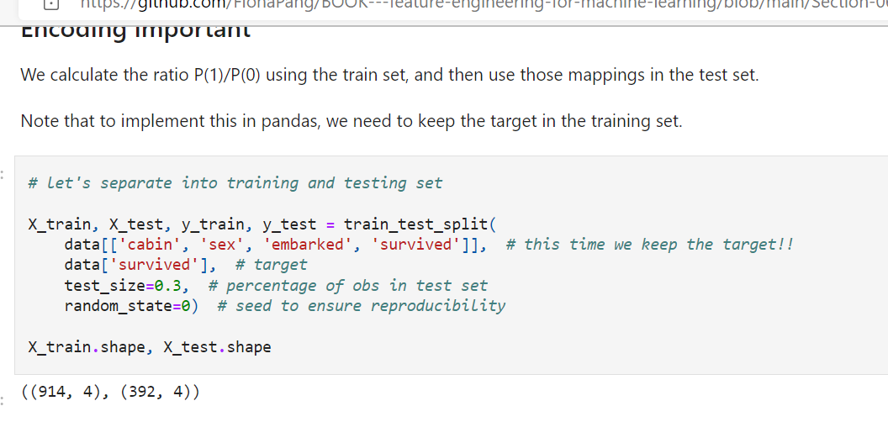

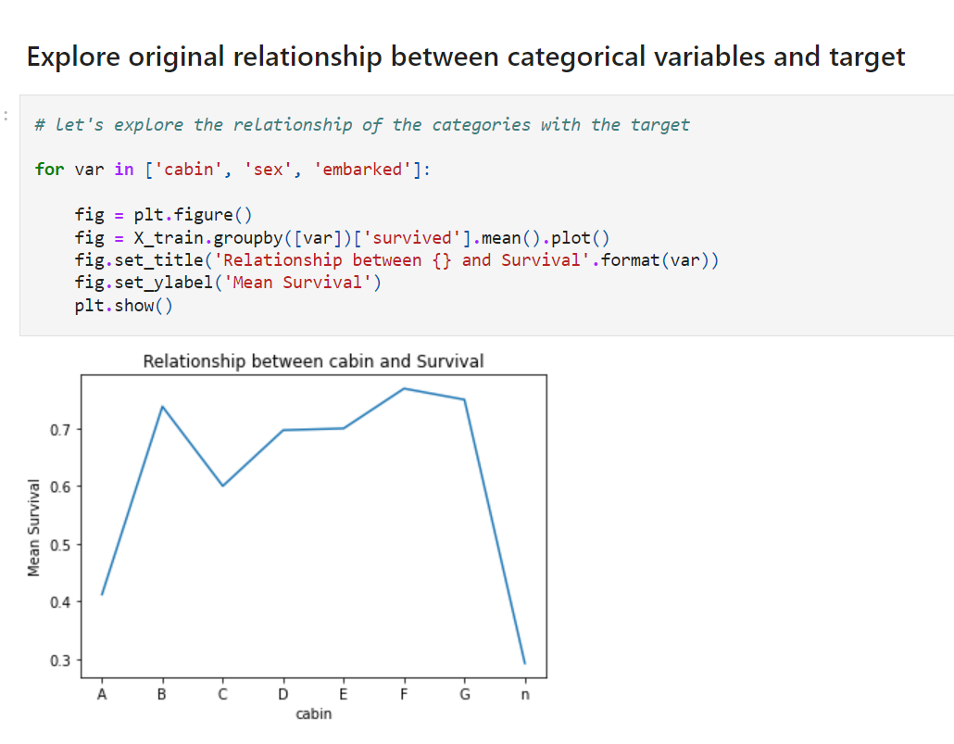

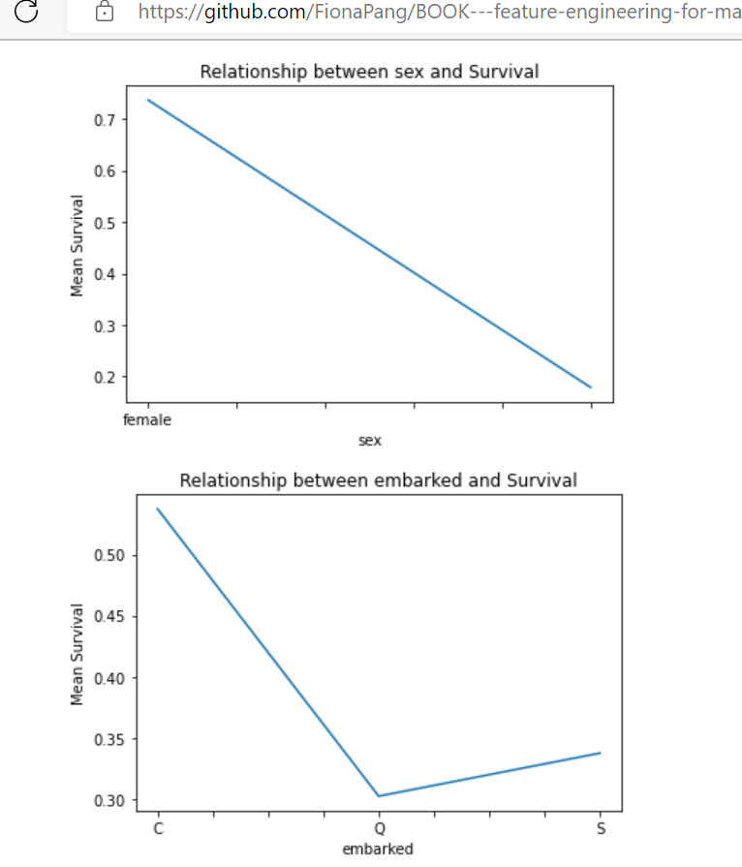

You can see that the relationship between the target and cabin and embarked goes up and down, depending on the category.

**Probability ratio encoding with pandas**

**Advantages**

* quick
* returns pandas dataframe

**Limitations of pandas:**

* it does not preserve information from train data to propagate to test data

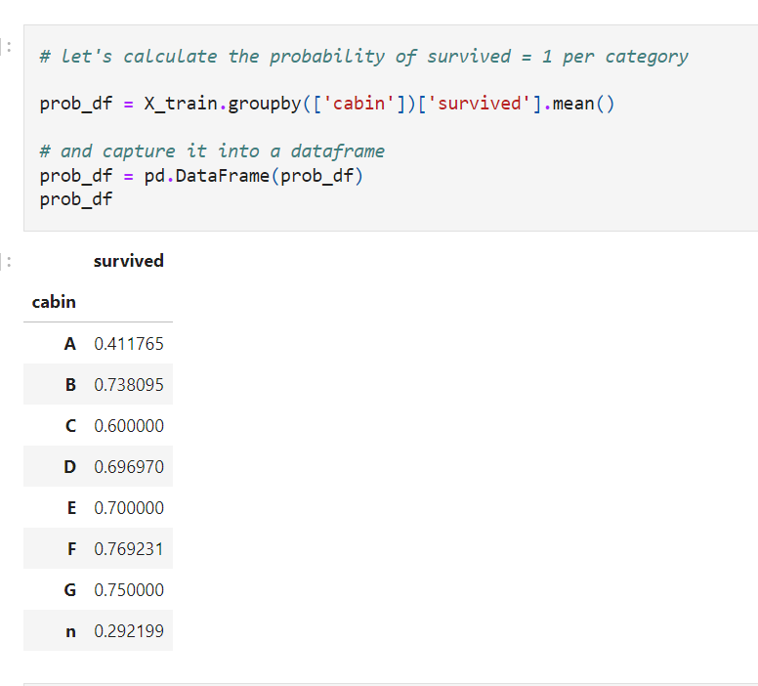

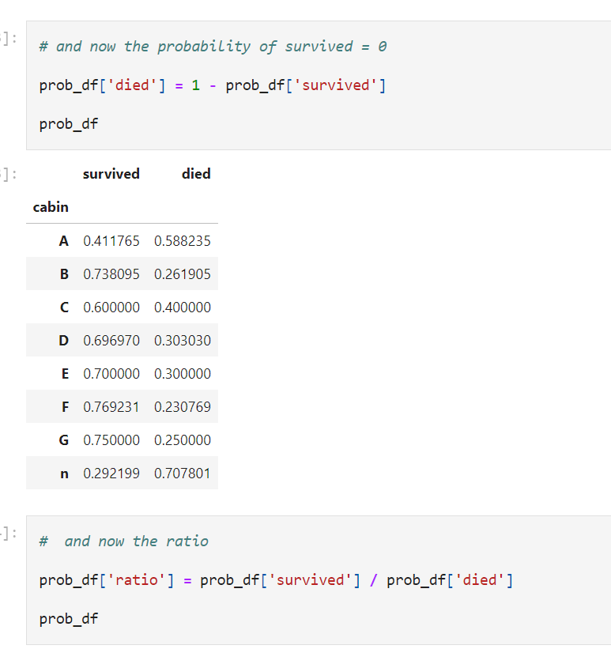

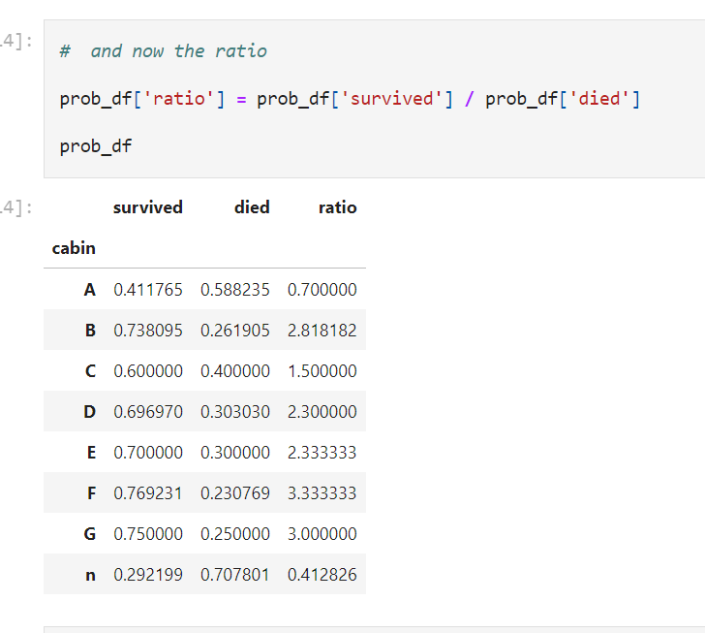

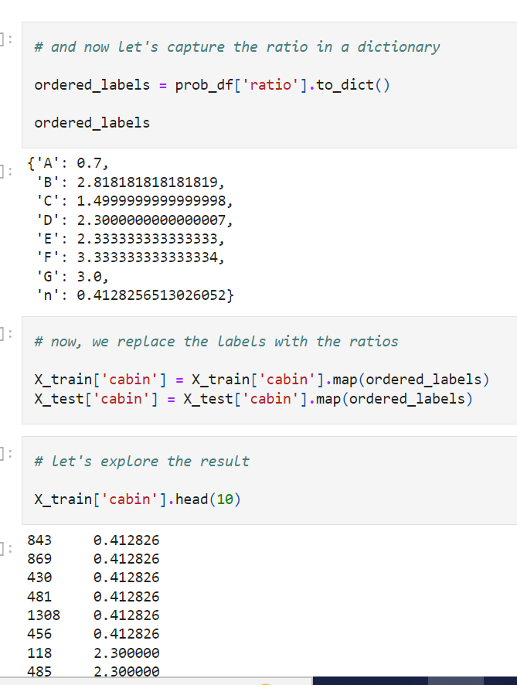

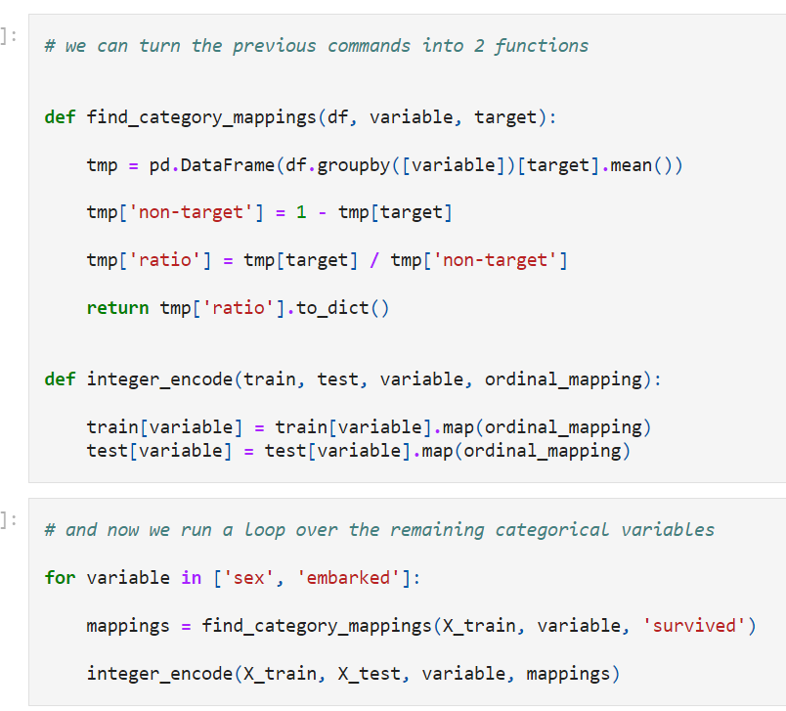

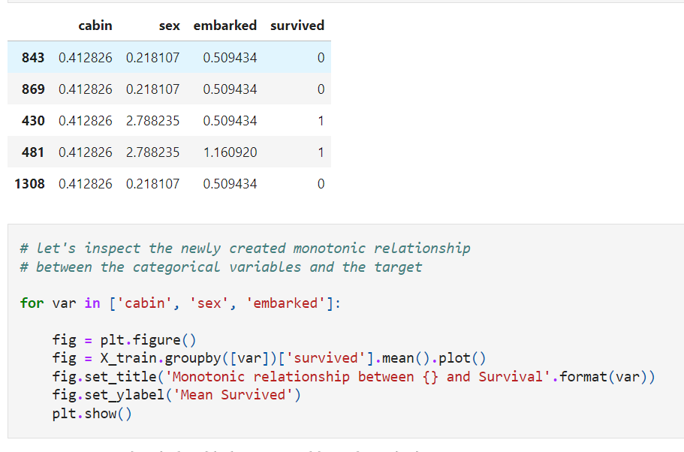

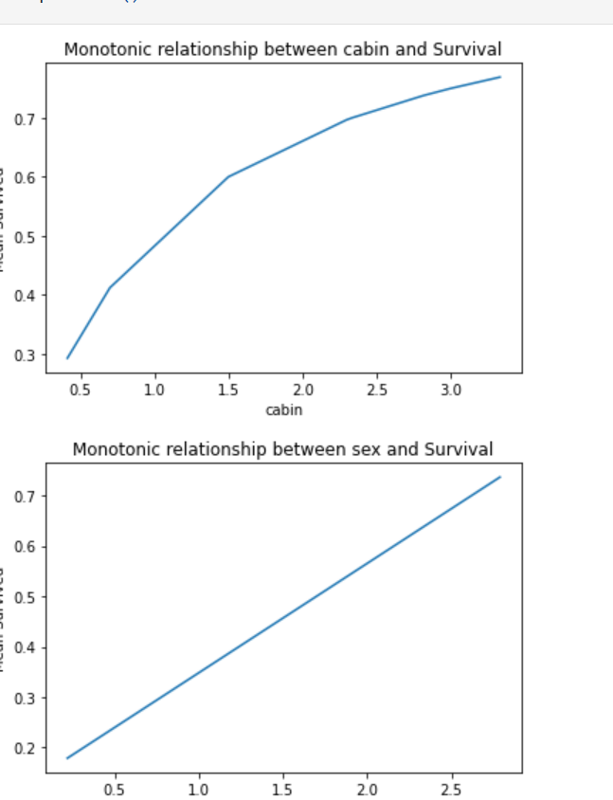

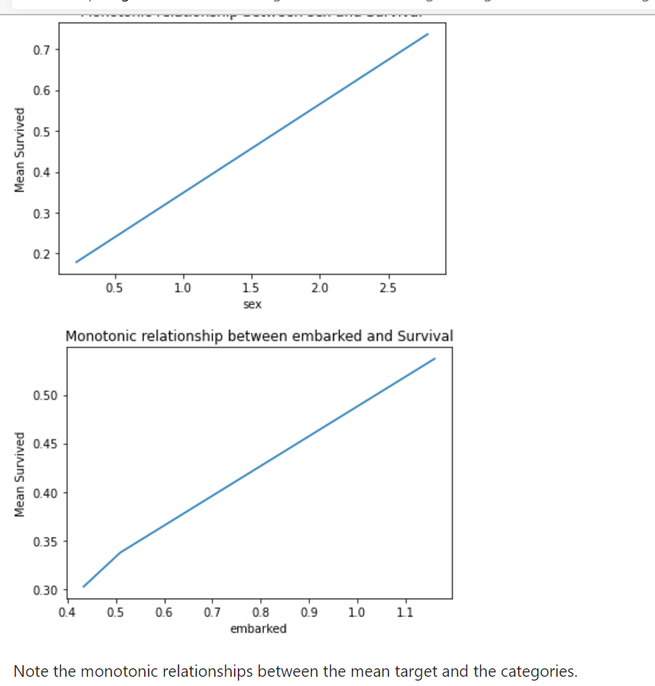

**Note**

Replacing categorical labels with this code and method will generate missing values for categories present in the test set that were not seen in the training set. Therefore it is extremely important to handle rare labels before-hand. I will explain how to do this, in a later notebook.

**In addition, it will create NA or Inf if the probability of target = 0 is zero, as the division by zero is not defined.**

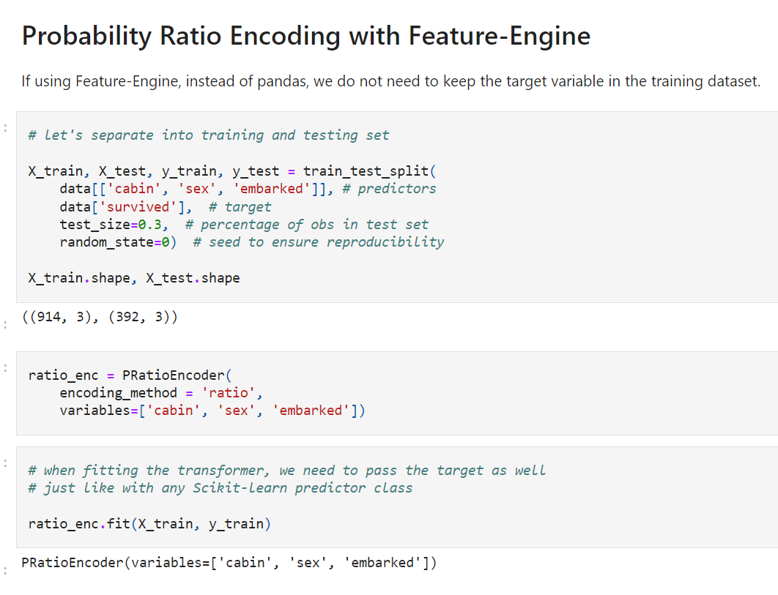

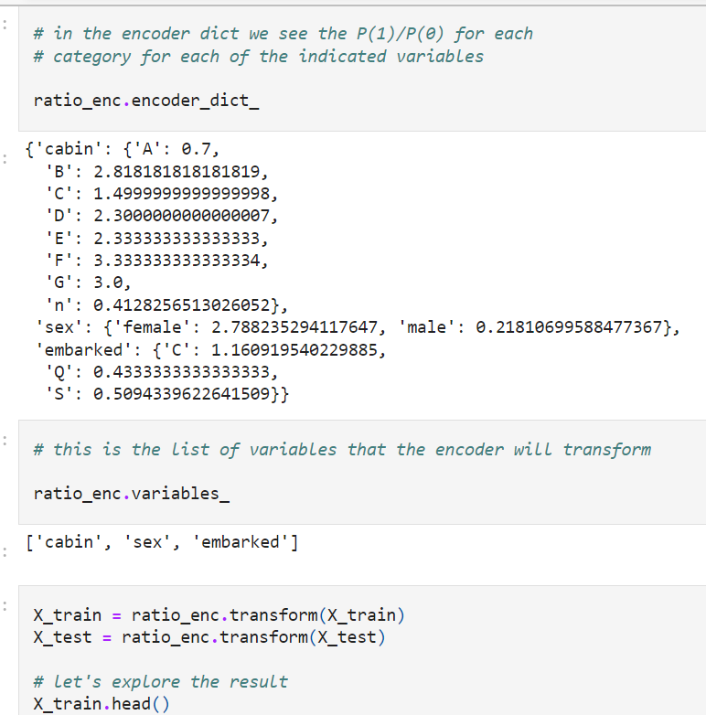

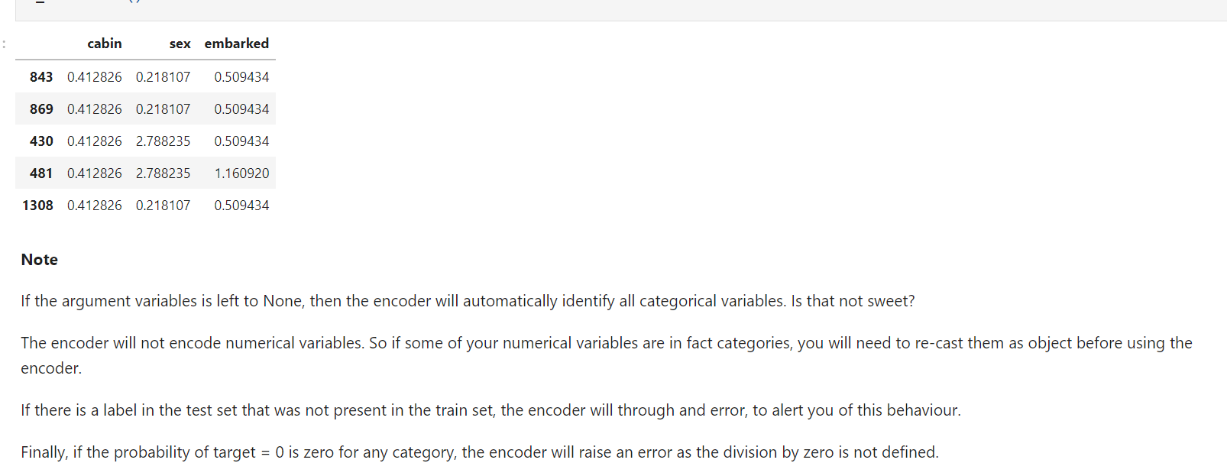

**Weight of evidence**

Weight of Evidence (WoE) was developed primarily for the **credit and financial industries** to help build more predictive models to evaluate the **risk of loan default**. That is, to predict how likely the **money lent to a person or institution is to be lost.** Thus, Weight of Evidence is a measure of the "strength” of a grouping technique to separate good and bad risk (default).

* **WoE will be 0** if the **P(Goods) / P(Bads) = 1**, that is, if the outcome is random for that group.
* **If P(Bads) > P(Goods)** **the odds ratio will be < 1** and,
* **WoE will be < 0** if, P(Goods) > P(Bads).

WoE is well suited for **Logistic Regression**, because **the Logit transformation is simply the log of the odds, i.e., ln(P(Goods)/P(Bads))**. Therefore, by using **WoE-coded predictors in logistic regression,** the predictors are all prepared and coded to the same scale, and the parameters in the linear logistic regression equation can be directly compared.

The WoE transformation has three advantages:

* It creates a monotonic relationship between the target and the independent variables.
* It orders the categories on a "logistic" scale which is natural for logistic regression
* The transformed variables can then be compared because they are on the same scale. Therefore, it is possible to determine which one is more predictive.

The WoE also has a limitation:

* Prone to cause over-fitting

For more details follow this [article](https://www.listendata.com/2015/03/weight-of-evidence-woe-and-information.html#Steps-of-Calculating-WOE) and this [article](https://blogs.oracle.com/r/computing-weight-of-evidence-woe-and-information-value-iv).

**In this demo:**

We will see how to perform one hot encoding with:

* pandas
* Feature-Engine
* Category encoders

And the advantages and limitations of each implementation using the Titanic dataset.

Woe=in(prop of good event/prop bad events)

Pro good events= sum of positive observation per category / total positive obser

Pro bad event= sum of – observation per category/ total negative observation

Cabins survived non survived % good % bad good= surv/total survd woe

A 50 30 0.33 0.35 bad%= non sur/total non sur -0.057

B 75 40 --------------- 0.50 047 0.060

C 25 15 0.17 0.18 -0.057

Total 150 85

Total pass 235

Woe= devide % good/%bad

Weight of evidence:

Creats monotonic relationship between target and variable

It orders categories on logistic scale

Transformed variables can be compared because they are on same scale

Limitation:

May lead to over fitting

Not defined when numeratr or denom are 0

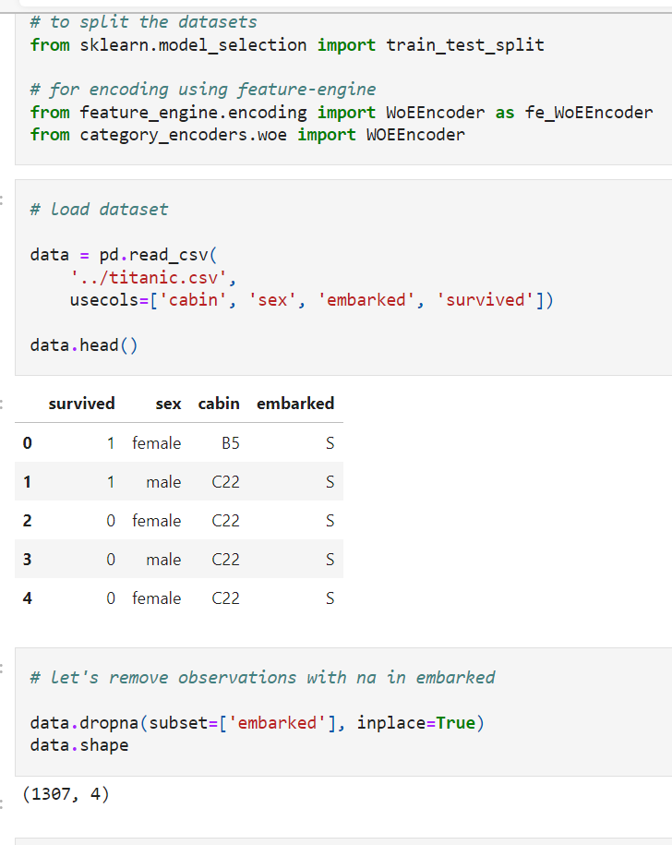

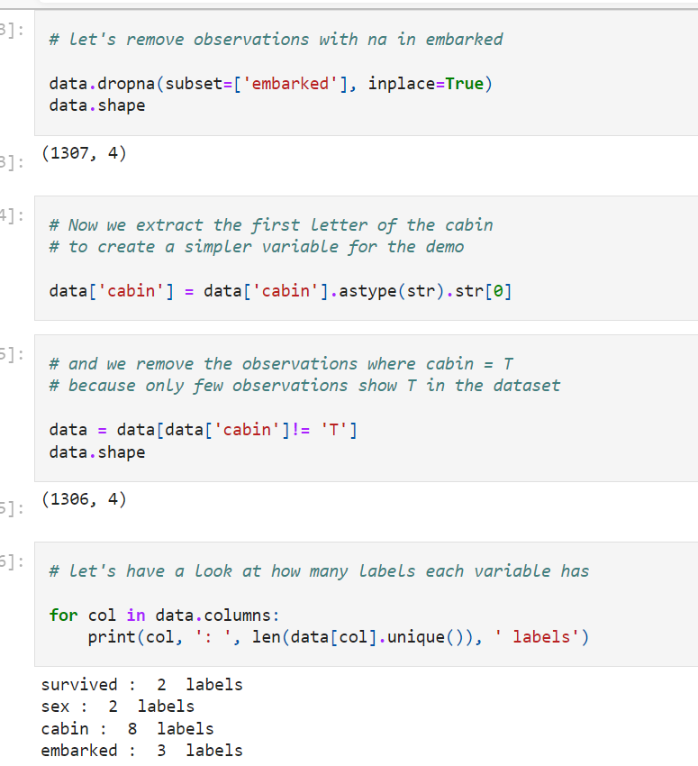

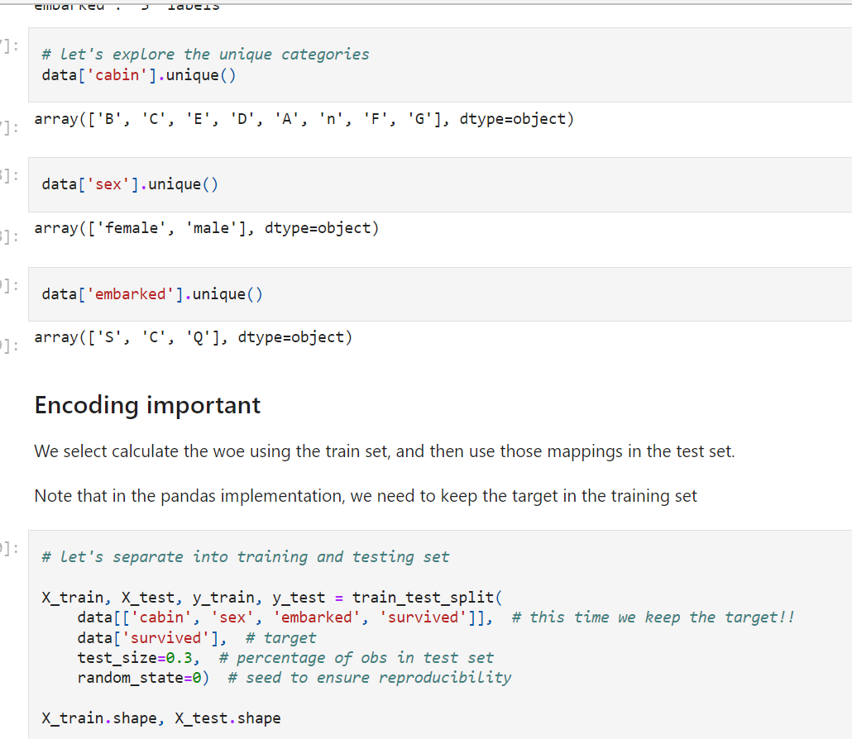

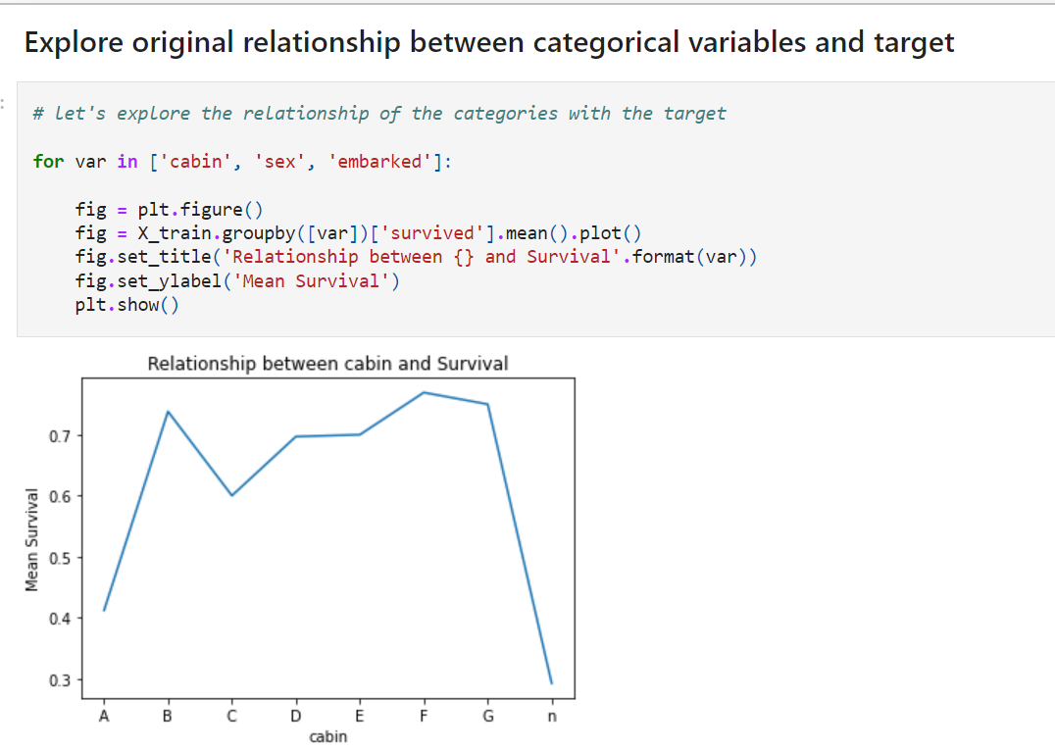

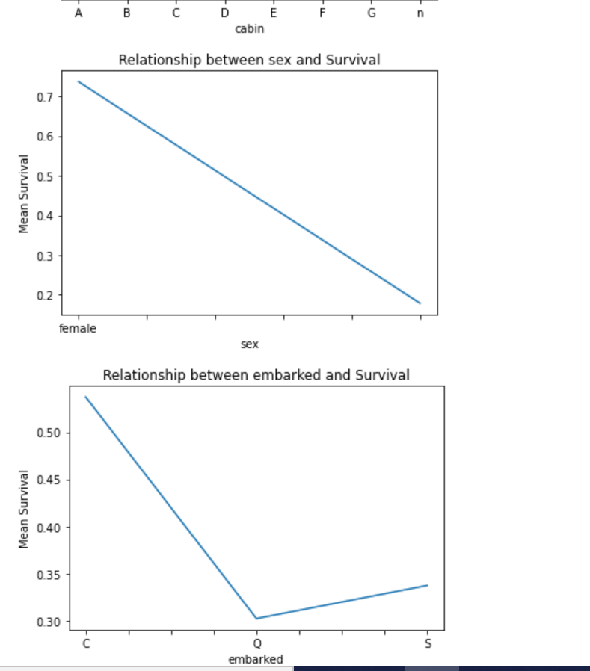

**Weight of Evidence with pandas**

**Advantages**

* quick
* returns pandas dataframe

**Limitations of pandas:**

* it does not preserve information from train data to propagate to test data

We need to store the mappings separately if planning to use the model in production.

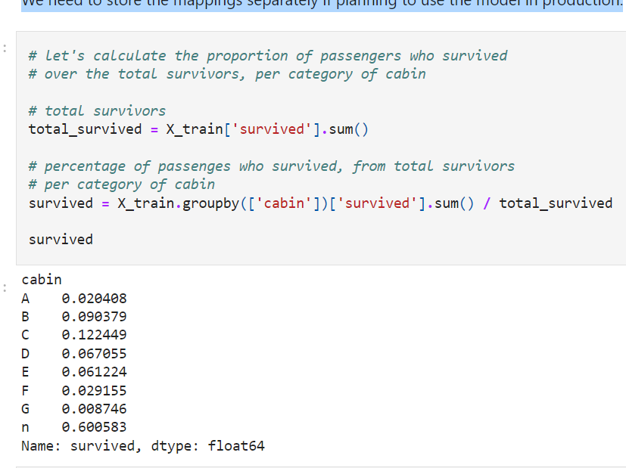

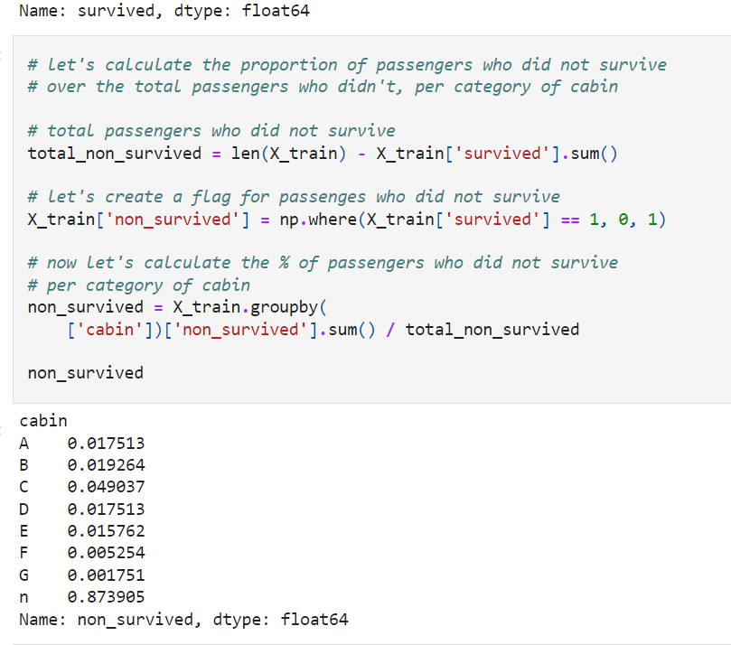

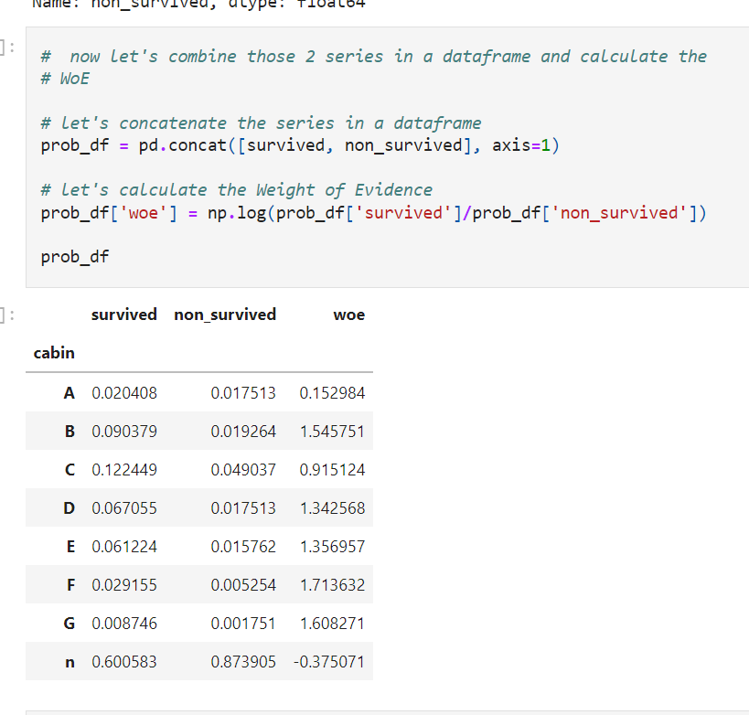

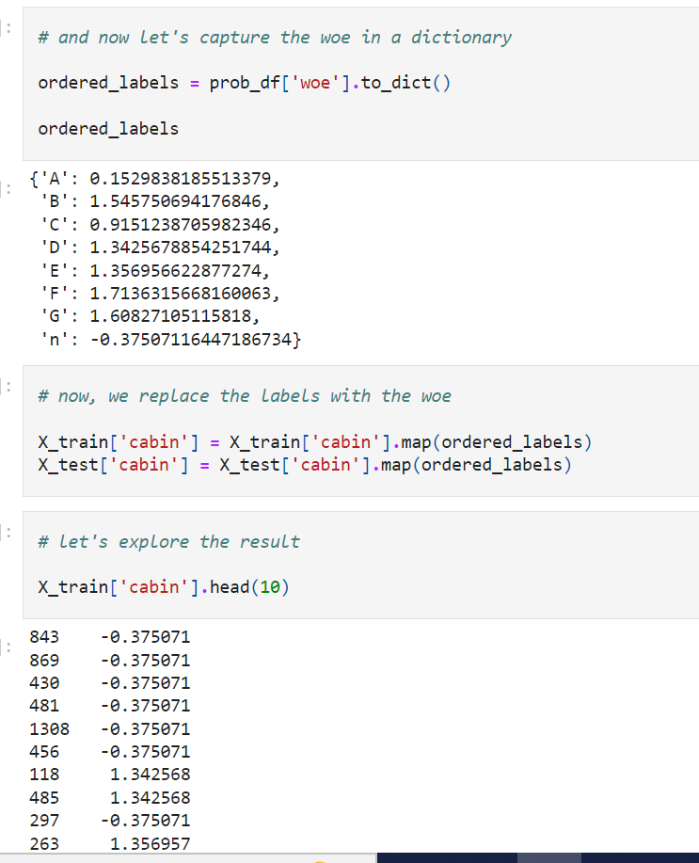

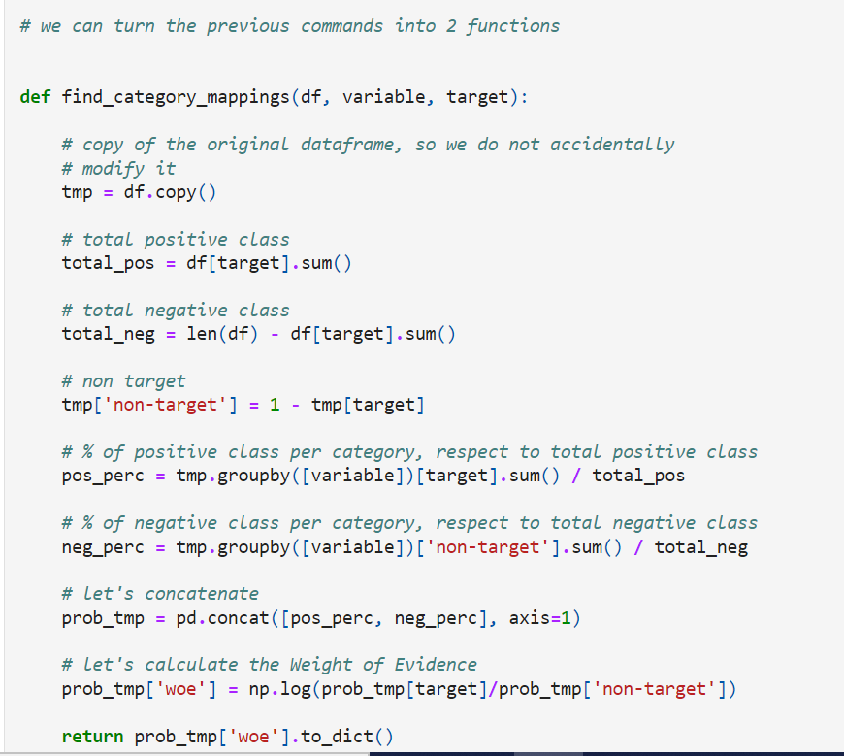

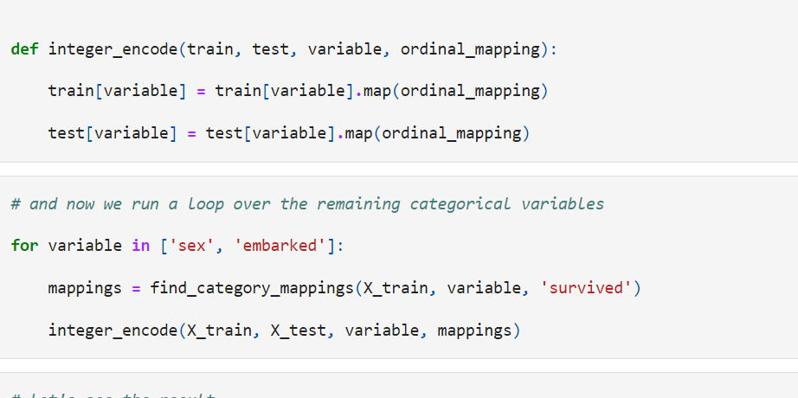

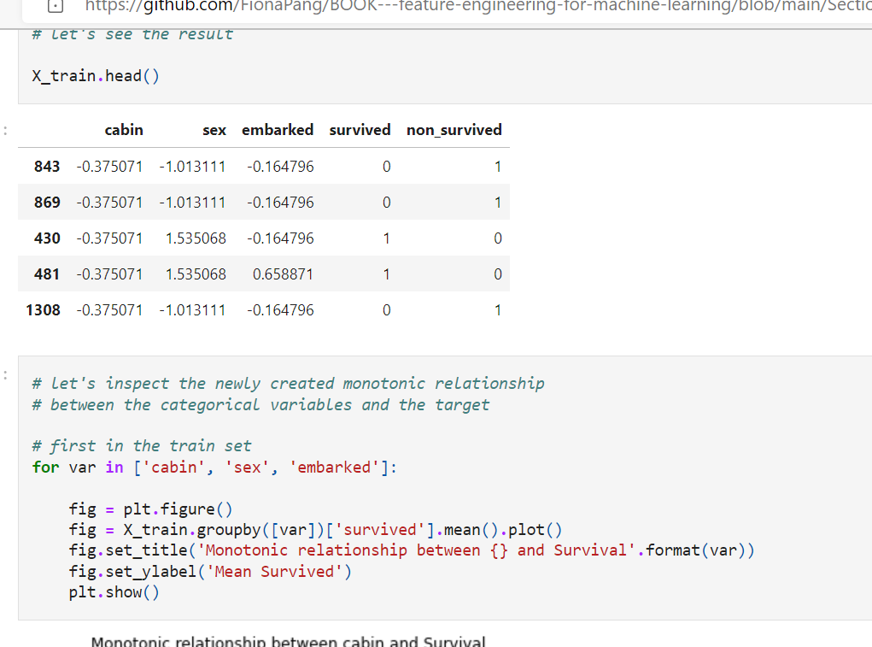

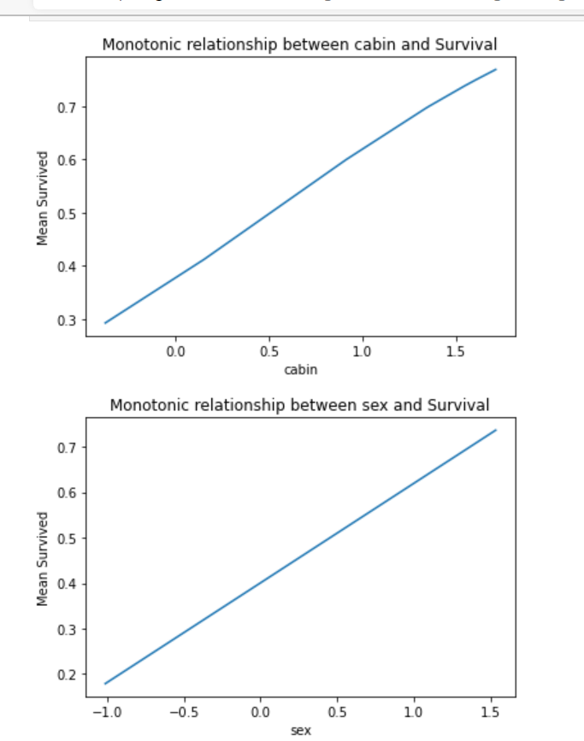

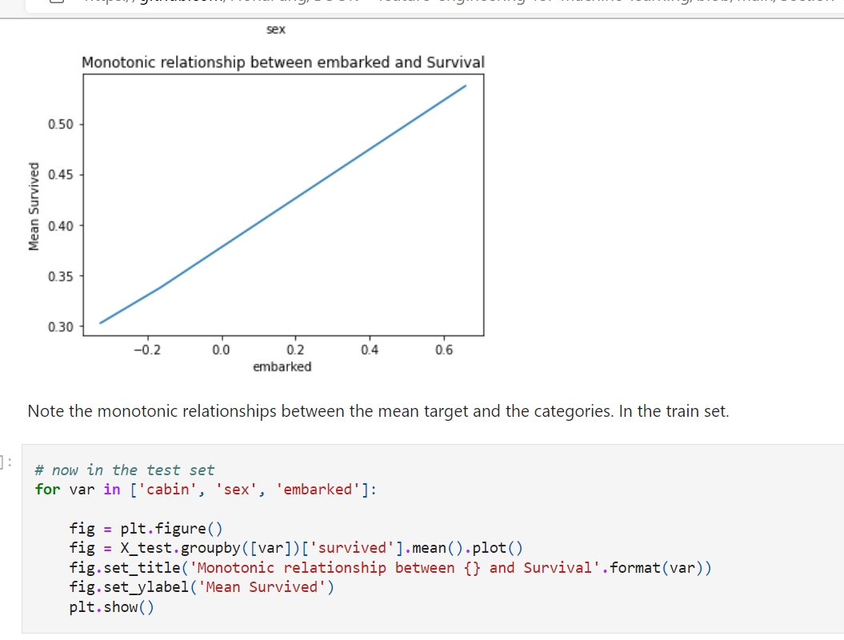

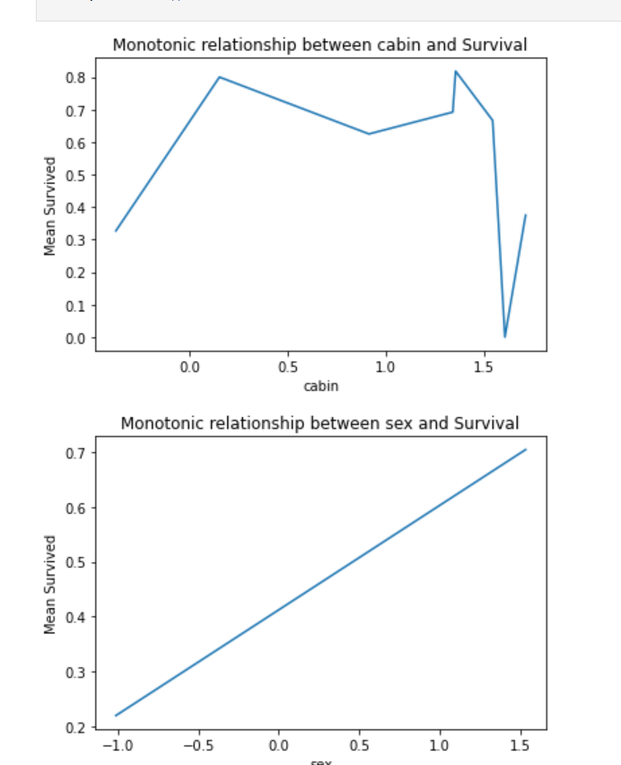

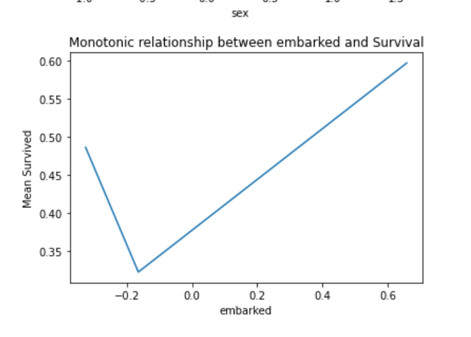

The monotonic relationship does not hold when **encoding the categorical variables in the test set**. This could mean that the **categories are not informative of the target** or the proportion of survivors is not homogeneous between in the categories in the train and test sets.

In situations like this, we could try grouping rare labels into a joint category as we will cover later in this section, before applying the Weight of evidence transformation.

**Note**

Replacing categorical labels with this code and method will generate missing values for categories present in the test set that were not seen in the training set. Therefore it is extremely important to handle rare labels before-hand. I will explain how to do this, in a later notebook.

**In addition, it will create NA or Inf if any of the 2 terms in the ratio of the WoE formula are 0**

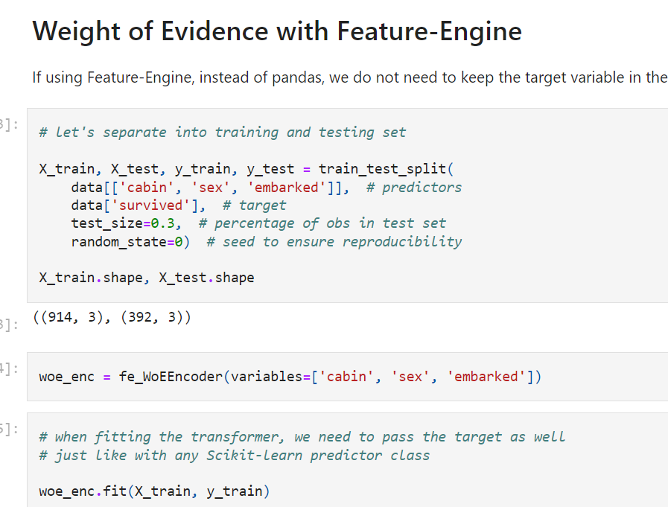

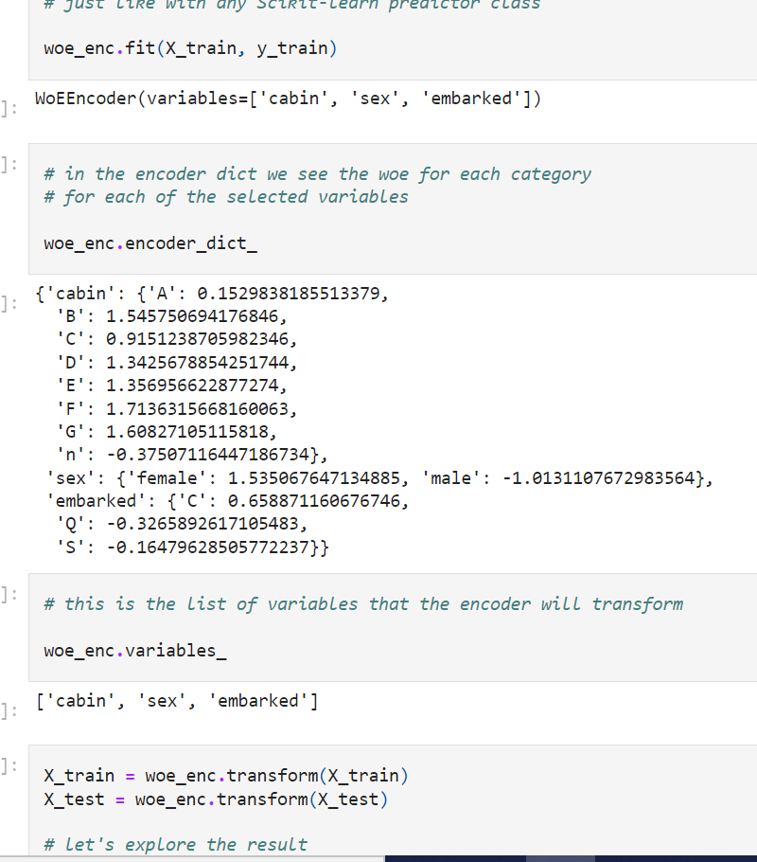

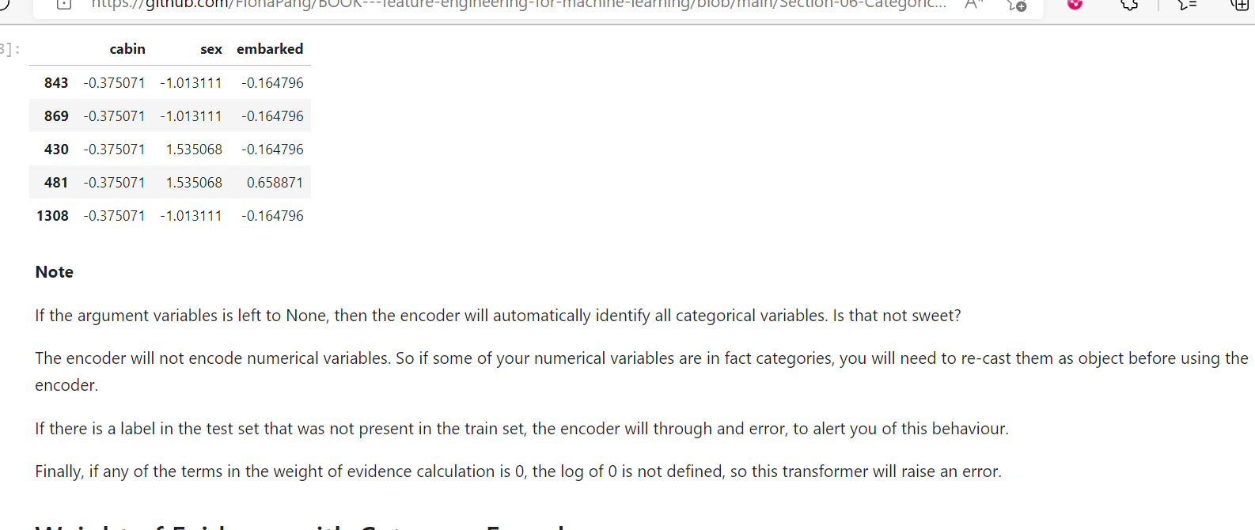

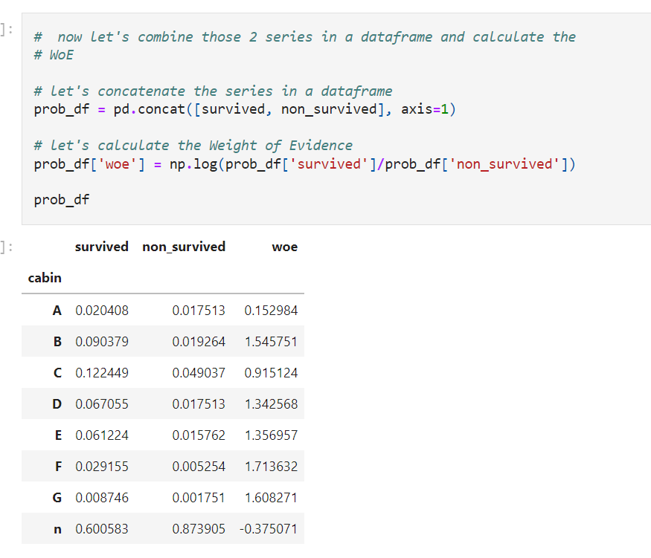

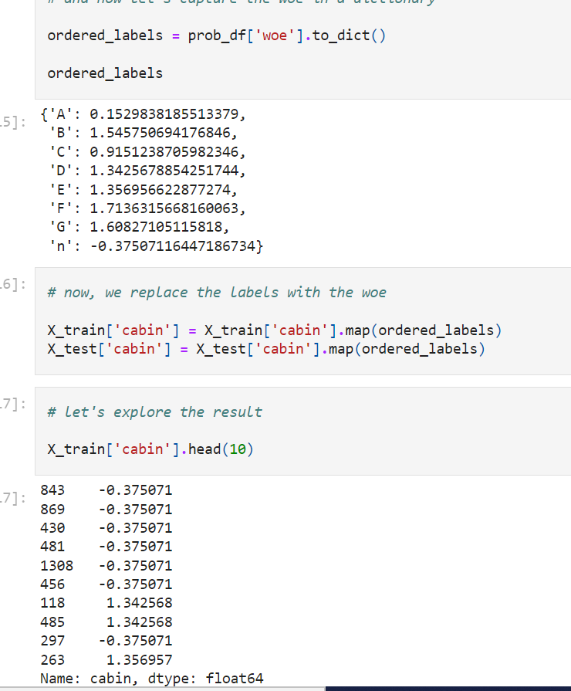

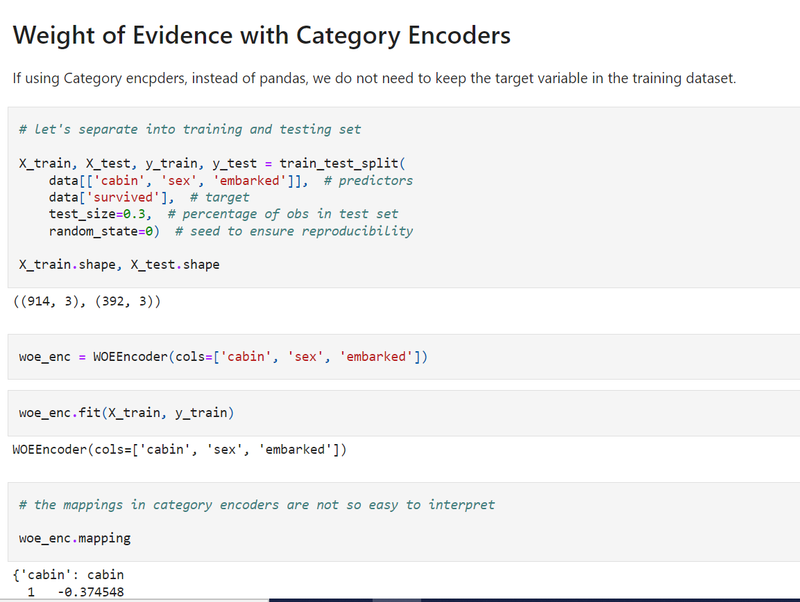

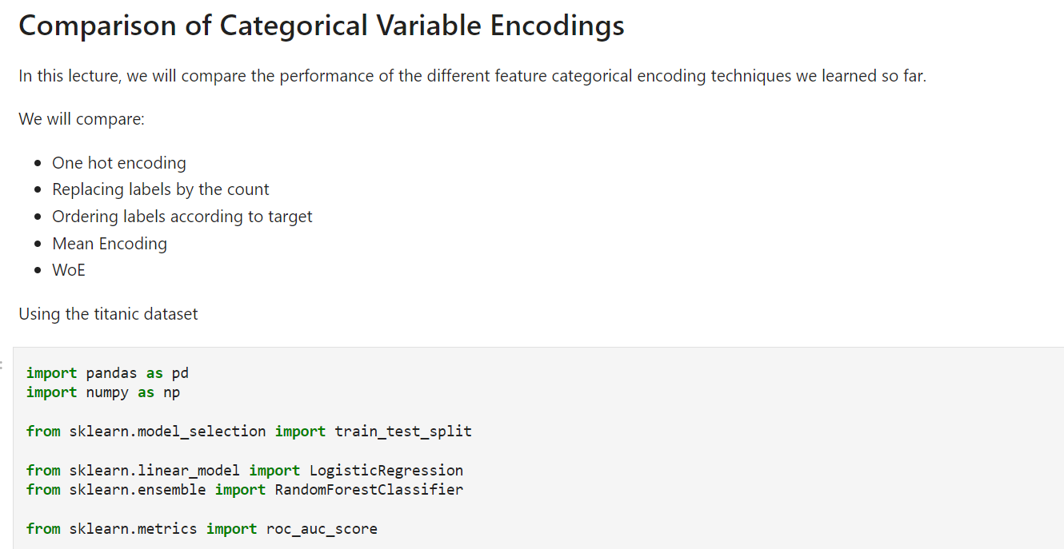

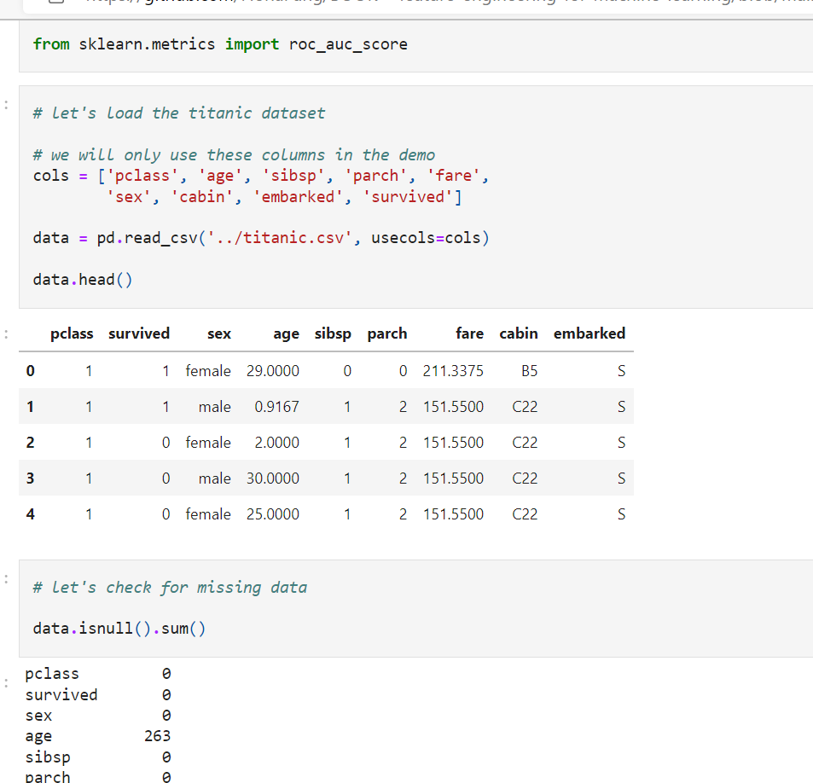

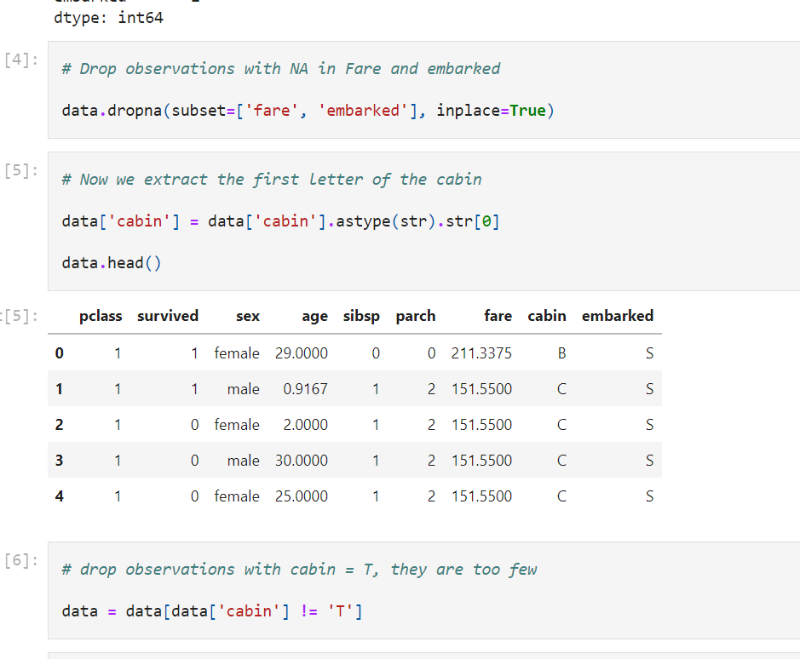

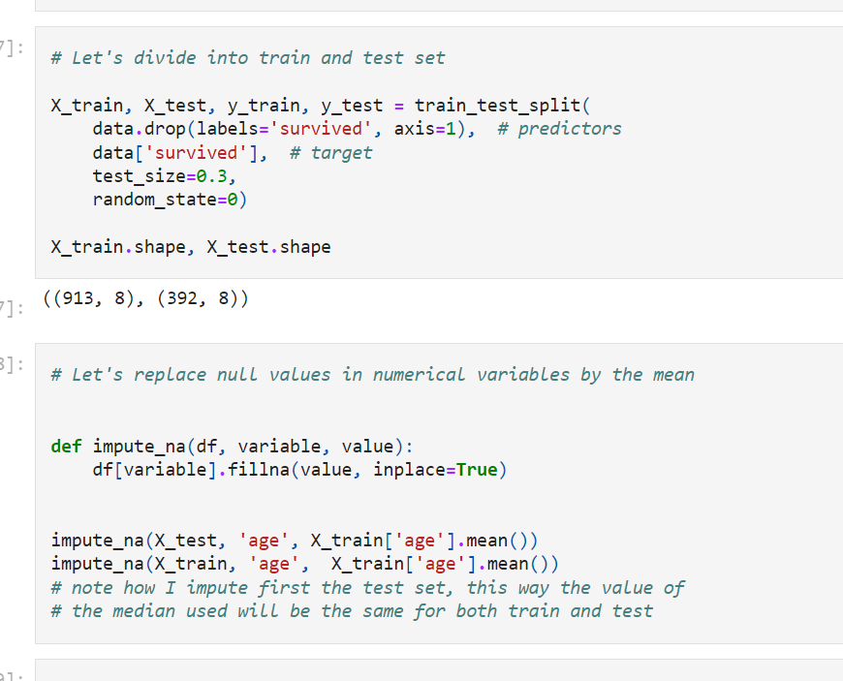

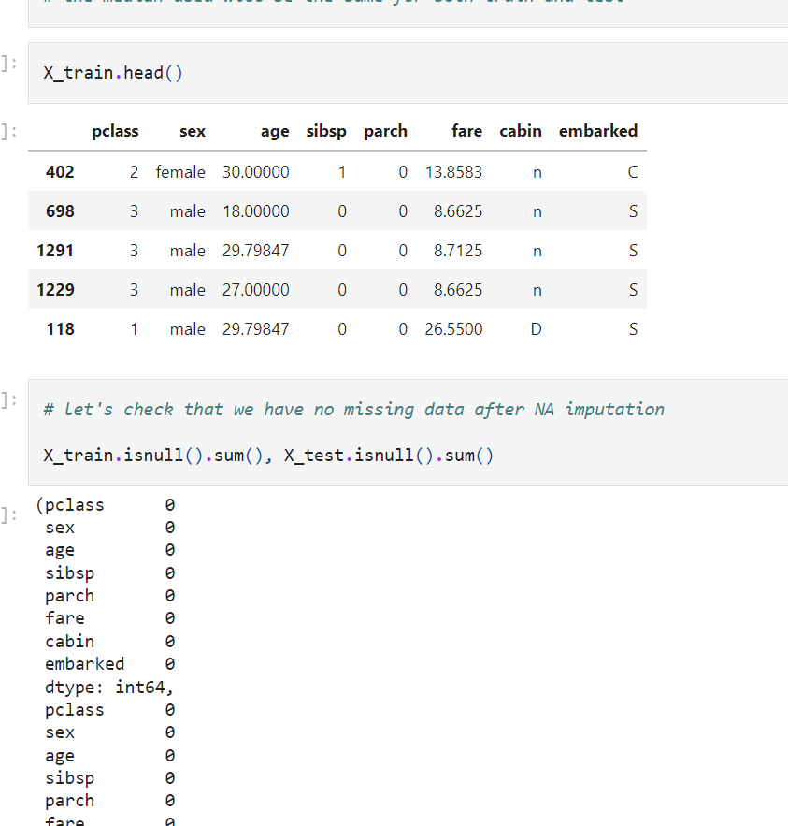

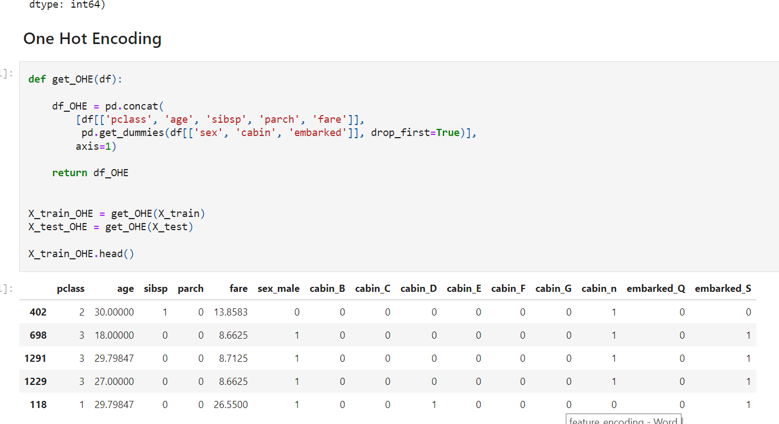

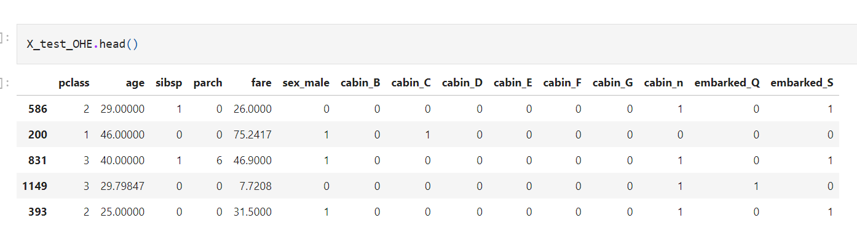

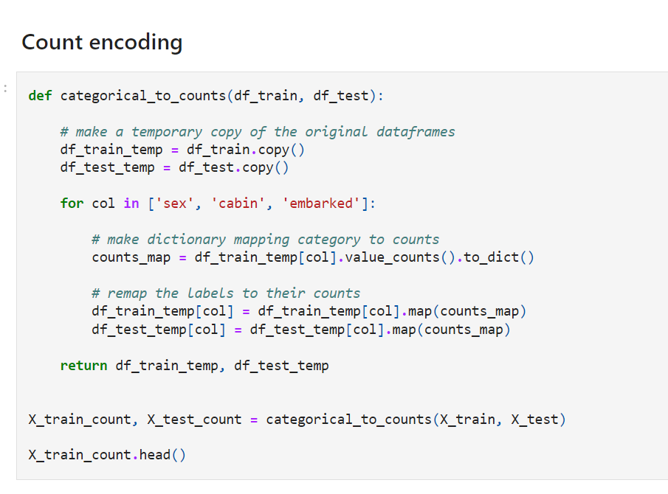

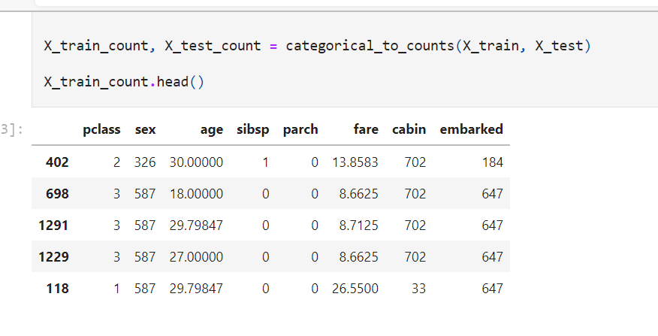

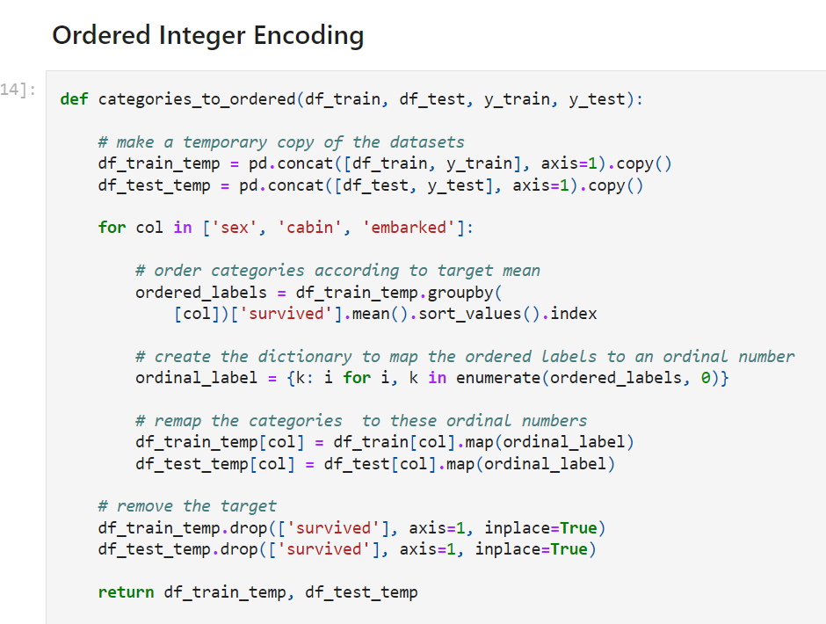

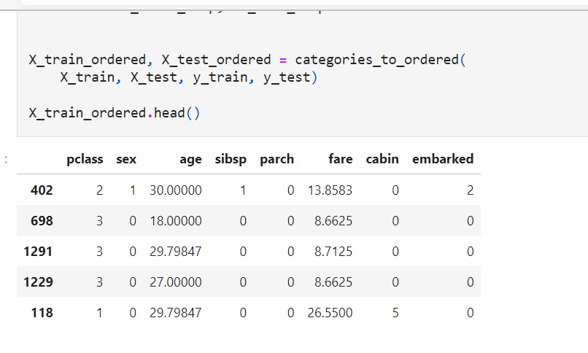

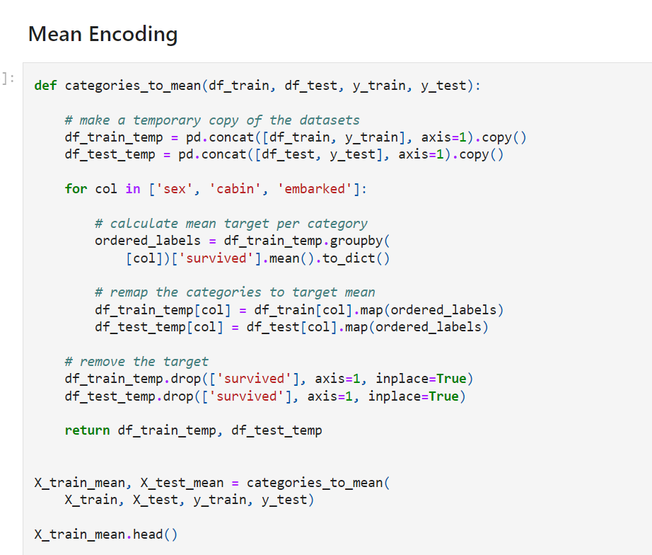

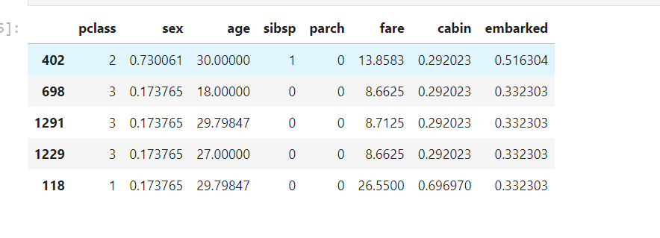

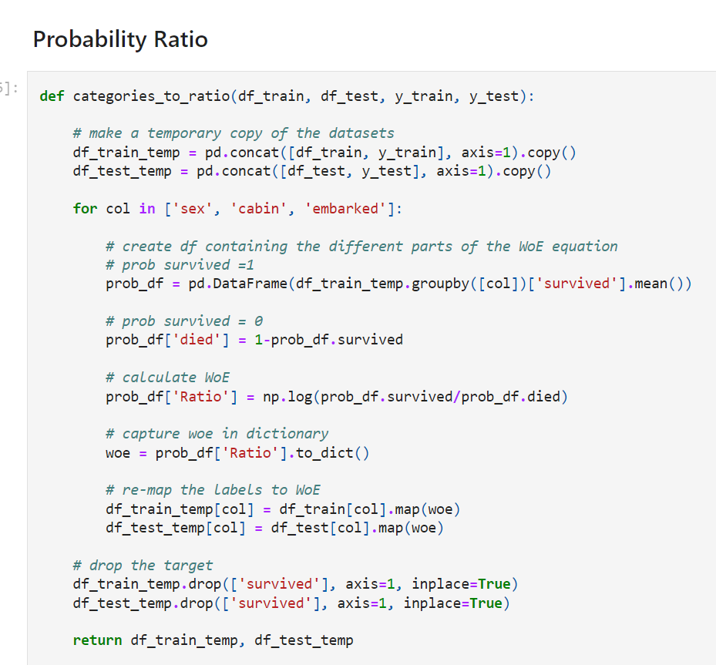

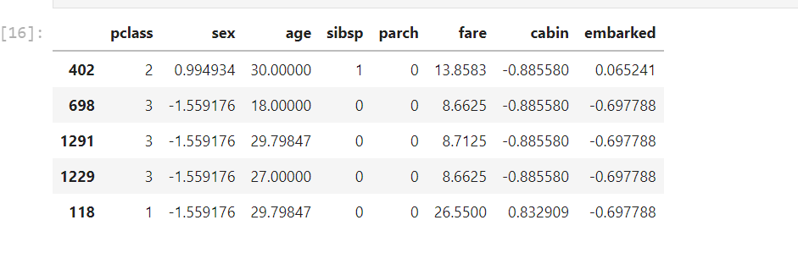

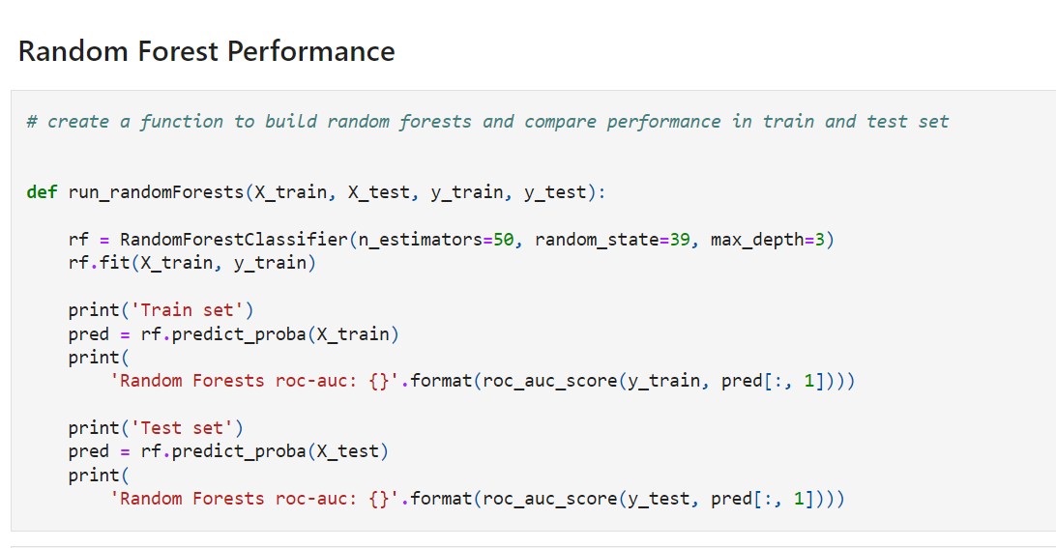

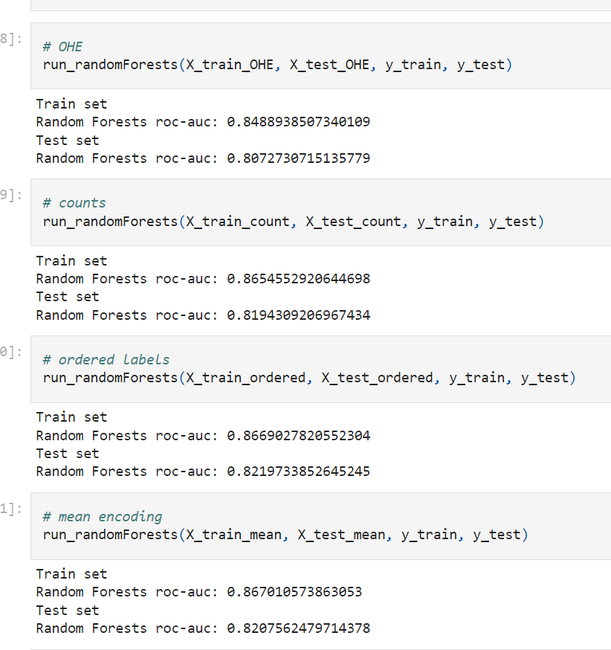

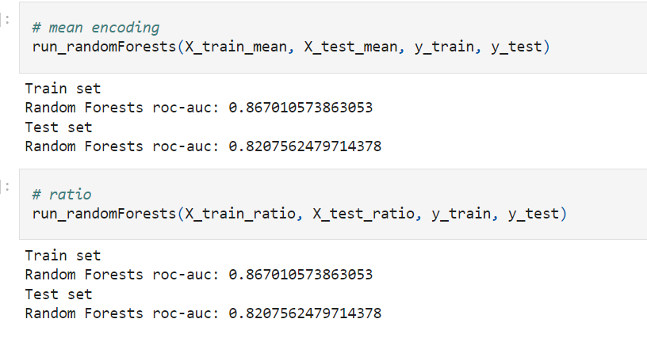

Comparing the **roc_auc values on the test sets**, we can see that **one hot encoding has the worse** performance. This makes sense because **trees do not perform well in datasets with big feature spaces.**

The remaining **encodings returned similar performances**. This also makes sense, because trees are **non-linear models**, so **target guided encodings may not necessarily improve the model performance**

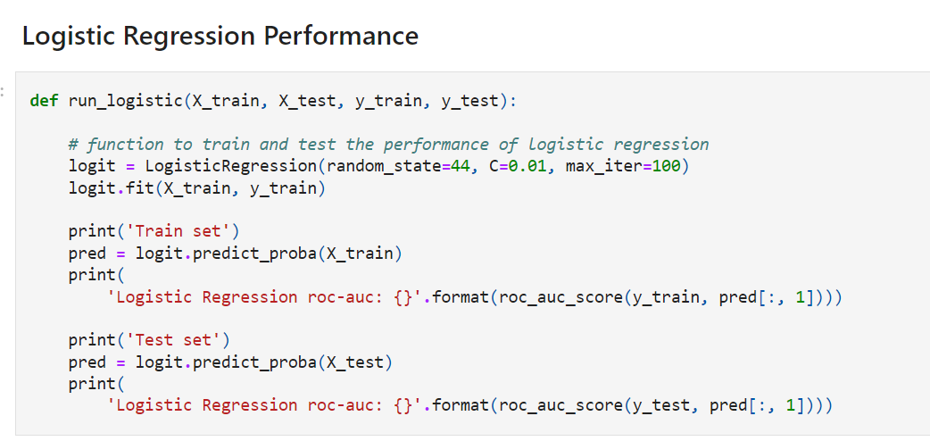

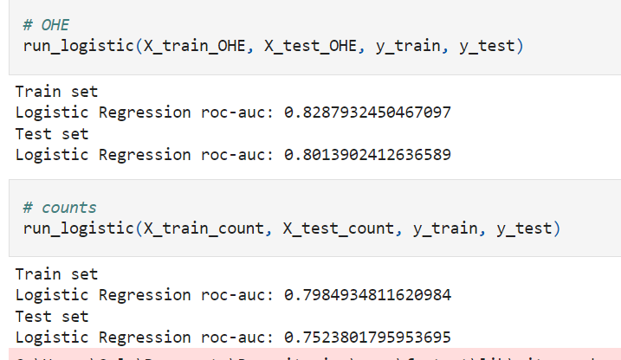

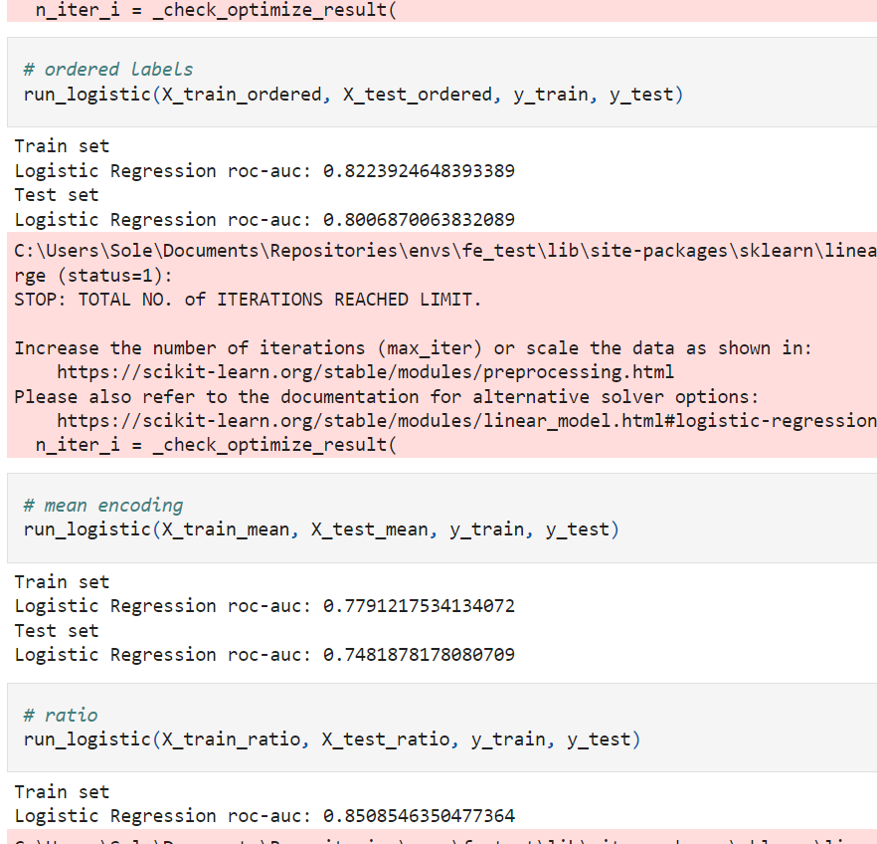

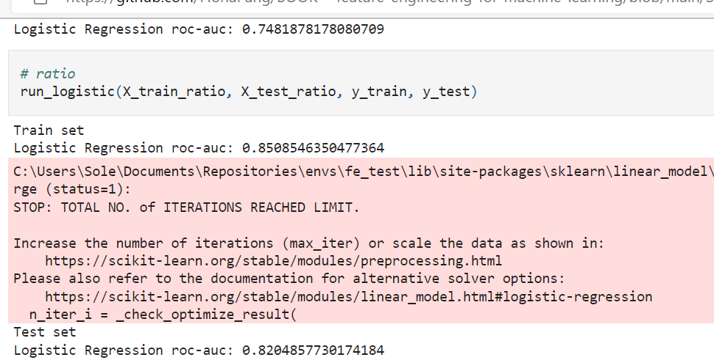

For Logistic regression, **the best performances are obtained** with **one hot encoding**, as it **preserves linear relationships with variables and target**, and **also with weight of evidence**, and ordered encoding.

Note **however how count encoding**, **returns the worse performance** as it does not create a monotonic relationship between variables and target, and in this case, mean target encoding is probably causing over-fitting

**Engineering Rare Categories**

Rare values are categories within a **categorical variable that are present only in a small percentage of the observations**.

There is no rule of thumb to determine **how small is a small percentage**, but typically, **any value below 5 % can be considered rare.**

As we discussed in section 3 of the course, **Infrequent labels are so few**, that it **is hard to derive reliable information from them.** But more importantly, if you remember from section 3, infrequent labels tend to **appear only on train set or only on the test set:**

* If only on the train set, they may cause over-fitting
* If only on the test set, our machine learning model will not know how to score them

Therefore, to avoid this behaviour, we tend to **group those into a new category called 'Rare' or 'Other'.**

Rare labels can appear **in low or highly cardinal variables**. There is no rule of thumb to determine **how many different labels are considered high cardinality**. It depend as well on how many observations there are in the dataset. In a dataset with 1,000 observations, 100 labels may seem a lot, whereas in a dataset with 100,000 observations it may not be so high.

Highly cardinal variables tend to **have many infrequent or rare categories**, whereas low cardinal variables, may have only 1 or 2 rare labels.

**Note the following:**

**Note that grouping infrequent labels or categories under a new category called 'Rare' or 'Other' is the common practice in machine learning for business.**

* **Grouping categories into rare for variables** that show **low cardinality may or may not improve model performance,** however, we tend to re-group them into a new category to smooth model deployment.
* Grouping categories into rare for variables with high cardinality, tends **to improve model performance as well.**

**In this demo:**

We will learn how to **re-group rare labels under a new category called rare**, and compare the implications of this encoding in variables with:

* One predominant category
* A small number of categories
* High cardinality

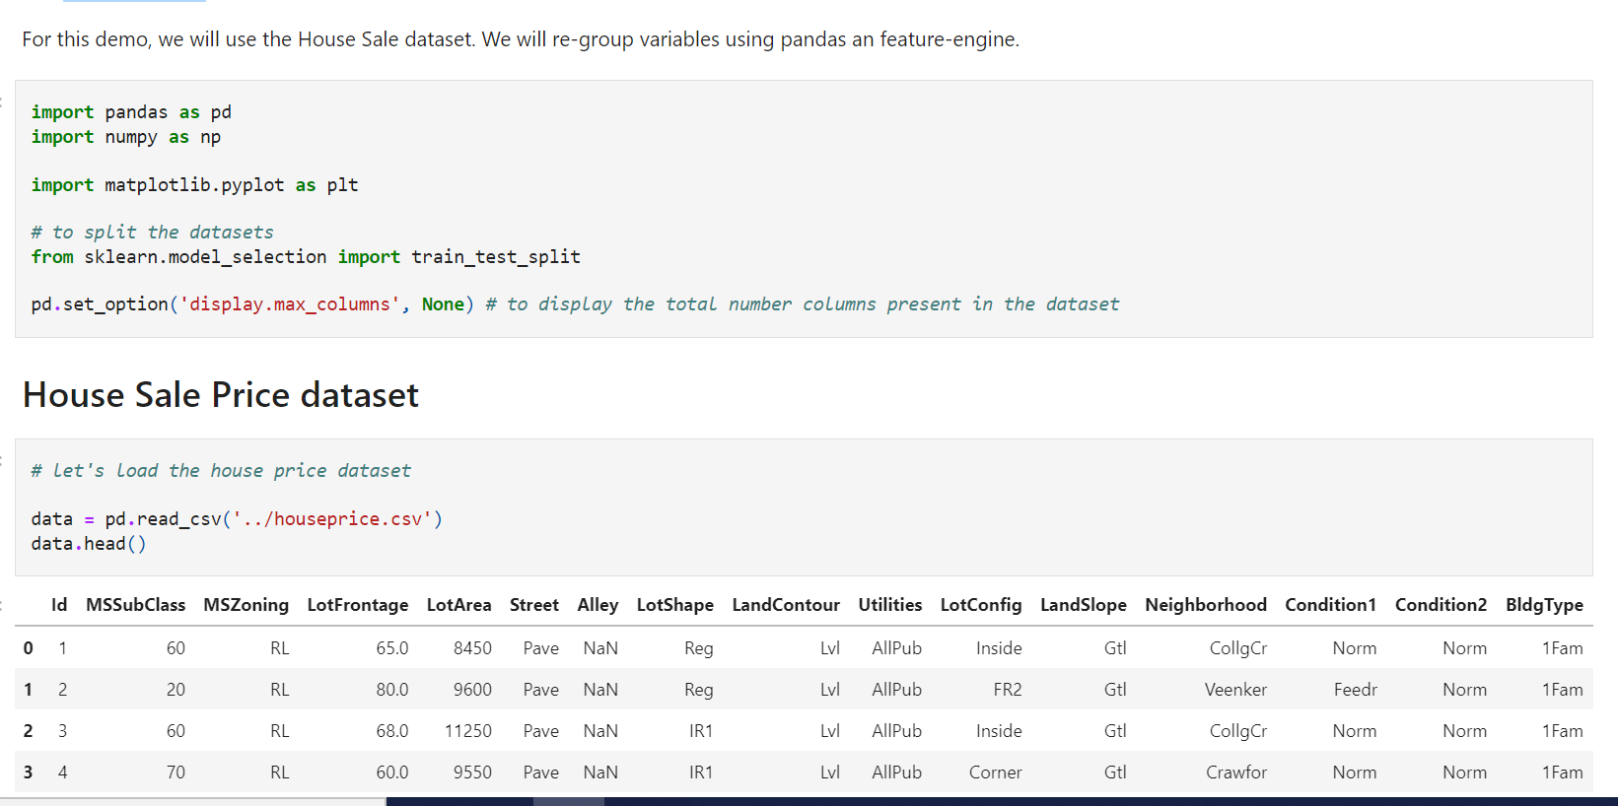

**Important**

The identification of **rare labels should be done using only the training set**, and **then propagated to the test set.**

Rare labels should be identified in the training set only. In practice, what we will do is identify **non-rare labels**, and then any other label, either in the train or the test or future live data that is not in that list of **non-rare** labels, will be re=grouped into the new category.

For example, let's imagine that we have in the training set **the variable 'city'** with the labels **'London', 'Manchester' and 'Yorkshire'. 'Yorkshire' is present in less than 5% of the observations** so we decide to re-group it in a new category **called 'Rare'.**

In the test set, we should also **replace 'Yorkshire' by 'Rare'**, **regardless of the percentage of observations for 'Yorkshire' in the test set**. In addition, if in the test set we find the category **'Milton Keynes', that was not present in the training set**, we should also replace that category by **'Rare'.**

On other words, **all categories present in test set**, **not present in the list of non-rare categories** derived from the training set, **should be treated as rare values** and re-grouped into 'Rare'.

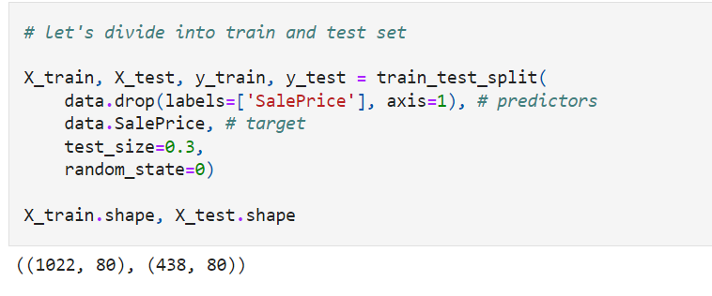

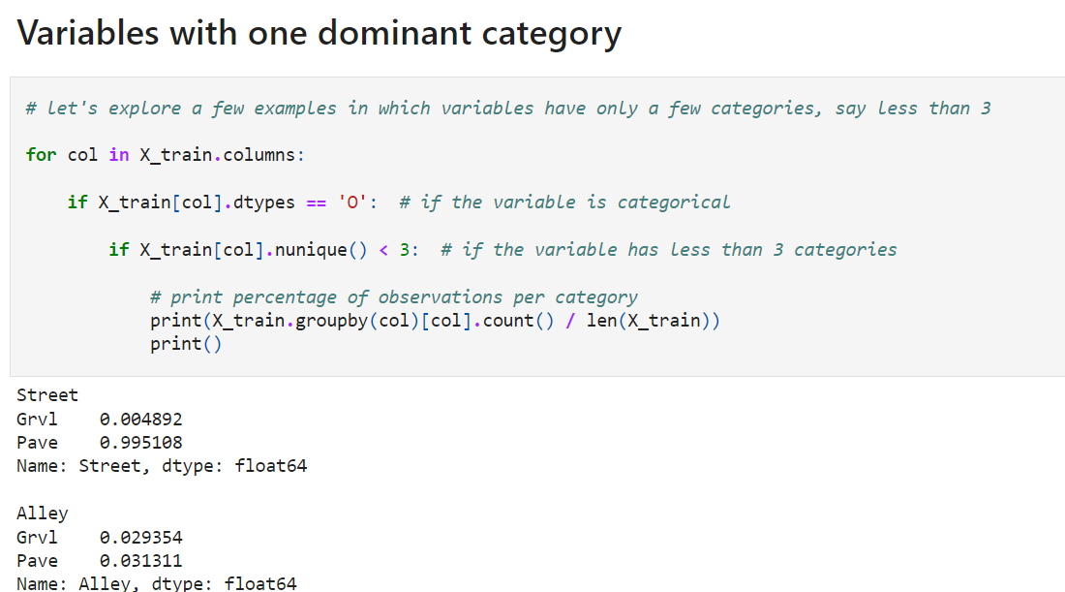

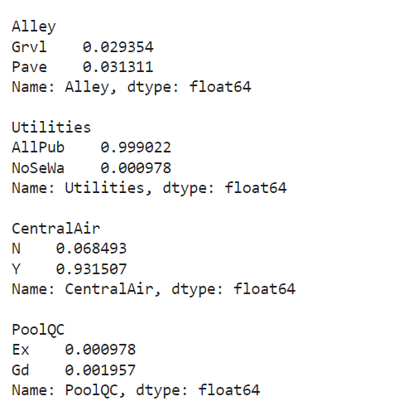

**Conclusion**

The 3 variables above, Street, Utilities and CentralAir, show one dominating category which accounts for more than 93-99% of the observations. Re-grouping the rare label in this situation does not make any sense. We could determine if these variables are useful with exploratory analysis, or any feature selection algorithm, or drop the variables altogether.

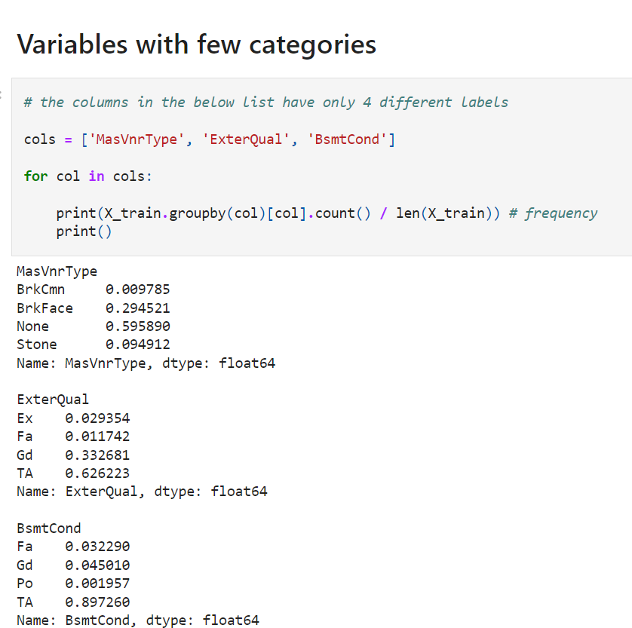

The variables above have only 4 categories, and in all three cases, there is at least one category that is infrequent, that is, that is present in less than 5% of the observations.

When the variable has **only a few categories**, then perhaps it makes **no sense to re-categorise the rare labels into something else.**

For example the first variable MasVnrType shows only 1 rare label, BrkCmn. Thus, re-categorising it into a new label will leave the variable in the same situation.

The second variable ExterQual, contains 2 rare labels Ex and Fa, we could group these 2 into a new label called 'Rare'.

The third variable BsmtCond contains 3 rare labels, Fa, Gd and Po, so we could group these 3 under the new label 'Rare'.

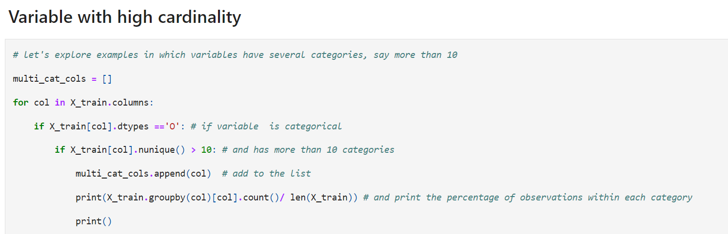

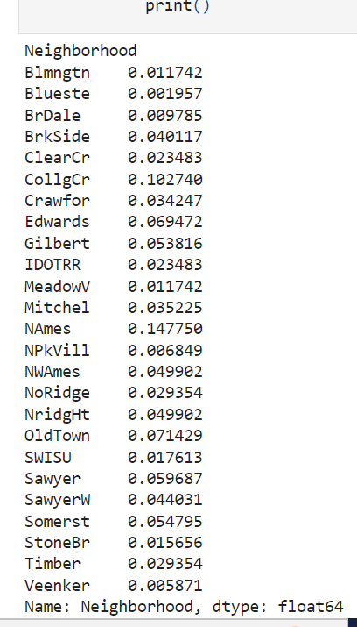

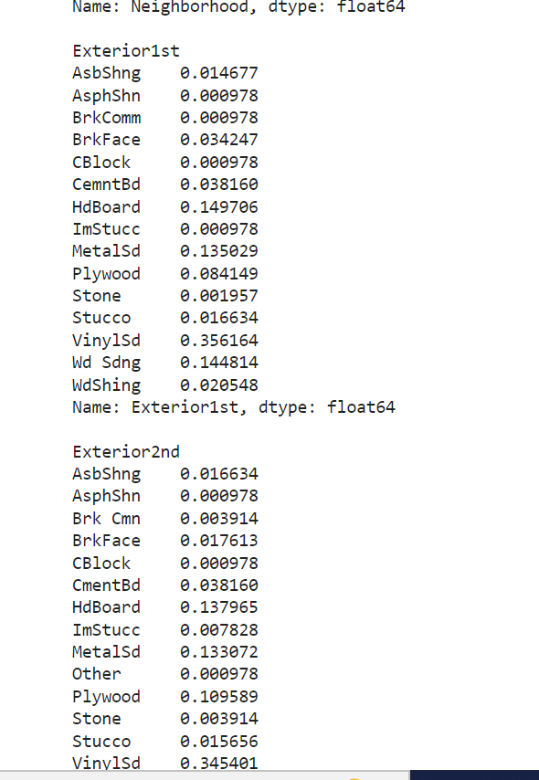

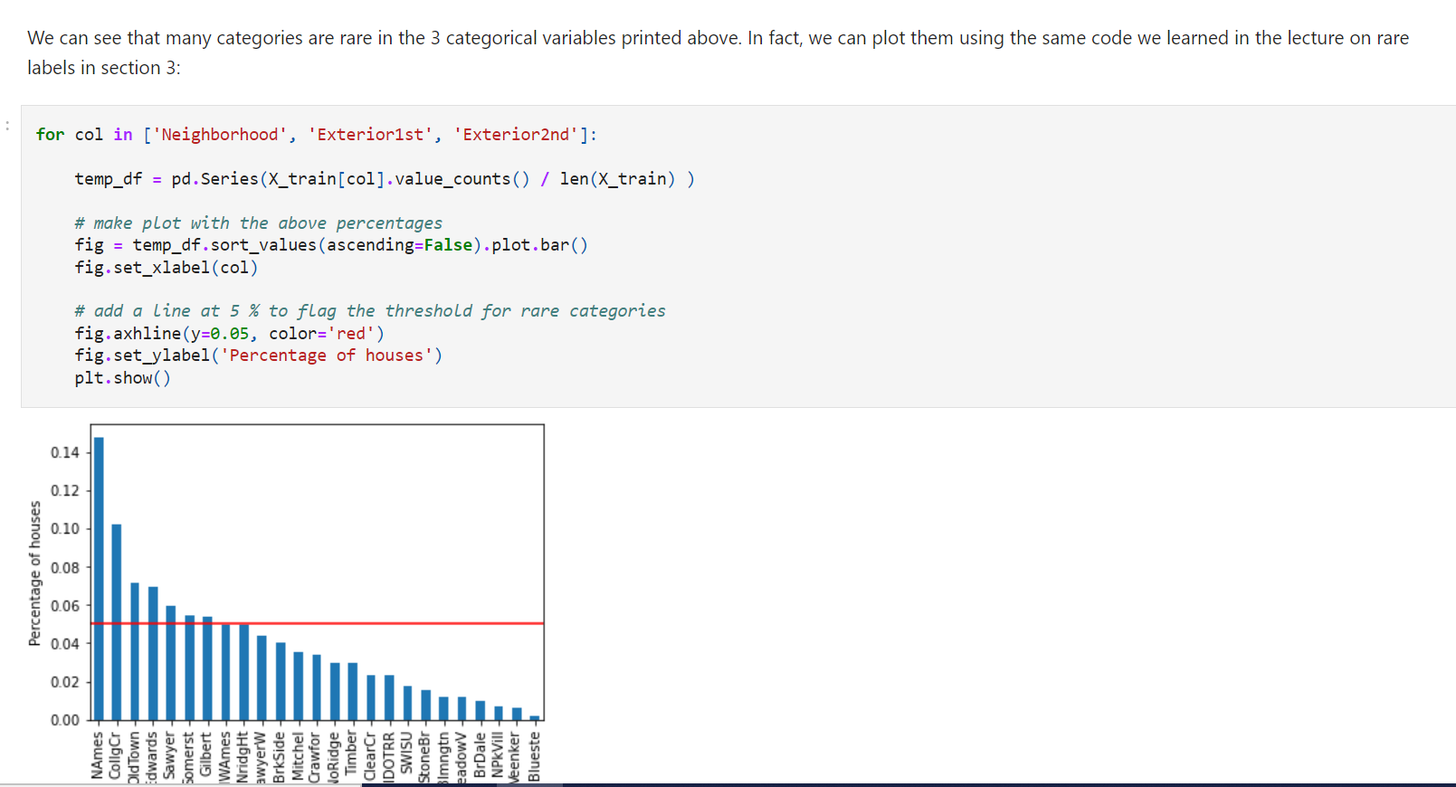

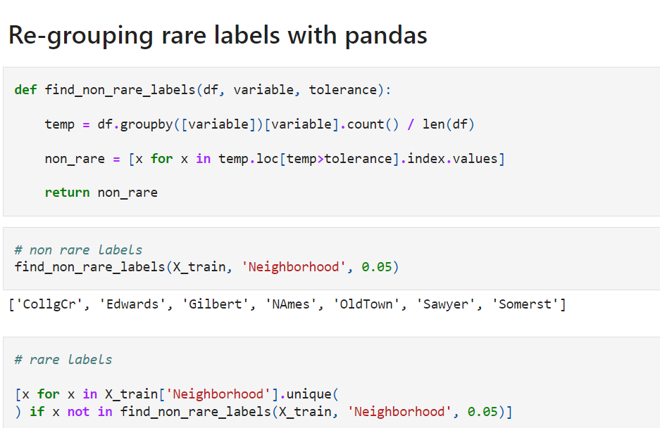

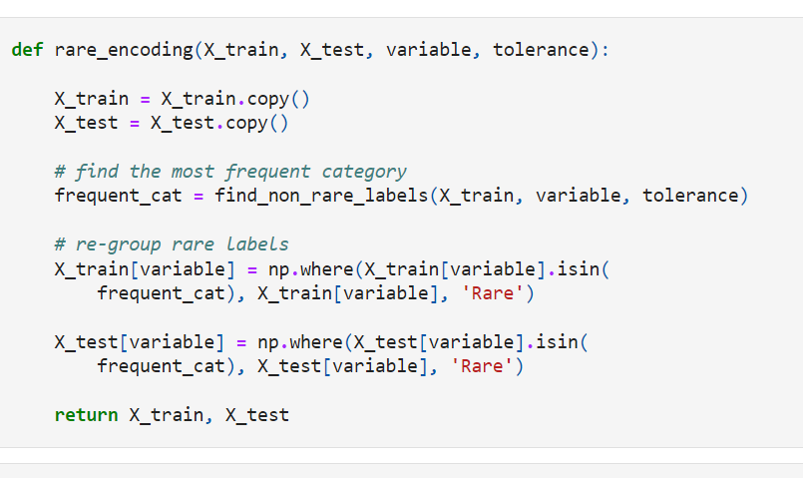

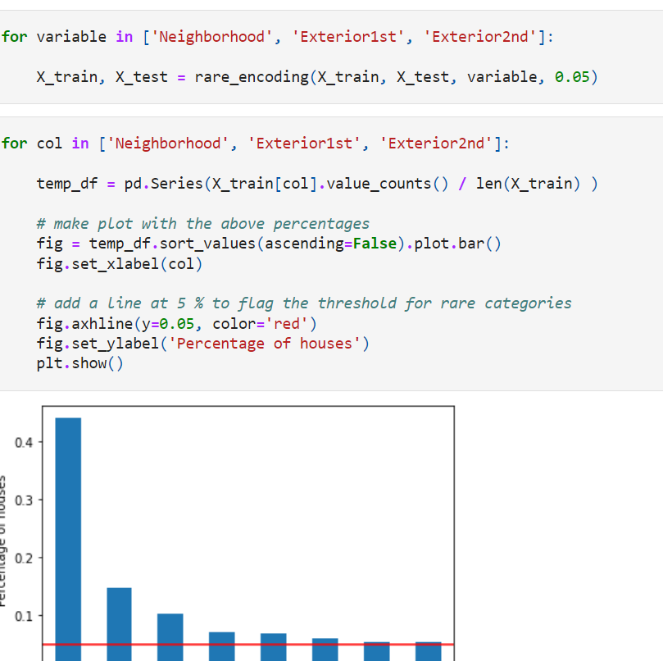

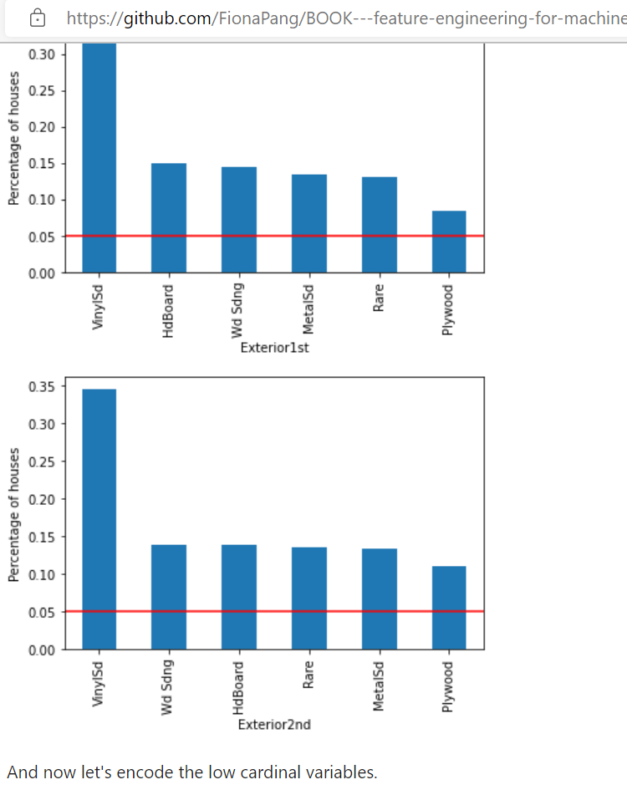

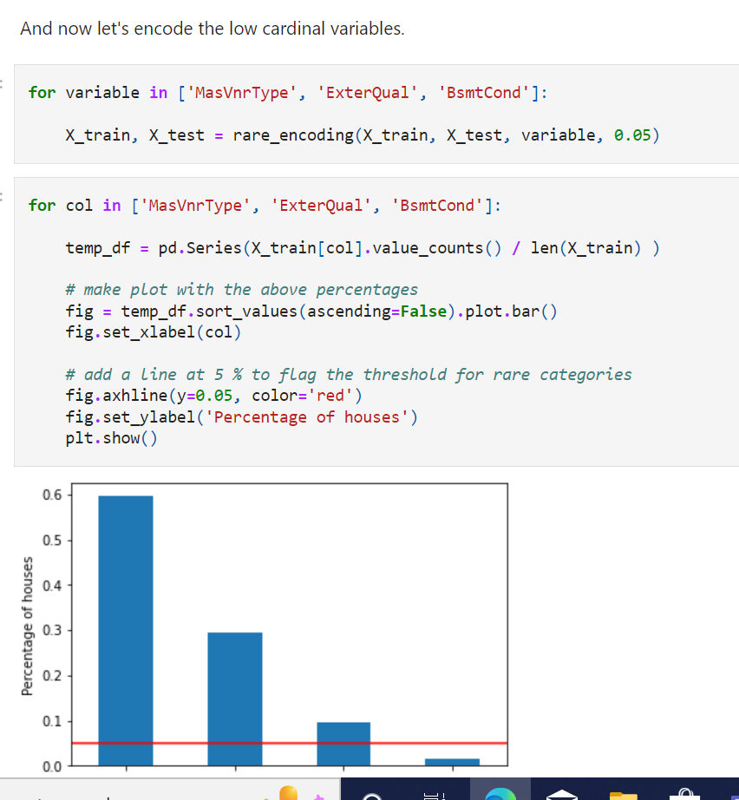

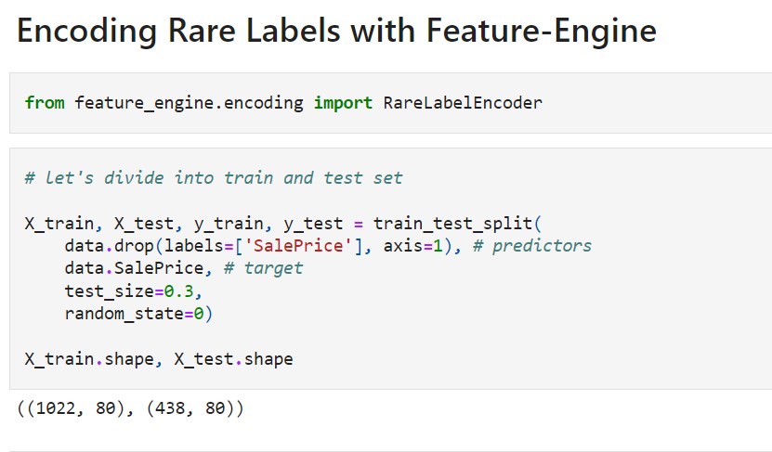

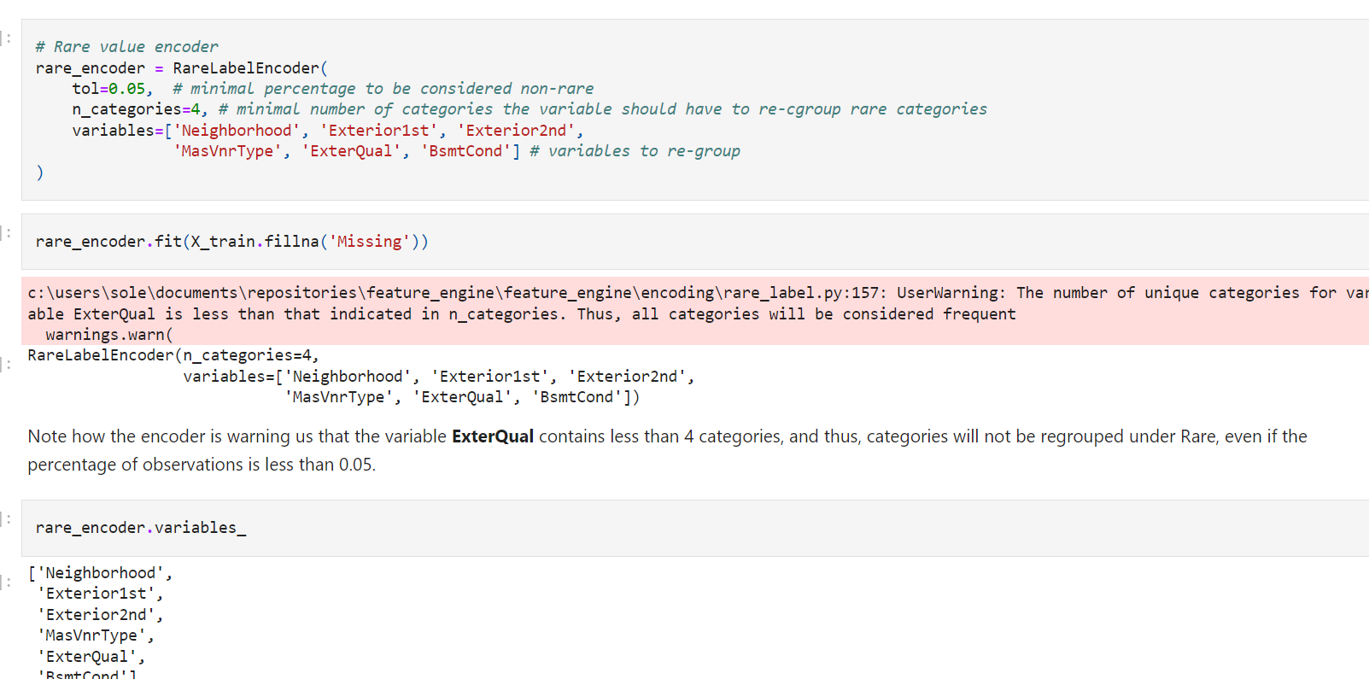

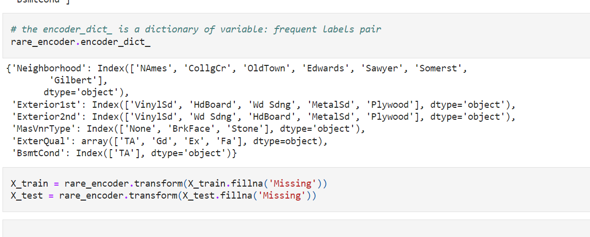

**Additional reading resources**

Weight of Evidence

* [WoE Module from StatSoft](http://documentation.statsoft.com/portals/0/formula%20guide/Weight%20of%20Evidence%20Formula%20Guide.pdf)
* [WoE Statistica](http://documentation.statsoft.com/StatisticaHelp.aspx?path=WeightofEvidence/WeightofEvidenceWoEIntroductoryOverview)

Score card development for credit risk

* [Plug and Score](https://plug-n-score.com/learning/scorecard-development-stages.htm#Binning)
* [Score card development from SAS](http://www.sas.com/storefront/aux/en/spcrisks/59376_excerpt.pdf)

Alternative methods of categorical variable encoding

* [Will's blog](http://www.willmcginnis.com/2015/11/29/beyond-one-hot-an-exploration-of-categorical-variables/)
* [Visiting Categorical Features and Encoding in Decision Trees](https://medium.com/data-design/visiting-categorical-features-and-encoding-in-decision-trees-53400fa65931)
* [Feature Engineering: A comprehensive Overview](http://www.trainindatablog.com/feature-engineering-for-machine-learning-comprehensive-overview/)
* [Smarter Ways to Encode Categorical Data for Machine Learning](https://towardsdatascience.com/smarter-ways-to-encode-categorical-data-for-machine-learning-part-1-of-3-6dca2f71b159)
* [Classification of Tutor systems with high cardinality (KDD competition)](http://pslcdatashop.org/KDDCup/workshop/)
* [Light weight solution to KDD data mining challenge](http://pslcdatashop.org/KDDCup/workshop/)

Several encoding and imputation methods described in this course

* [The 2009 Knowledge Discovery in Data Competition (KDD Cup 2009)](http://www.mtome.com/Publications/CiML/CiML-v3-book.pdf)